1GE+2.5GE DUAL MODE ONU
USER MANUAL

Version V1.1
Release Date 2025-5-29
Contents
Chapter 1 Product Introduction 1
1.1 Product Description 1
1.2 Special features 1
1.3 Technical Parameter 1
1.3.1 Common ONU 1
1.3.2 Panel ONU 2
1.4 Application chart 3
1.5 Panel description 3
1.5.1 Common ONU 3
1.5.2 Panel ONU 5
Chapter 2 Quick Installation 7
2.1 Standard Packing Contents 7
2.2 Quick Installation 7
Chapter 3 Configuration 9
3.1 Login 9
3.2 Status 10
3.2.1 Device Information 10
3.2.2 Statistics 11
3.2.3 Logout 11
3.3 Setup 12
3.3.1 WAN 12
3.3.2 LAN 14
3.4 Advanced 17
3.4.1 Route 17
3.4.2 NAT 18
3.4.3 QoS 20
3.4.4 CWMP 21
3.4.5 Port Mapping 22
3.4.6 VLAN Mapping 22
3.4.7 Others 23
3.5 Service 24
3.5.1 IGMP 24
3.5.2 UPnP 25
3.6 Firewall 26
3.6.1 MAC Filtering 26
3.6.3 IP/Port Filtering 27
3.6.3 URL Filter 28
3.6.4 ACL 29
3.6.5 DoS Setting 30
3.7 Maintenance 31
3.7.1 Update 31
3.7.2 Password 33
3.7.3 Reboot/Restore 33
3.7.4 Time 34
3.7.5 Log 35
3.7.6 Diagnostics 35

Chapter 1 Product Introduction

1.1 Product Description
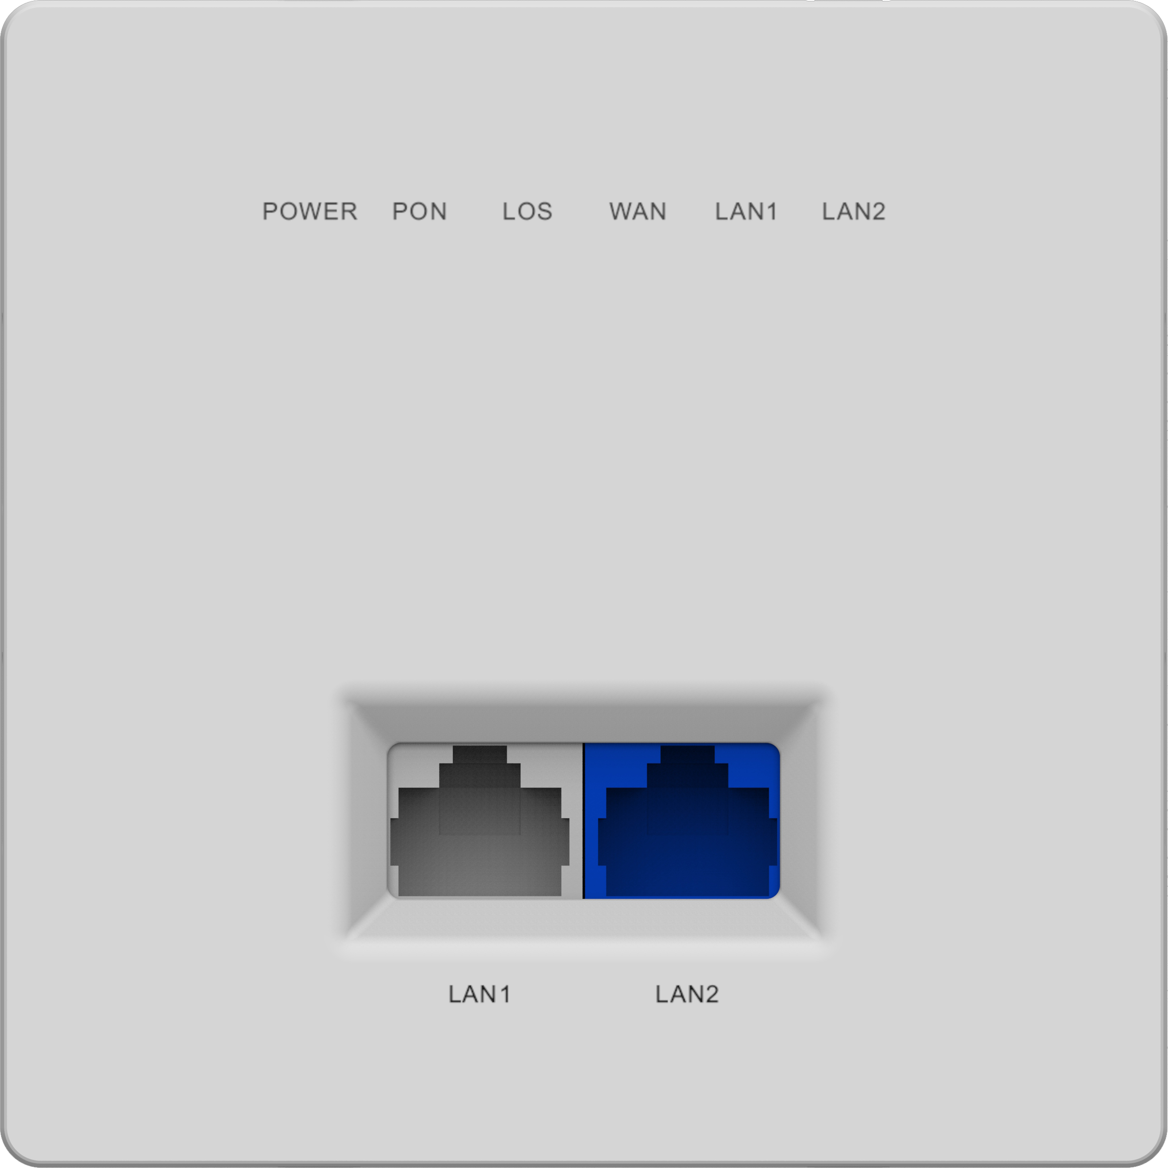
1GE+2.5GE Dual mode ONU meets telecom operators FTTO (office), FTTD (Desk), FTTH(Home) broadband speed, SOHO broadband access, video surveillance and other requirements and design EPON/GPON Gigabit Ethernet products. It is based on mature and stable, cost-effective EPON/GPON technology, high reliability, easy management, configuration flexibility and good quality of service (QoS) guarantees. They are fully compliant with GPON and EPON technical regulations such as ITU-T G.984.x, IEEE802.3ah and so on. Dual mode ONU can detect and exchange PON mode automatically.
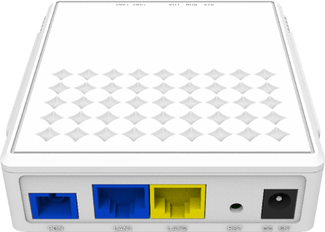

1GE+2.5GE Dual Mode ONU | 1GE+2.5GE Dual Mode Panel ONU

Figure 1-1: 1GE+2.5GE Dual Mode ONU

1.2 Special features
- Integrated auto detecting, auto configuration, and auto firmware upgrade technology.
- Support OAM/OMCI remote configuration and maintenance.
- Support rich VLAN, DHCP Server and IGMP snooping multicast feature.
- Fully compatibility with the mainstream OLT brands.
- Support NAT, Firewall function.
- Support bridge and router mode.

1.3 Technical Parameter

1.3.1 Common ONU
Technical items | Descriptions
PON interface | 1 G/EPON port(EPON PX20+ and GPON Class B+)  Receiving sensitivity: ≤-28dBm  Transmitting optical power: 0~+4dBm  Transmission distance: 20KM
Wavelength | Tx1310nm,Rx 1490nm
Optical interface | SC/PC connector
Interface | 1* 10/100/1000Mbps and 1* 10/100/1000/2500Mbps auto adaptive Ethernet interfaces. Full /Half Duplex, RJ45 connectors.
Indicator | SYS, PON, LOS, LAN1, LAN2
Operating condition | Operating temp:-10℃～+55℃  Operating humidity:5%～95% (non-condensing)
Storing condition | Operating temp:-40℃～+70℃  Operating humidity5%～95%(non-condensing)
Power supply | DC 12V, 0.5A
Power consumption | ≤4W
Dimension | 100mm*92mm*29.5mm(L*W*H)
weight | 0.13Kg

1.3.2 Panel ONU
Technical items | Descriptions
PON interface | 1 G/EPON port(EPON PX20+ and GPON Class B+)  Receiving sensitivity: -28dBm  Transmitting optical power: 0~+4dBm  Transmission distance: 20KM
Wavelength | Tx1310nm,Rx 1490nm
Optical interface | SC/PC connector
Interface | 1* 10/100/1000Mbps +1* 10/100/1000/2500Mbps auto adaptive Ethernet interfaces. Full /Half Duplex, RJ45 connectors.
Indicator | PWR, PON, LOS, WAN, LAN1, LAN2
Operating condition | Operating temp:-10 °C~ +55°C  Operating humidity:5% ~ 95% (non-condensing)
Storing condition | Storing temp: -40 °C~ +70°C  Storing humidity: 5% ~ 95% (non-condensing)
Power supply | 100 ~ 240V AC, 50/60Hz
Dimension | 86mm×86mm×33.3mm(L×W×H)
Net weight | 0.16Kg

1.4 Application chart
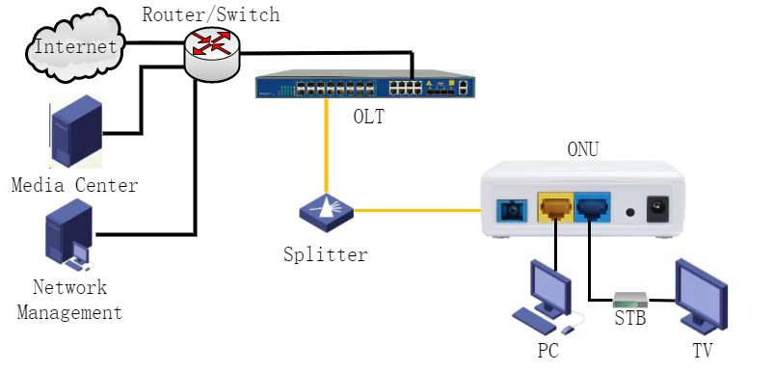
Figure 1-2: Application chart

1.5 Panel description

1.5.1 Common ONU
Interface/Button panel
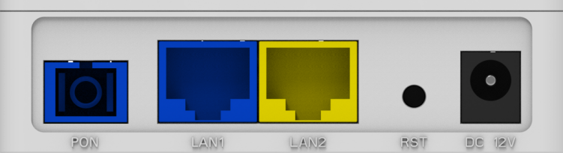
Figure 1-3: Interface/Button panel

Name | Description
PON | Connect to OLT by SC type fiber connector, single mode optical fiber cable.
LAN | Connect PC or other devices with Ethernet port by Cat5 cable, RJ-45 connector.
DC 12V | Connect with power adapter. DC 12V, 0.5A.
RST | Press RST button over 10 seconds, onu restores factory default and reboot.
Indication Panel
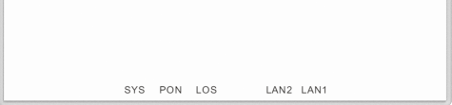
Figure 1-4: Indication panel

Name | Status | Description
SYS | ON/ OFF | System is not running or fatal error.
SYS | Blink | Normal running.
PON | ON | The device is registered to the PON system.
PON | OFF | The device is not registered to the PON system.
PON | Blink | The device is registering.
LOS | OFF | The device has received optical signal.
LOS | Blink | The device does not receive optical signal.
LAN1  LAN2 | ON | Port is connected properly (LINK).
LAN1  LAN2 | OFF | Port is not connected properly.
LAN1  LAN2 | Blink | Port is sending or/and receiving data.

1.5.2 Panel ONU
Interface/Button panel
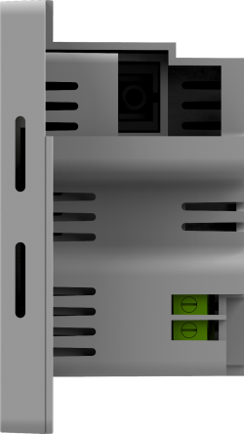
Figure 1-5: Interface

Name | Description
PON | Connect to OLT by SC type fiber connector, single mode optical fiber cable.
LAN | Connect PC or other devices with Ethernet port by Cat5 cable, RJ-45 connector.
Indication Panel

Figure 1-6: Indication panel

Name | Status | Description
POWER | ON | The device is powered up.
POWER | OFF | The device is powered down.
POWER | Blink | The device does not receive optical signal.
PON | ON | The device is registered to the PON system.
PON | OFF | The device is not registered to the PON system.
PON | Blink | The device is registering.
LOS | OFF | The device has received optical signal.
LOS | Blink | The device does not receive optical signal.
WAN | ON | WAN connection is up.
WAN | OFF | WAN connection is down.
LAN1  LAN2 | ON | Port is connected properly (LINK).
LAN1  LAN2 | OFF | Port is not connected properly.
LAN1  LAN2 | Blink | Port is sending or/and receiving data.

Chapter 2 Quick Installation

2.1 Standard Packing Contents
When you received our product, please check carefully to make sure that our products whether have some defects or not. If something wrong with shipping, please contact carrier; other damage or lack of some parts, please contact with dealer.

Contents | Quantity
Dual Mode ONU | 1 pc
Power Adapter | 1 pc
Installation Guide | 1 pc

2.2 Quick Installation
- Connecting the optical fiber cable to the unit.
- Remove the protective cap of the optical fiber.
- Clean the end of the optical fiber with an optical fiber end cleaner.
- Remove the protective cap of the ONU optical interface (PON interface). Connect the fiber to the PON port on the unit.
Note: When measuring the optical power before connecting to the ONU, it is recommended to use a PON Power Meter.
While connecting, please note:
          - Keep the optical connector and the optical fiber clean.
          - Make sure there are no tight bends in the fiber and that the bending diameter is greater than 6cm. Otherwise, the optical signal loss may be increased, to the extent that signal may be unavailable.
          - Cover all optic ports and connectors with protective cap to guard against dust and moisture when the fiber is not used.
- Apply power to the unit. Push the power button.
- After the ONU is power ON, Indicators should light up as for normal operation. Check whether the PON interface status LED (PON) is on continuously. If it is, the connection is normal; otherwise there is either problem of the physical connection or the optical level at either end. This may be caused by either too much or too little attenuation over the optical fiber. Please refer to the Layout Description section of this installation manual for normal LED activity.
- Check all signal levels and services on all the ONU communication ports.
Unit Installation Adjustment
Installing the ONU on a horizontal surface (Bench top)
Put the ONU on a clean, flat, sturdy bench top. You must keep the clearance for all sides of the unit to more than 10cm for heat dissipation.
Installing the ONU on a vertical surface (Hanging on a wall)
You can install the ONU on a vertical surface by using the mounting holes on the bottom of the ONU chassis and two flat-head wood screws.
            - Insert the screws into the wall. The screw positions must be in the same horizontal line and the distance between them must be 145mm. Reserved at least 6mm between the screw caps and the wall.
            - Hang the ONU on the screws through the mounting holes.

Chapter 3 Configuration
After finishing the basic connection configuration, you can use its basic function. In order to satisfy individuation service requirements, this charter provides the user parameter modification and individuation configuration description.
This model of ONU is designed as SFU(single family unit, bridge mode), there is no bridge mode WAN in ONU. When it works on bridge mode, VLAN of LAN port should be configured by OLT. When it works on router mode, you may configure through its web management.

3.1 Login
The device is configured by the web interface. The following steps will enable you to login:
- Conform “Quick Installation” to install;
- The device default IP is 192.168.1.1;
- Open web browser, type the device IP in address bar;
- Entry of the user name and password will be prompted. Enter the default login user name and password.
By default, Administration level user name is "admin", password is "stdONUi0i".

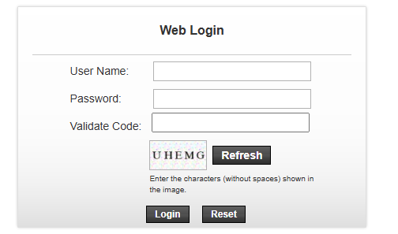
Figure 3-1: Login

For security, you will be asked to modify password after you logged in with default password. The new password must meet the requirements that display on the web page. After submitted, it requires you to login with new password.
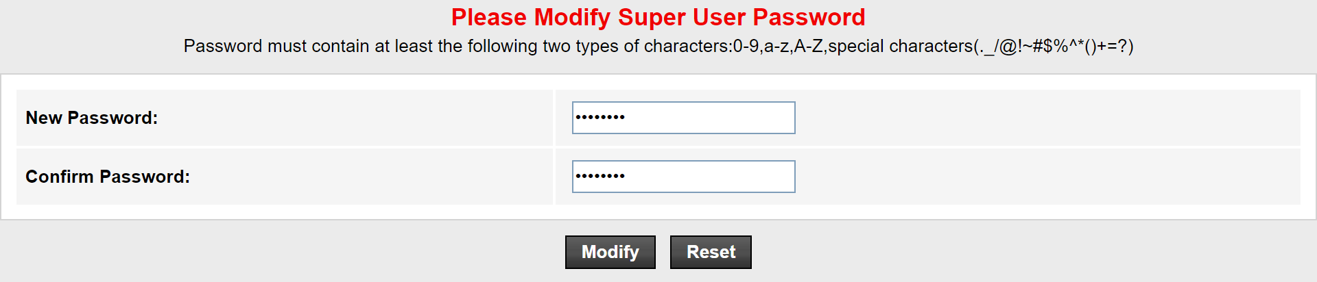
Figure 3-2: Change Password

3.2 Status
This part shows the main information of product.

3.2.1 Device Information

3.2.1.1 Device Info
This page shows the device basic information, such as Software Version, PON SN, LAN info, WAN info and so on.
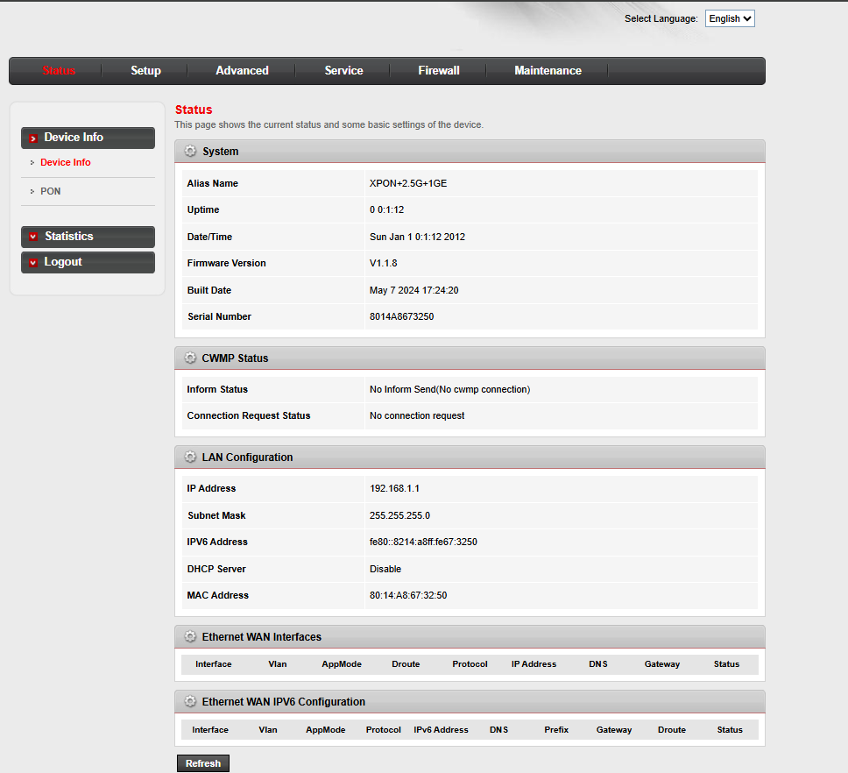
Figure 3-3: Device Information

3.2.1.2 PON Status
This page shows the current system status of PON.
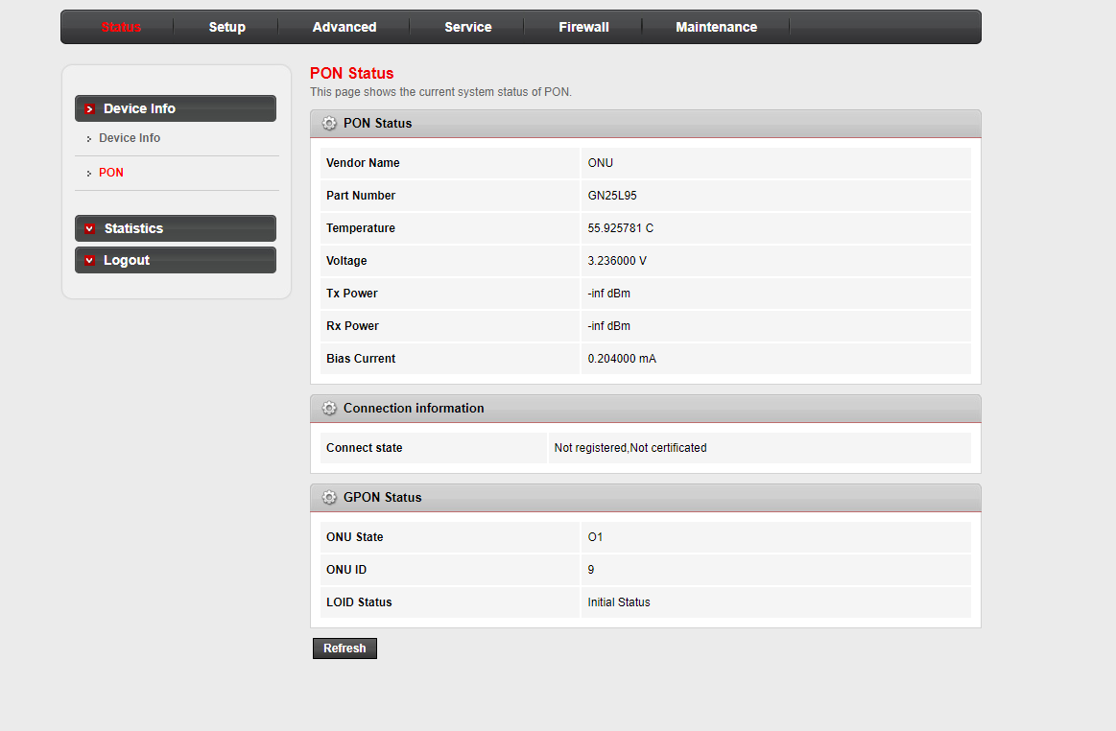
Figure 3-4: PON Status

3.2.2 Statistics
This page shows the packet statistics for transmission and reception regarding to network interface.
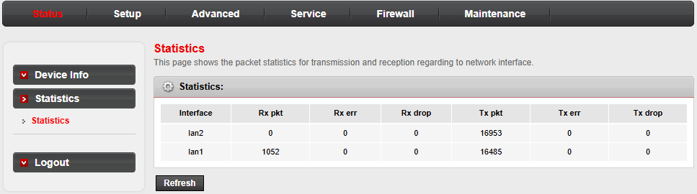
Figure 3-5: WAN Connection

3.2.3 Logout
This page is used to logout from the Device.
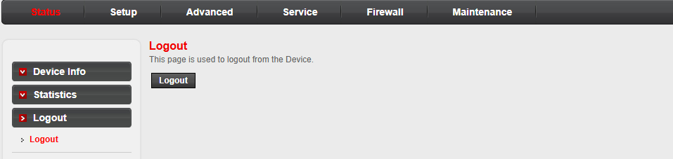
Figure 3-6: Logout

3.3 Setup

3.3.1 WAN

3.3.1.1 WAN Configuration
This page is used to configure the parameters for the WAN interface of your ONU. Note : Only when connect type of PPPoE is "Manual", the "Connect" and "Disconnect" button can be available.
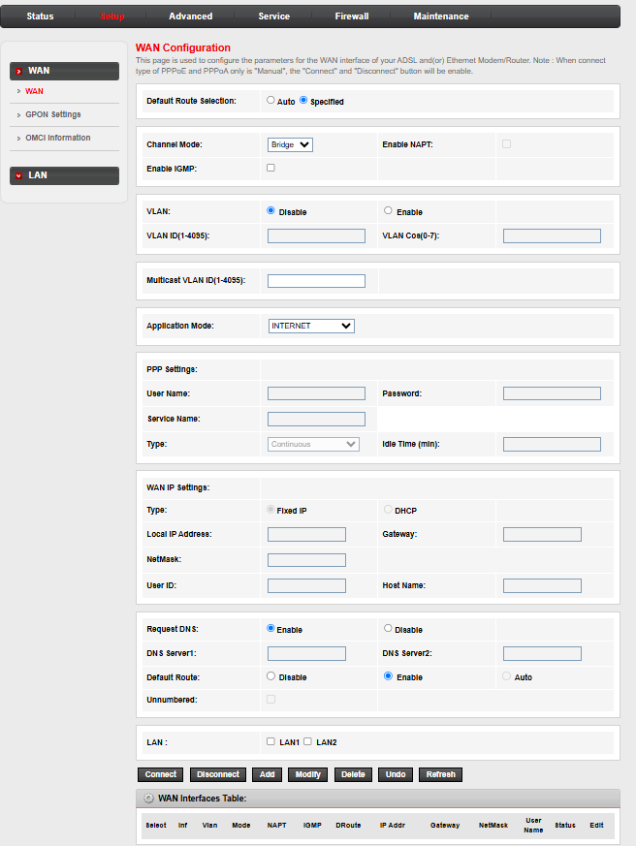
Figure 3-7: WAN Connection

3.3.1.2 PON Settings
This page is used to configure the parameters for your GPON network access.
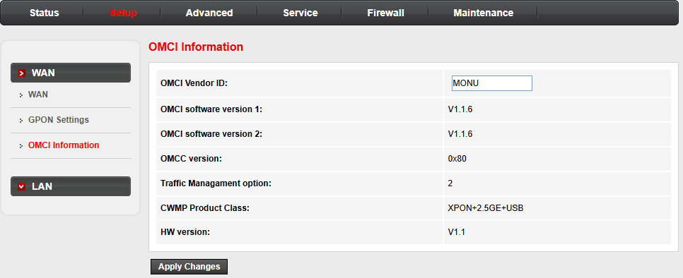
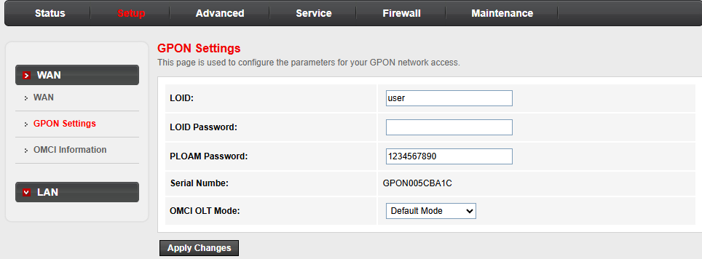
Figure 3-8: PON Settings and Info

3.3.2 LAN

3.3.2.1 LAN Interface Setup
This page is used to configure the LAN interface of your Router. You can change the setting for IP address, subnet mask, etc..
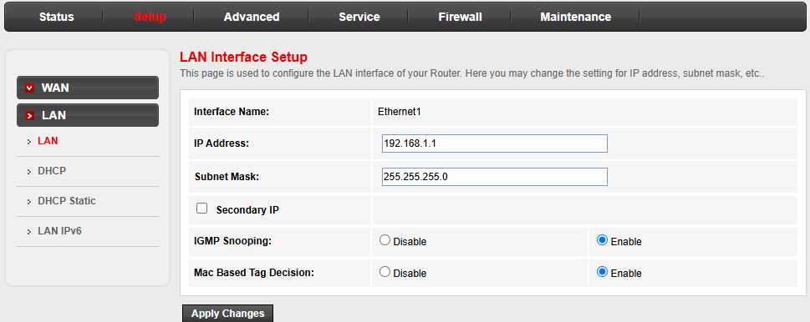
Figure 3-9: LAN Interface Setup

3.3.2.2 DHCP Mode
This page can be used to configure the DHCP mode:None,DHCP Relay or DHCP Server.
- Enable the DHCP Server if you are using this device as a DHCP server. This page lists the IP address pools available to host on your LAN. The device assigns IP addresses to hosts on your network as they request Internet access.
- Enable the DHCP Relay if you are using the other DHCP server to assign IP addresses to your hosts on the LAN. Then you can set the DHCP server IP address.
- I f you choose "None", the ONU will do nothing when the host request an IP address.
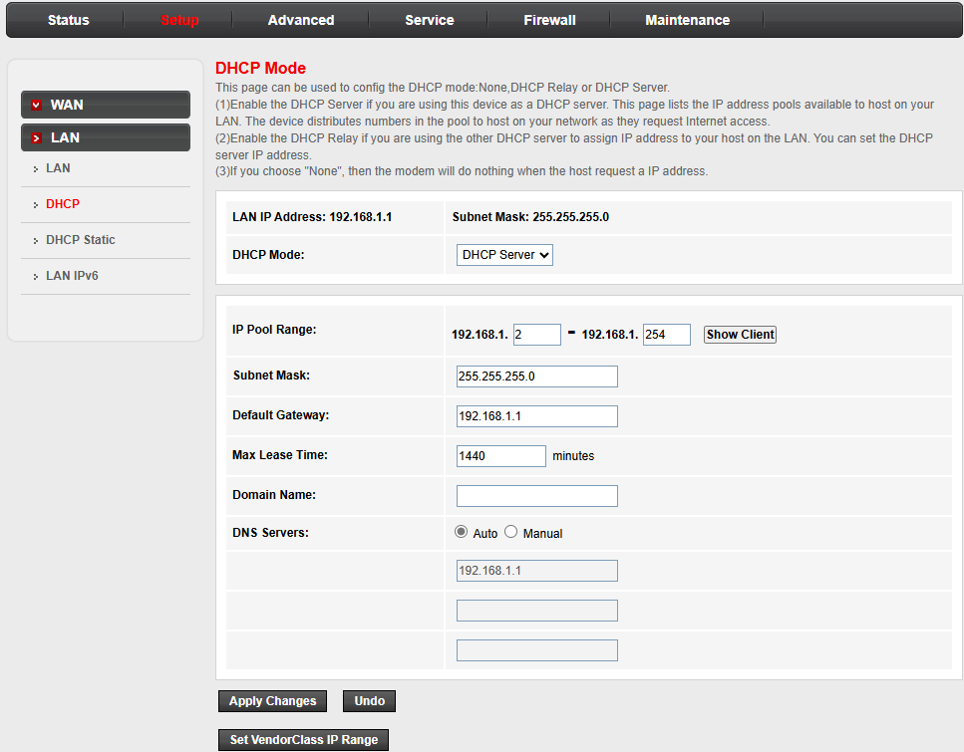
Figure 3-10: DHCP Mode

3.3.2.3 DHCP Static IP
This page lists the IP address for specific MAC address on your LAN. ONU assigns the fixed IP address to the specific MAC address according to the configuration as they request Internet access.
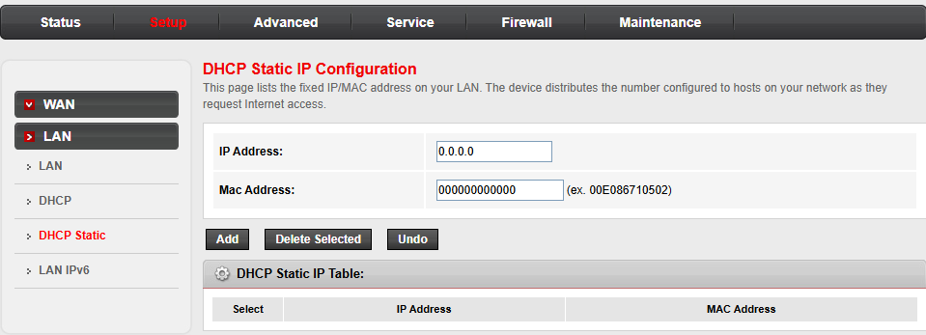
Figure 3-11: DHCP Static IP Configuration

3.3.2.4 LAN IPv6 Setting
This page is used to configure ipv6 LAN setting. User can set LAN RA server work mode and LAN DHCPv6 server work mode.
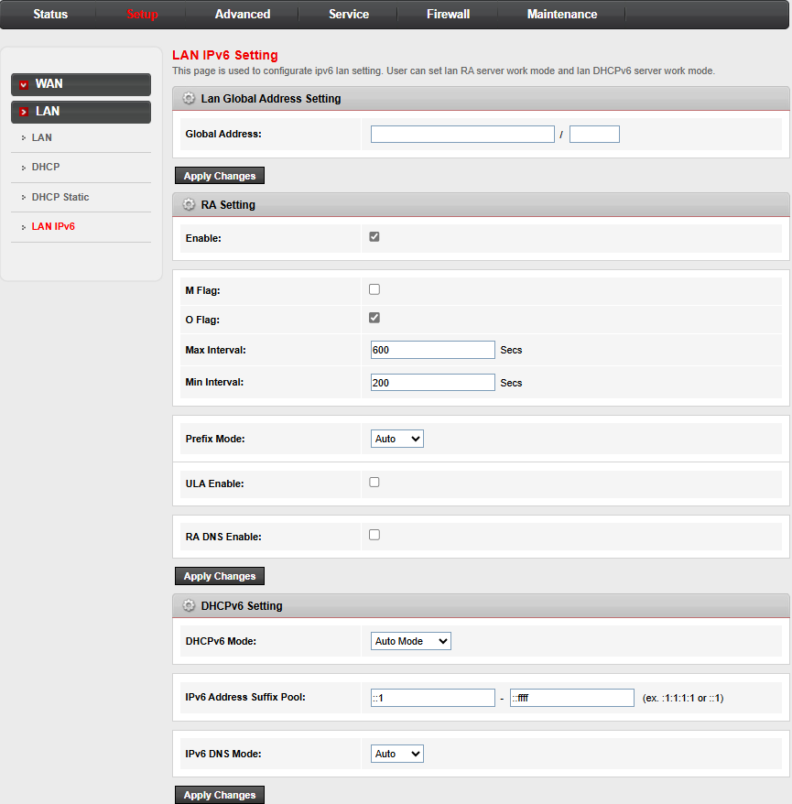
Figure 3-12: DHCP IPv6 Setting

3.4 Advanced

3.4.1 Route

3.4.1.1 Static Route
This page is used to configure the routing information. Here you can add/delete IP route rules.
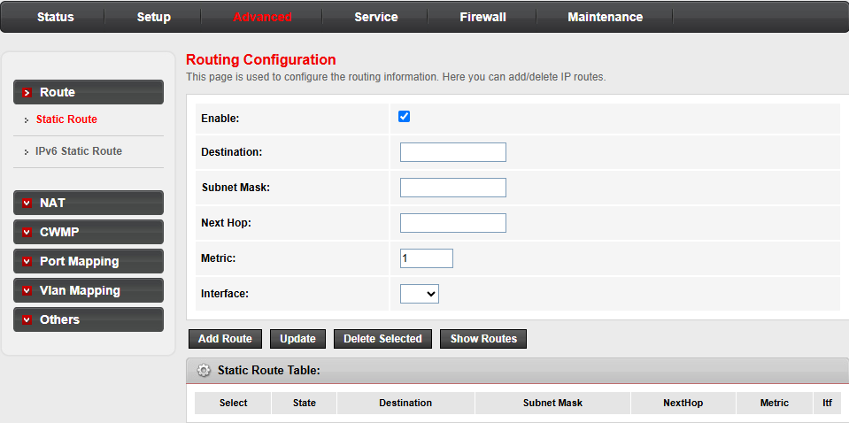
Figure 3-13: Routing Configuration

3.4.1.2 IPv6 Static Route
This page is used to configure the IPv6 routing information. Here you can add/delete IPv6 routes.
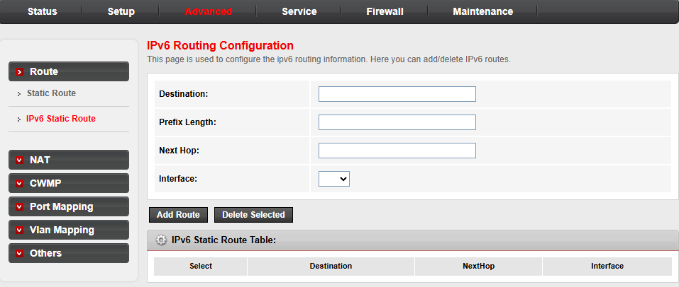
Figure 3-14: IPv6 Routing Configuration

3.4.2 NAT

3.4.2.1 DMZ
A Demilitarized Zone is used to provide Internet services without sacrificing unauthorized access to its local private network. Typically, the DMZ host contains devices accessible to Internet traffic, such as Web (HTTP ) servers, FTP servers, SMTP (e-mail) servers and DNS servers.
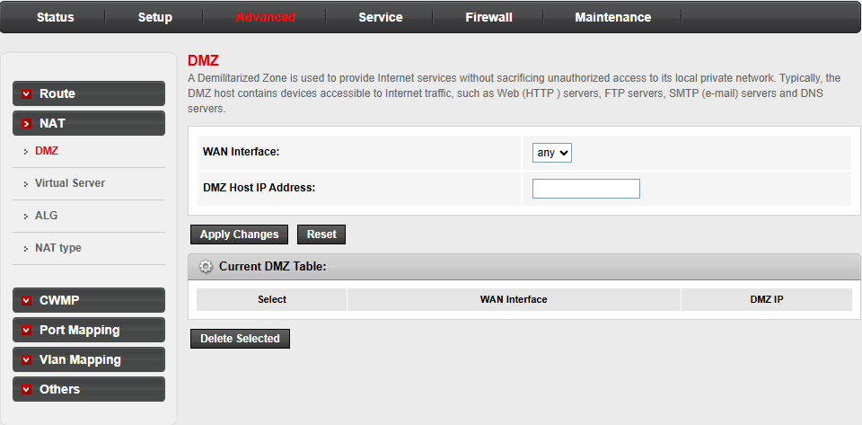
Figure 3-15: DMZ

3.4.2.2 Virtual Server
This page allows you to configure virtual server, so other hosts can access the server through the Gateway.
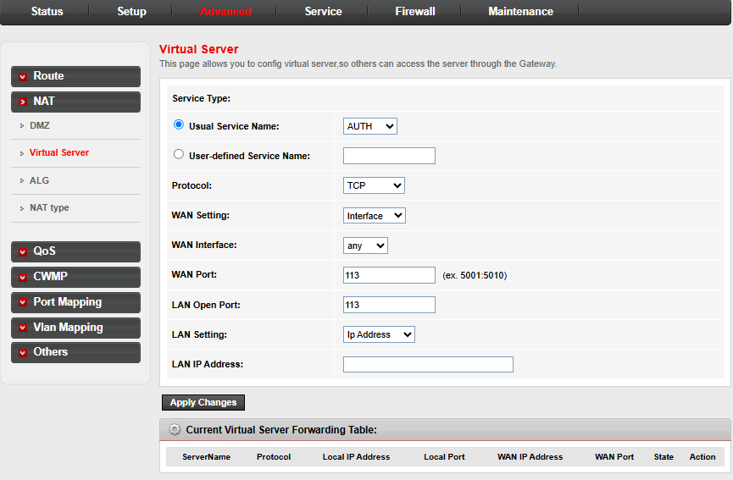
Figure 3-16: Virtual Server

3.4.2.3 ALG
Setup NAT ALG and Pass-Through configuration.
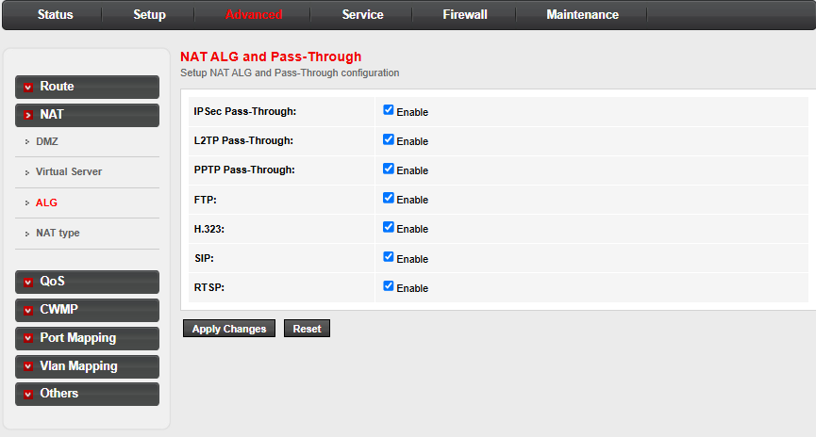
Figure 3-17: ALG

3.4.2.4 NAT TYPE
Setup NAT TYPE configuration.
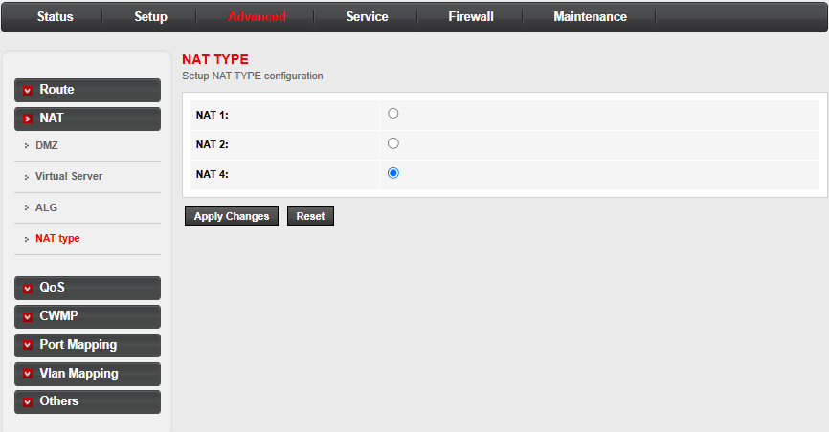
Figure 3-18: NAT TYPE

3.4.3 QoS

3.4.3.1 QoS
This page allows user to set QoS rules.
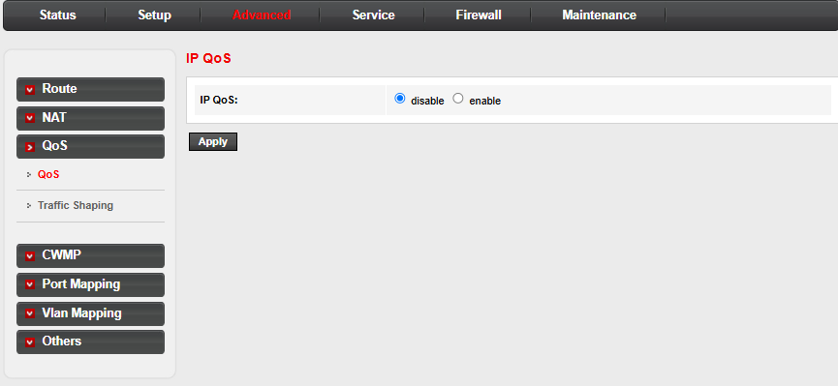
Figure 3-19: QoS Configuration

3.4.3.2 Traffic Shaping
Entries in this table are used for traffic control.
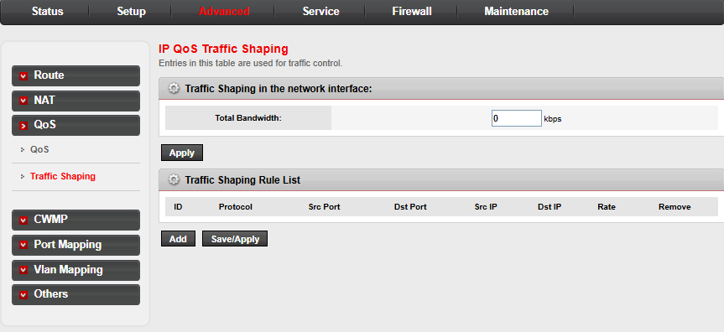
Figure 3-20: IP QoS Traffic Shaping

3.4.4 CWMP
This page is used to configure the TR-069 CPE. You can change the setting for the ACS parameters.
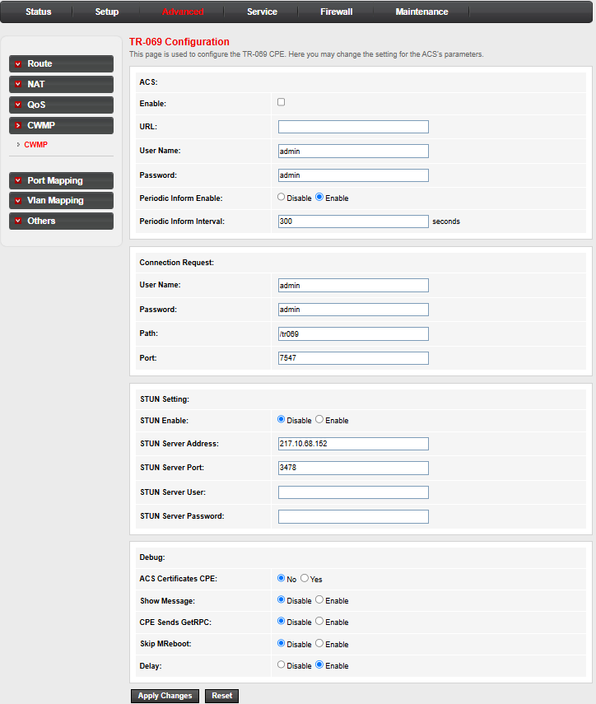
Figure 3-21: TR-069 Configuration

3.4.5 Port Mapping
To manipulate a mapping group:
1. Select a group from the table.
2. Select interfaces from the available/grouped interface list and add it to the grouped/available interface list using the arrow buttons to manipulate the required mapping of the ports.
3. Click "Apply Changes" button to save the changes.
Note that the selected interfaces will be removed from their existing groups and added to the new group.
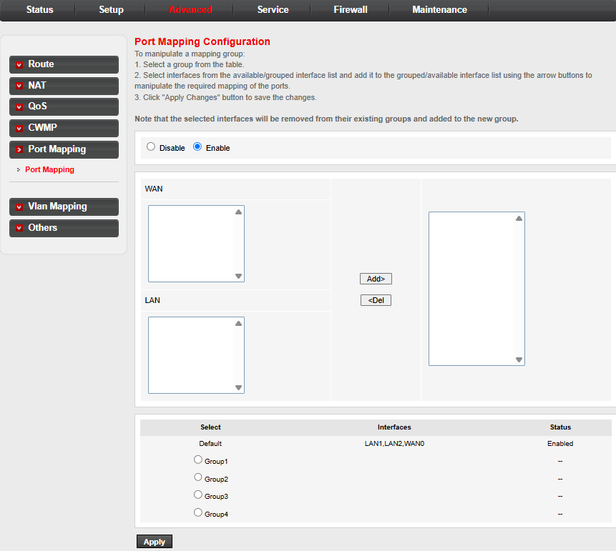
Figure 3-21: Port Mapping Configuration

3.4.6 VLAN Mapping
This page is used to configure VLAN binding for LAN ports.
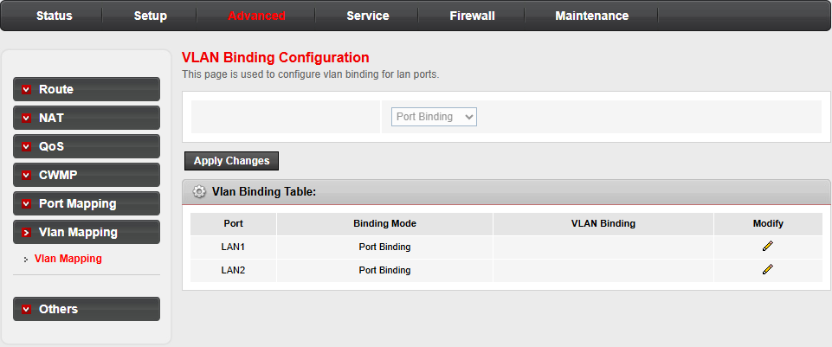
Figure 3-23: VLAN Binding Configuration

3.4.7 Others

3.4.7.1 Tunnel Configuration
This page is used to configure v6inv4 tunnel or v4inv6 tunnel.
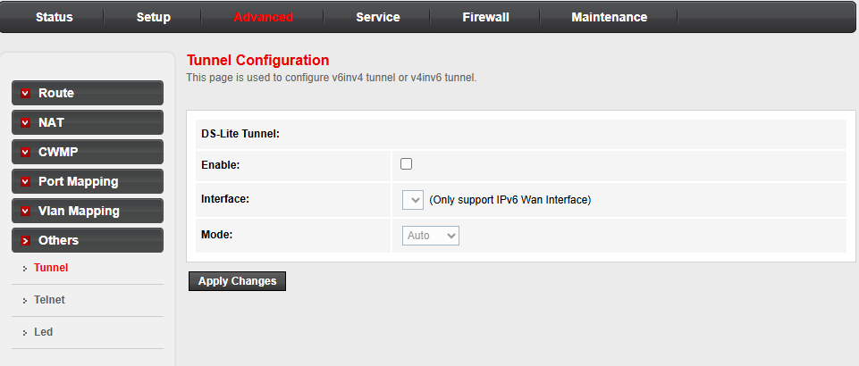
Figure 3-24: Tunnel Configuration

3.4.7.2 Telnet Configuration
This page is used to configure telnet function.
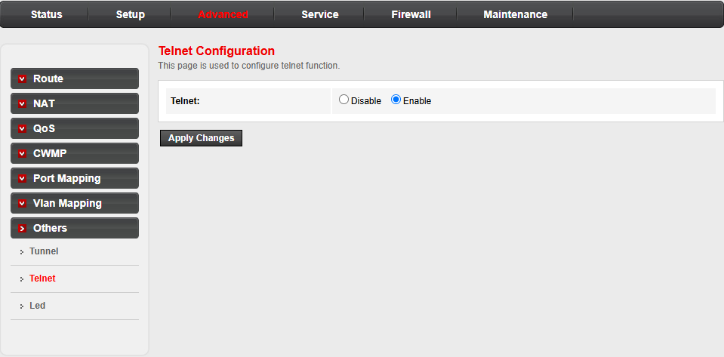
Figure 3-25: Telnet Configuration

3.4.7.3 Led Configuration
This page is used to turn on and turn off led lights.
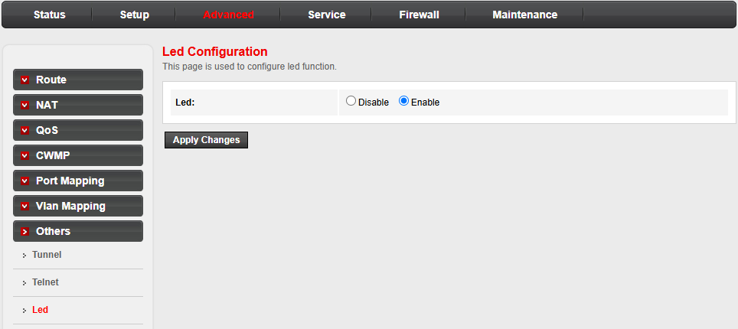
Figure 3-26: Led Configuration

3.5 Service

3.5.1 IGMP

3.5.1.1 IGMP Proxy
IGMP proxy enables the system to issue IGMP host messages on behalf of hosts that the system discovered through standard IGMP interfaces. The system acts as a proxy for its hosts when you enable it by doing the follows:
. Enable IGMP proxy on WAN interface (upstream), which connects to a router running IGMP.
. Enable IGMP on LAN interface (downstream), which connects to its hosts.
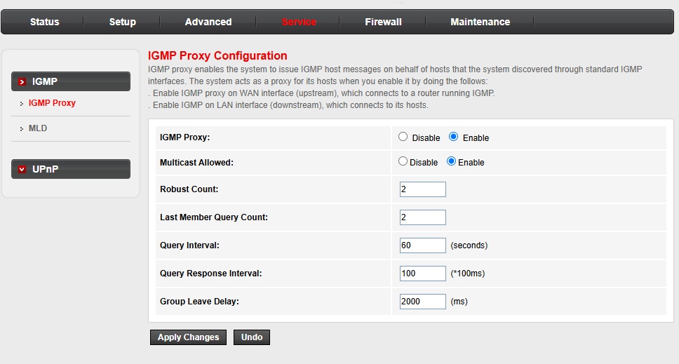
Figure 3-27: IGMP Proxy

3.5.1.2 MLD
MLD Proxy and Snooping can be configured here.
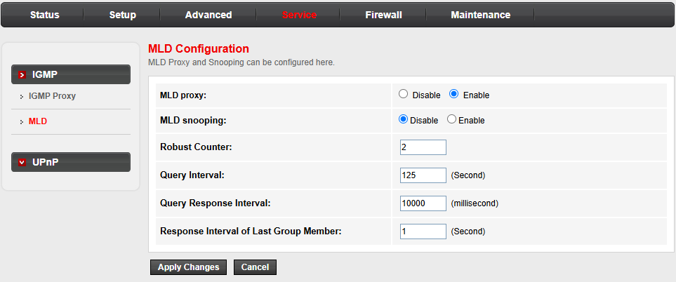
Figure 3-28: MLD Configuration

3.5.2 UPnP
This page is used to configure UPnP. The system acts as a daemon when you enable UPnP.
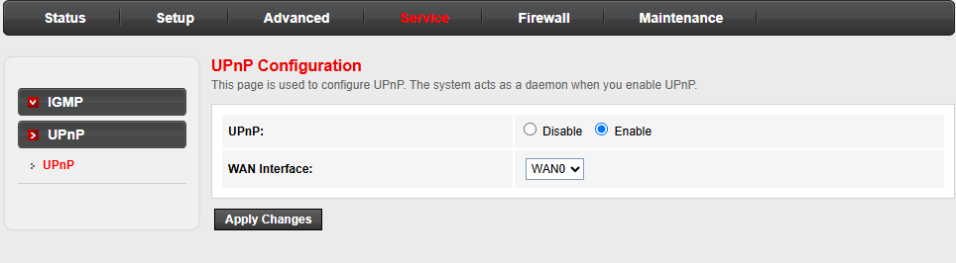
Figure 3-29: UPnP Configuration

3.6 Firewall

3.6.1 MAC Filtering

3.6.1.1 MAC Filtering
Entries in this table are used to restrict certain types of data packets from your local network to Internet through the Gateway. Use of such filters can be helpful in securing or restricting your local network.
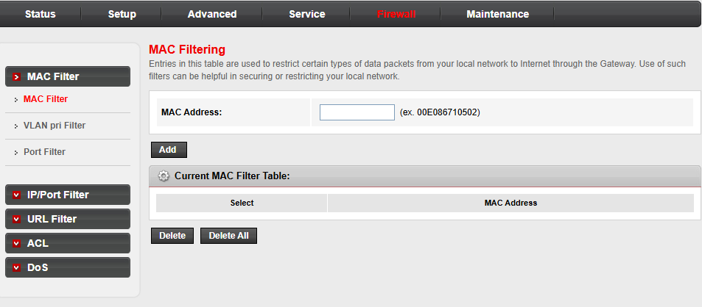
Figure 3-30: MAC Filtering

3.6.1.2 VLAN Pri Filtering
This page is used to configure VLAN pri upstream filtering.
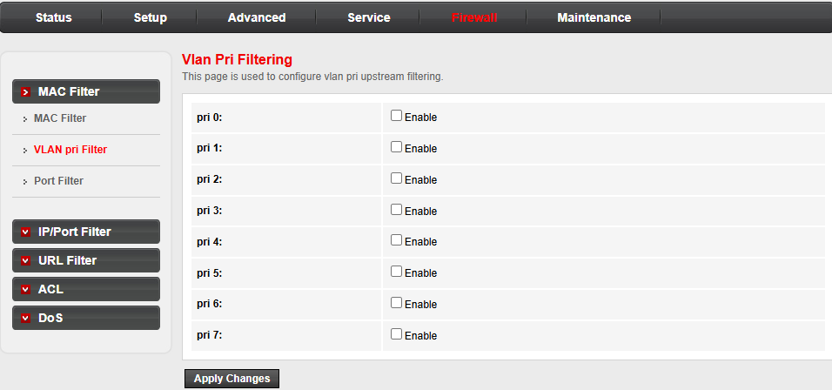
Figure 3-31: VLAN Pri Filtering

3.6.1.3 Port Filtering
This page is used to configure port upstream filtering.
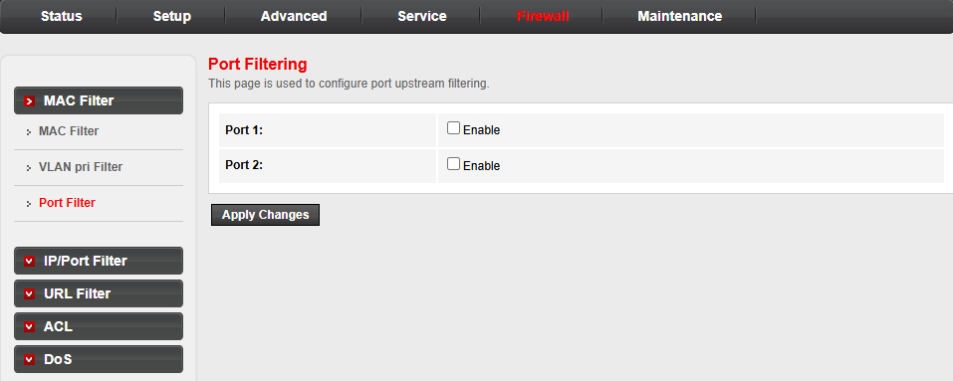
Figure 3-32: Port Filtering

3.6.3 IP/Port Filtering

3.6.2.1 IP/Port Filtering
Entries in this table are used to restrict certain types of data packets from your local network to Internet through the Gateway. Use of such filters can be helpful in securing or restricting your local network.his page allows user to set web page login timeout. If don’t operate the web page for the time out, the account will logout automatically.
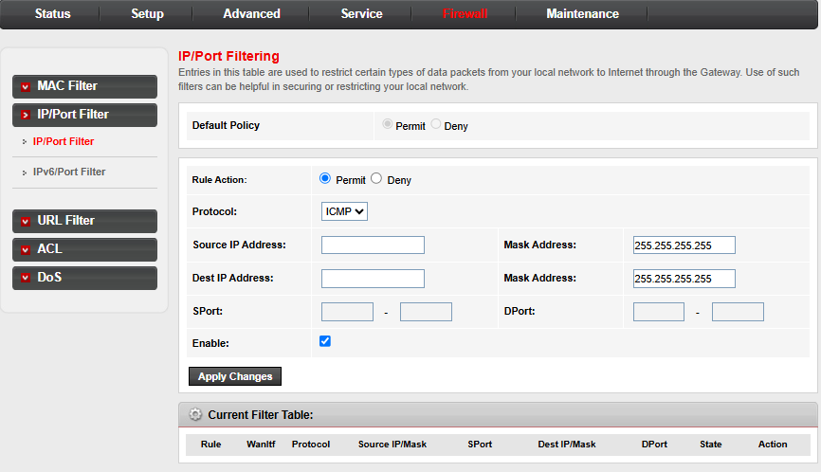
Figure 3-33: IP/Port Filtering

3.6.2.2 IPv6/Port Filtering
Entries in this table are used to restrict certain types of IPv6 data packets from your local network to Internet through the Gateway. Use of such filters can be helpful in securing or restricting your local network.
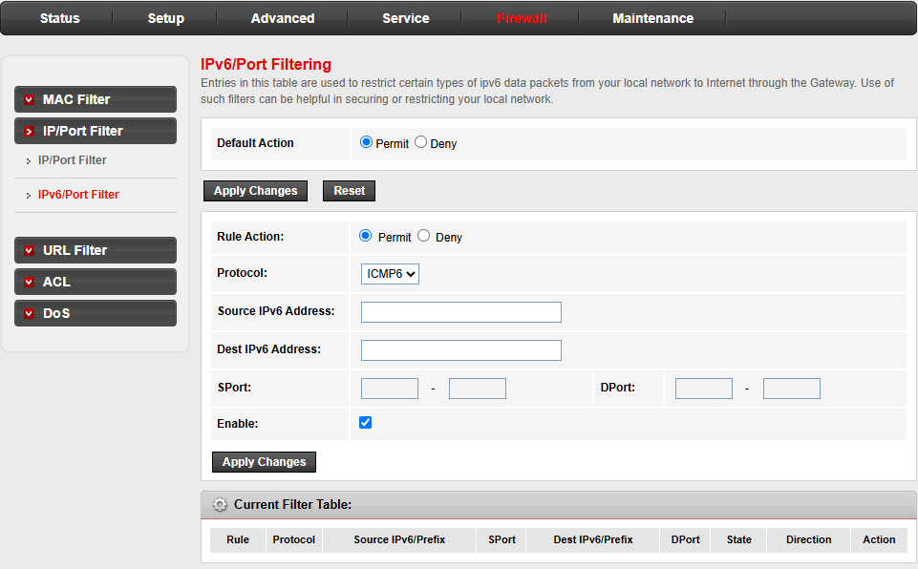
Figure 3-34: IPv6/Port Filtering

3.6.3 URL Filter
This page is used to configure the filtered keyword. Here you can add/delete filtered keyword.
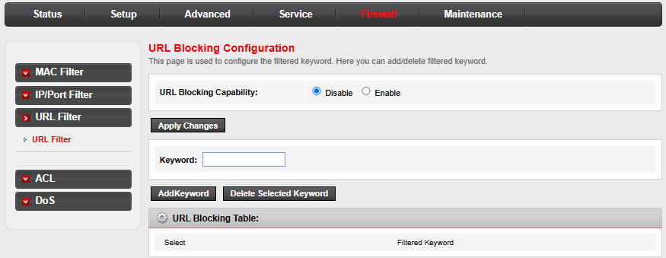
Figure 3-35: URL Blocking Configuration

3.6.4 ACL

3.6.4.1 ACL
You can specify which services are accessable form LAN or WAN side.
Entries in this ACL table are used to permit certain types of data packets from your local network or Internet network to the Gateway.
Using of such access control can be helpful in securing or restricting the Gateway management.
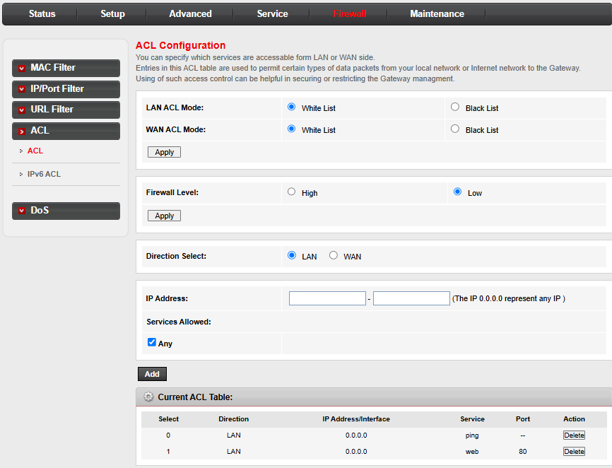
Figure 3-36: ACL

3.6.4.2 IPv6 ACL
You can specify which services are accessable form LAN or WAN side.
Entries in this ACL table are used to permit certain types of data packets from your local network or Internet network to the Gateway.
Using of such access control can be helpful in securing or restricting the Gateway management. is page allows user to set port mirror for troubleshooting. After configured port mirror, the traffic of WAN connection will be copied and sent to LAN port.
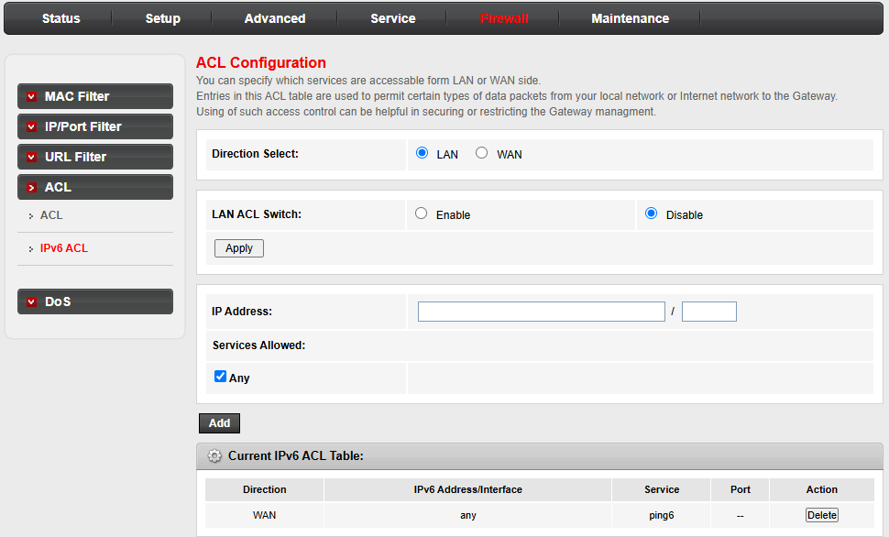
Figure 3-37: IPv6 ACL

3.6.5 DoS Setting
A "denial-of-service" (DoS) attack is characterized by an explicit attempt by hackers to prevent legitimate users of a service from using that service.
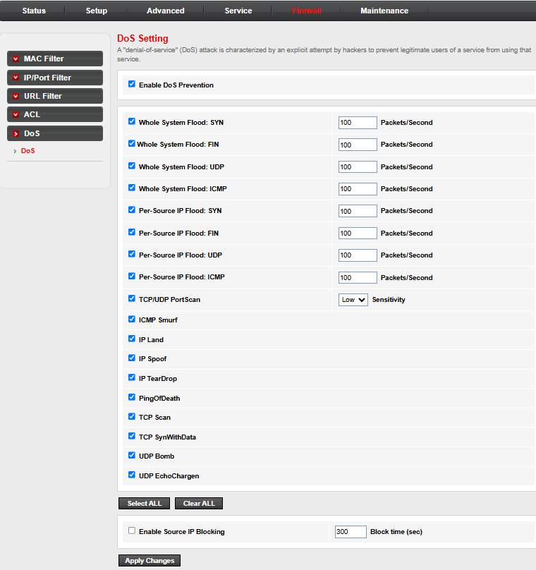
Figure 3-38: DoS Setting

3.7 Maintenance

3.7.1 Update

3.7.1.1 Firmware Update
This page allows you upgrade the Router firmware to new version. Please note, do not power off the device during the upload because it may crash the system.
Note:System will reboot after file is uploaded.
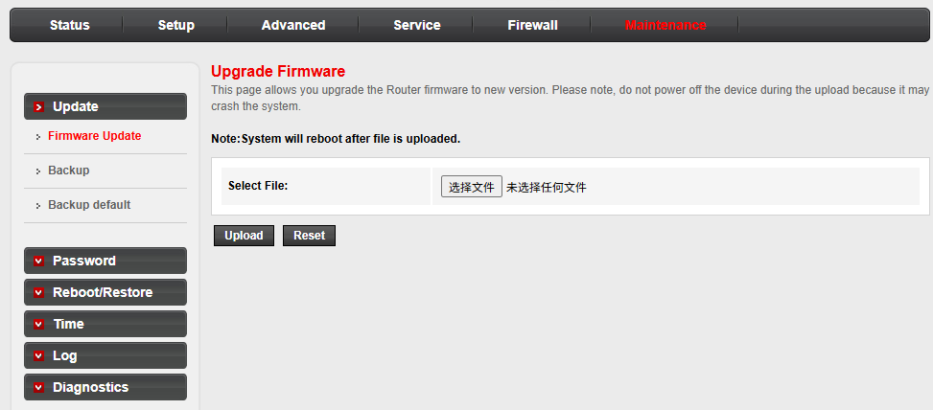
Figure 3-39: Upgrade Firmware

3.7.1.2 Backup
Once the router is configured you can save the configuration settings to a configuration file on your hard drive. You also have the option to load configuration settings.
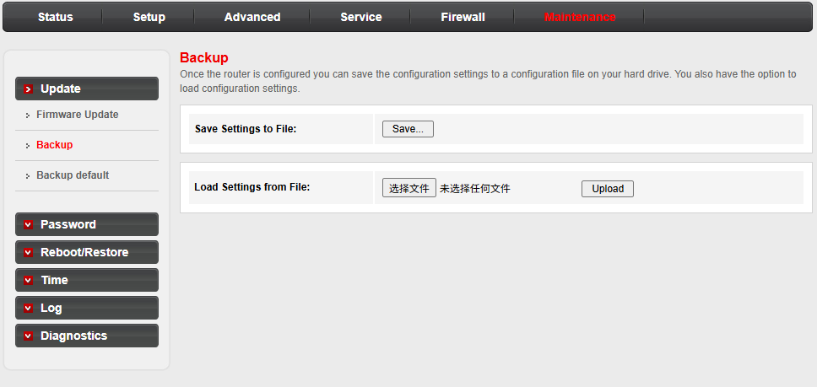
Figure 3-40: Backup

3.7.1.3 Backup default
You can save the current configuration settings as a default configuration file on your router. You also have the option to load default configuration settings, then this configuration will be router's default setting.
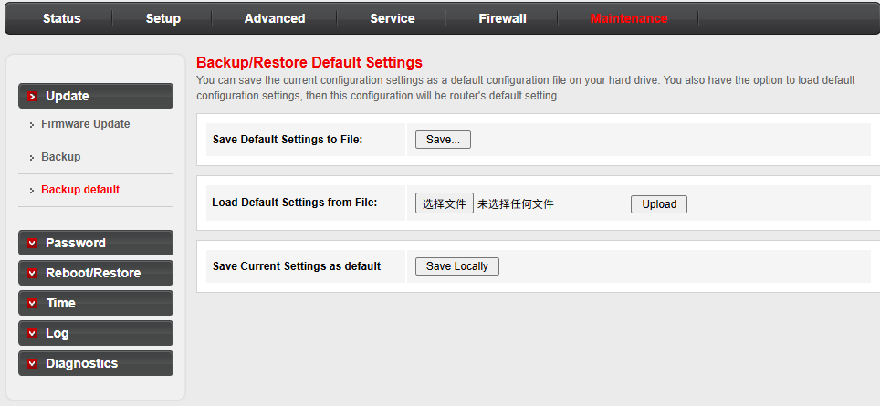
Figure 3-41: Backup/Restore Default Settings

3.7.2 Password
This page is used to add user account to access the web server of Router. Empty user name or password is not allowed.
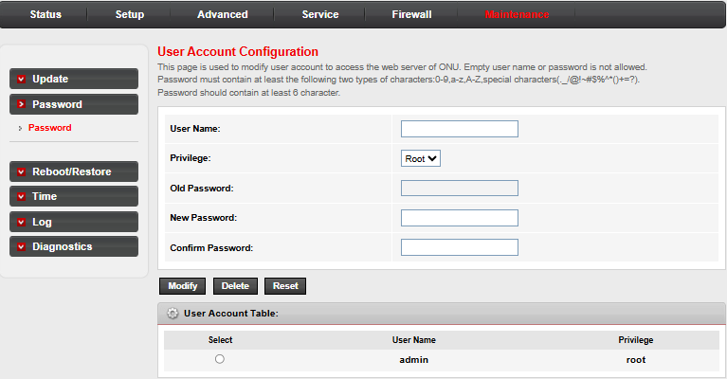
Figure 3-42: User Account Configuration

3.7.3 Reboot/Restore

3.7.3.1 Reboot/Restore
This page is used to reboot your system or restore to default setting.
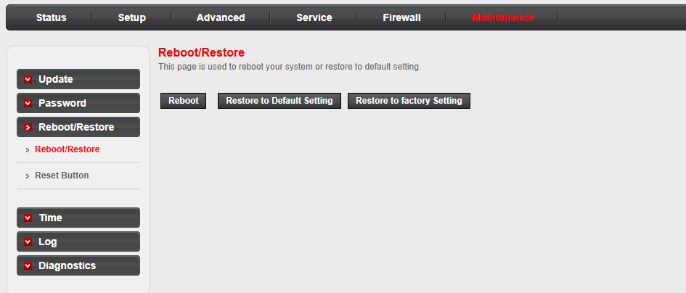
Figure 3-43: Reboot

3.7.3.2 Reset Button Configuration
This page is used to configure reset button state.
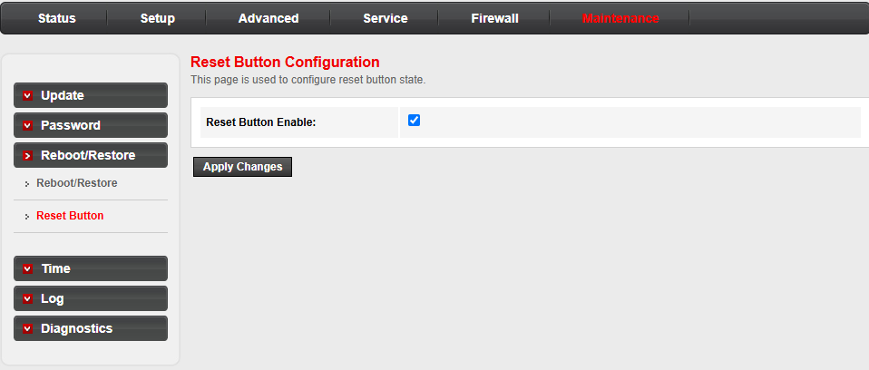
Figure 3-44: Reset Button Configuration

3.7.4 Time
This page is used to configure the system time and Network Time Protocol(NTP) server. Here you can change the settings or view some information on the system time and NTP parameters.
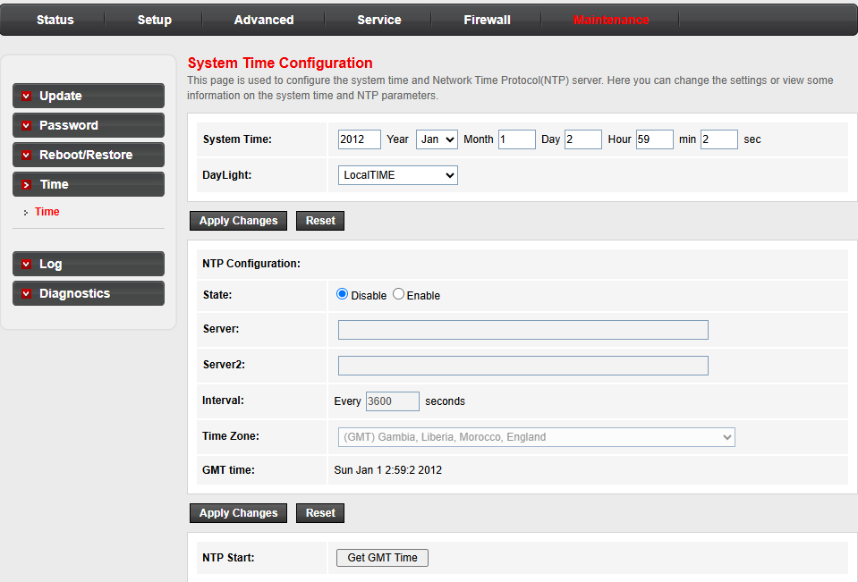
Figure 3-45: System Time Configuration

3.7.5 Log
This page is used to display the system event log table. By checking Error or Notice ( or both)will set the log flag. By clicking the ">>|", it will display the newest log information below.
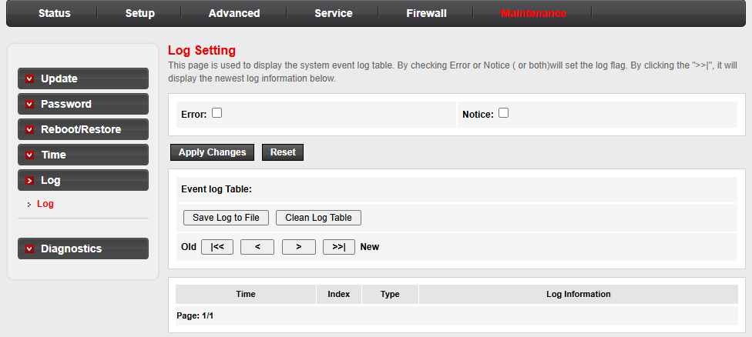
Figure 3-46: Log Setting

3.7.6 Diagnostics

3.7.6.1 Ping Diagnostic
This page is used to diagnose network connectivity.
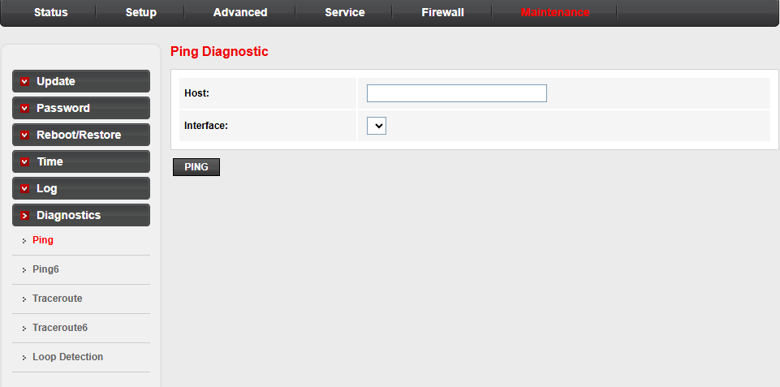
Figure 3-47: Ping Diagnostic

3.7.6.2 IPv6 Ping Diagnostic
This page is used to diagnose IPv6 network connectivity.
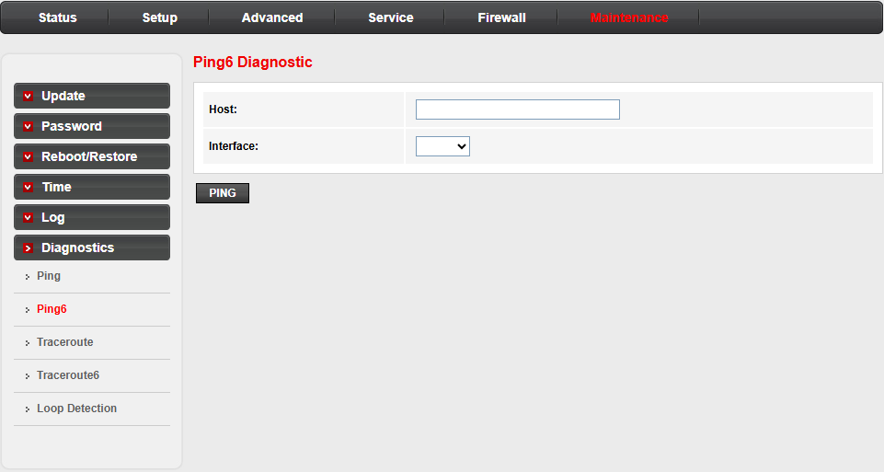
Figure 3-48: Ping6 Diagnostic

3.7.6.3 TraceRoute Diagnostic
This page is used to track and diagnose routing and forwarding.
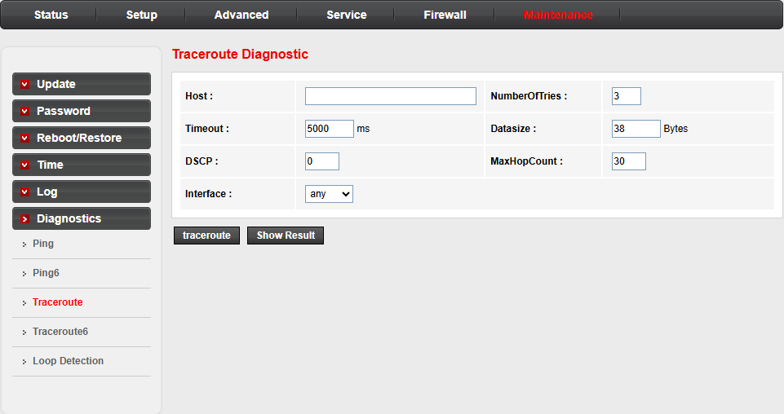
Figure 3-49: TraceRoute Diagnostic

3.7.6.4 IPv6 TraceRoute Diagnostic
This page is used to track and diagnose IPv6 routing and forwarding.
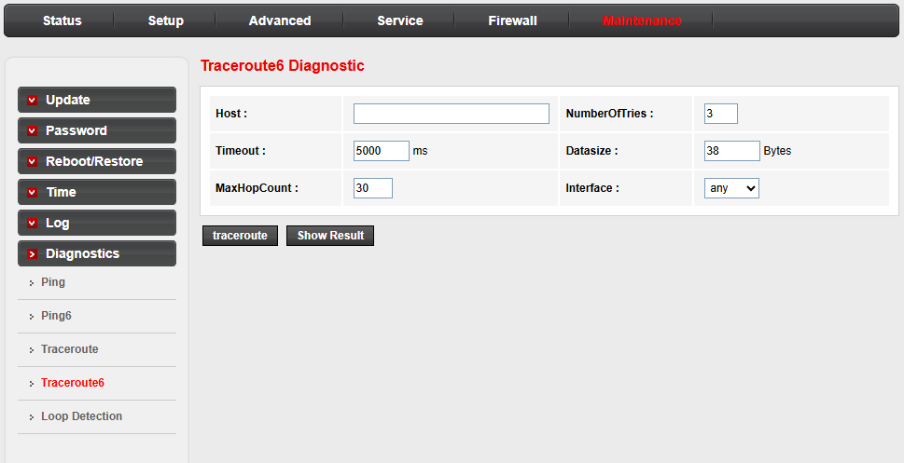
Figure 3-50: TraceRoute6 Diagnostic

3.7.6.5 Loop Detection
This page is used to configure loop detection parameters. Here you can change the settings or view loop detect status.
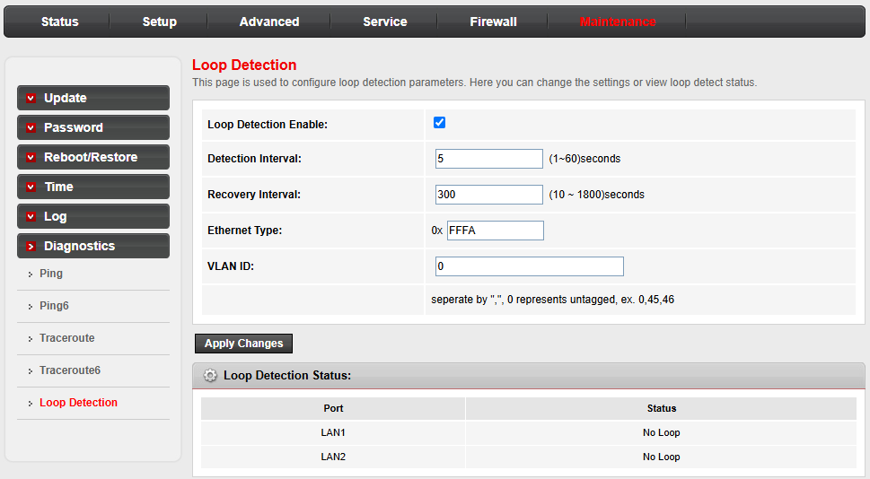
Figure 3-51: Loop Detection

