GPON OLT (2 PON) WEB
USER MANUAL

Version V1.0
Release Date 2024-8-27

CONTENTS
Chapter 1 System Description 1
1.1 Overview 1
1.1.1 OLT Introduction 1
1.1.2 OS Requirement 1
1.2 Connection 2
Chapter 2 OLT Information 3
2.1 Login 3
2.2 Device Information 3
Chapter 3 OLT Configuration 5
3.1 VLAN 5
3.1.1 Create VLAN 5
3.1.2 VLAN Port 6
3.1.3 QinQ/Translation 6
3.2 Uplink Port 7
3.2.1 Information 7
3.2.2 Configuration 7
3.3 PON 8
3.3.1 Information 8
3.3.2 Configuration 9
3.3.3 Range 9
3.3.4 Perf-Stats Information 10
3.3.5 Perf-Stats Configuration 10
3.4 MAC 11
3.4.1 MAC Table 11
3.4.2 Configuration 11
3.4.3 MAC Flapping Information 12
3.4.4 MAC Flapping Configuration 13
3.4.5 MAC Flapping Port Configuration 13
3.5 LACP 13
3.5.1 Static LACP 13
3.5.2 Dynamic LACP 14
3.6 QoS 15
3.7 ACL 15
3.7.1 IP Filter 15
3.7.2 MAC Filter 16
3.7.3 IP/MAC Filter 16
3.7.4 Ingress Effect Filter 17
3.7.5 Egress Effect Filter 17
3.8 IPv6 ACL 18
3.8.1 IPv6 Filter 18
3.8.2 IPv6/MAC Filter 19
3.8.3 IPv6 Ingress Effect Filter 19
3.8.4 IPv6 Egress Effect Filter 20
3.9 IGMP 20
3.9.1 Group Member 20
3.9.2 Global 21
3.9.3 Port 21
3.9.4 Port User VLAN 22
3.9.5 Port Mrouter 22
3.9.6 Static Group 23
3.10 IPv6 MLD 23
3.10.1 Group Member 23
3.10.2 Global 24
3.10.3 Port 24
3.10.4 Port User VLAN 25
3.10.5 Port Mrouter 25
3.10.6 Static Group 26
3.11 STP 26
3.11.1 Information 27
3.11.2 Global 27
3.11.3 Port 28
3.12 Loopback 28
3.12.1 Information 29
3.12.2 Global 29
3.12.3 Port 30
3.13 DHCP 30
3.13.1 DHCP Server 30
3.13.2 DHCP Relay 32
3.13.3 DHCP Snooping 34
3.14 DHCPv6 39
3.14.1 DHCPv6 Server 39
3.14.2 DHCPv6 Relay 41
3.15 IPv6 SLAAC 42
3.15.1 IPv6 SLAAC 42
3.15.2 IPv6 SLAAC Prefix 43
3.15.3 RDNSS 43
3.16 Route 44
3.16.1 IP 44
3.16.2 Static Route 46
3.16.3 RIP 47
3.16.4 OSPF 51
3.16.5 Key Chain 55
3.16.6 Route Table 56
3.17 IPv6 Route 57
3.17.1 IPv6 57
3.17.2 IPv6 Static Route 58
3.17.3 RIPng 58
3.17.4 OSPF6 62
3.17.5 IPv6 Route Table 65
3.18 PPPoE Intermediate Agent 66
3.18.1 PPPoE Intermediate Agent 66
3.18.2 PPPoE Intermediate Agent Interface 67
3.19 Traffic Policy 67
3.19.1 Policy 67
3.19.2 Classifier 68
3.19.3 Behavior 69
Chapter 4 ONU Configuration 71
4.1 ONU AuthList 71
4.1.1 ONU List 71
4.1.2 ONU Status 81
4.1.3 ONU Optical Info 81
4.1.4 ONU Version Information 81
4.1.5 ONU Manual Add 82
4.1.6 ONU Allowist 82
4.1.7 ONU Statistics 83
4.2 ONU AutoFind 83
4.2.1 Automatic Discovery 83
4.2.2 Aging Time 84
4.3 ONU AutoLearn 84
4.3.1 ONU AutoLearn 84
4.3.2 ONU AutoBind 85
4.3.3 ONU AutoDelete 85
4.3.4 ONU Scheduled Reboot 86
4.4 ONU Upgrade 86
4.4.1 UpLoad Image 86
4.4.2 Manual Upgrade 87
4.4.3 Upgrade Status 87
4.4.4 Auto Upgrade 88
4.4.5 Auto Upgrade Status 88
4.5 Rogue ONU 89
4.6 ONU Common Service 89
Chapter 5 Profile Configuration 93
5.1 ONU Profile 93
5.1.1 Information 93
5.1.2 Add profile 93
5.2 DBA Profile 95
5.2.1 DBA profiles 95
5.2.2 Add profile 96
5.3 Traffic Profile 97
5.3.1 Traffic profiles 97
5.3.2 Add profile 98
5.4 Line Profile 98
5.4.1 Line profile 98
5.4.2 Add profile 99
5.5 Service Profile 103
5.5.1 Service profile 103
5.5.2 Add profile 103
5.6 Alarm Profile 106
5.6.1 Profile Infomation 106
5.6.2 Add Profile 107
5.7 Pri Profile 107
5.7.1 Pri Profile 108
5.7.2 Add Profile 108
5.8 IGMP Profile 109
5.8.1 IGMP Profile 109
5.8.2 Add Profile 110
5.9 Format Profile 111
5.9.1 Format Profile 112
5.9.2 Add Profile 112
5.10 Bind Profile 114
Chapter 6 System Configuration 116
6.1 System Log 116
6.1.1 System Log 116
6.1.2 Alarm 116
6.1.3 Threshold Alarm 117
6.1.4 Syslog Server 118
6.1.5 Syslog Server IPv6 119
6.2 Device Management 120
6.2.1 Firmware Upgrade 120
6.2.2 Device Reboot 121
6.2.3 Config File 122
6.2.4 Advance Config File 122
6.3 User Management 123
6.3.1 User manage 123
6.3.2 Role manage 124
6.4 SNMP 124
6.4.1 SNMP V1/V2 124
6.4.2 SNMP V3 125
6.4.3 SMNP V3 Trap 126
6.4.4 Remote Server 127
6.5 AUX IP 128
6.5.1 AUX IP 128
6.5.2 AUX IPv6 128
6. 6 DNS 129
6.6.1 IPv4 DNS 129
6.6.2 IPv6 DNS 130
6.7 System Time 131
6.7.1 RTC 131
6.7.2 NTP 132
6.8 FAN 133
6.9 Mirror 134
6.10 Login Management 135
6.10.1 Login Access List 135
6.10.2 Service Port 136
6.10.3 Login Timeout 137
6.10.4 Telnet Management 138
6.11 SSH 139
6.11.1 SSH State 139
6.11.2 SSH Enable 140
6.12 Tacacs+ 141
6.13 Radius 142
6.14 Dot1x 143
6.14.1 Dot1x Information 143
6.14.2 Dot1x Global Enable 144
6.14.3 Port Configuration 145
6.15 Network Diagnose 146
6.15.1 Ping Diagnose 146
6.15.2 Tracert Diagnose 146
6.15.3 Netstat Diagnose 147
6.15.4 Tcpdump Diagnose 148
6.15.5 Iperf Diagnose 148

Chapter 1 System Description

1.1 Overview

1.1.1 OLT Introduction
The WEB management user manual is for the OLTs listed in Table 1-1.
After you have completed installation, connection and commissioning of the equipment, you can start on configuring various services and functions for the equipment.
Table 1-1 GPON (2 PON) OLT interfaces
Product |  | 2 ports GPON OLT
Chassis | Racks | 1U 19 inch standard box
1G/10G  Uplink Port | QTY | 4
1G/10G  Uplink Port | Speed | 2*1G/10G  2*1G auto-negotiation
1G/10G  Uplink Port | Type(Independent) | 2*RJ45 and 2*SFP+ (SFP+ is compatible with 1GE/10GE)
PON Port | QTY | 2
PON Port | Physical Interface | 2*GPON
Management Ports |  | 1*10/100/1000BASE-T out-band port(AUX), 1*CONSOLE port，1*USB2.0, 1*Type-C USB console.
Management Mode |  | SNMP, WEB, and CLI(Console/Telnet/SSH)

1.1.2 OS Requirement
For OLT management, it supports or requires the following operation system.
Table 1-2 Operation System requirement
CPU | Memory | DISK | Video Card | Operating System
Frequency above 2GHz | 2GB  Or above | 10GB  disk space | 65000 color  resolving  capability  1024*768  and above | Windows2008  Windows XP  Windows 7  Windows 8  Windows 10  Windows 11

1.2 Connection
Connect the OLT AUX port to IP network. The OLT default management IP is 192.168.8.200.
Please set your PC IP to 192.168.8.X (e.g.192.168.8.123).

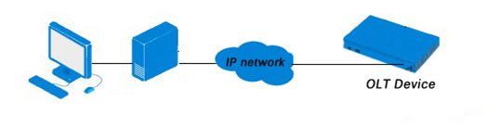
AUX

Chapter 2 OLT Information

2.1 Login
Follow the steps to login:
1. Conform “1.2 Connection” to connect;
2. The device default IP address is 192.168.8.200;
3. Open your web browser, type the device IP in address bar;
4. Entry of the username and password will be prompted. Enter the default login User Name and Password. The default username and password is "admin/Xpon@Olt9417#".
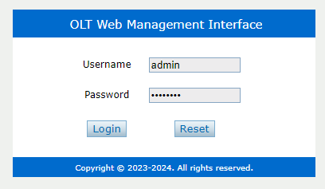
Figure 2.1-1: Login

2.2 Device Information
The OLT ports connection status are shown in the top of the interface, and about the OLT basic information.
OLT InformationDevice Information
This part shows the OLT information such as system name, serial number, hardware version, firmware version, MAC address and system time. The system name can be modified if need.
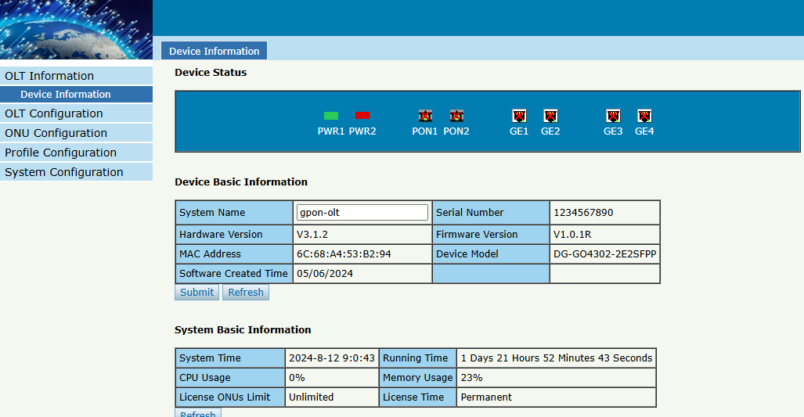
Figure 2.2-1: Device Information

Chapter 3 OLT Configuration
This section is about the basic service of OLT configuration.

3.1 VLAN
OLT equipment switch engine is fully compliant with the IEEE802.1Q VLAN standard and has the following main features:
- Support Port-based VLAN and IEEE802.1Q VLAN.
- Support full 4K VLAN group, VID range 1~4094.
All switch ports, including uplink ports and downlink ports, support VLAN partition.
VLAN 1 is the system reserved VLAN, it includes all switch ports which are UNTAG mode.

3.1.1 Create VLAN
OLT ConfigurationVLAN
In this user interface, you can create new VLAN.
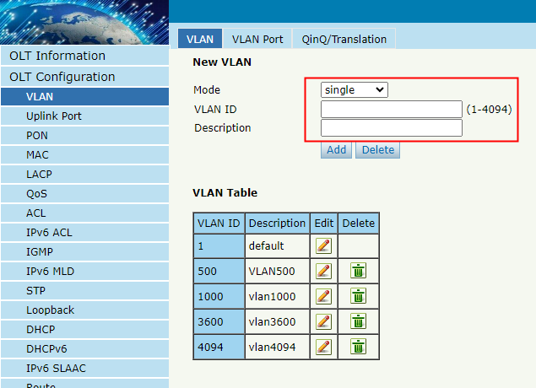
Figure 3.1-1: Create New VLAN

3.1.2 VLAN Port
OLT ConfigurationVLANVALN Port
Assign the ports to the VLANs that have been created. You can choose the tag or untag VLAN mode.
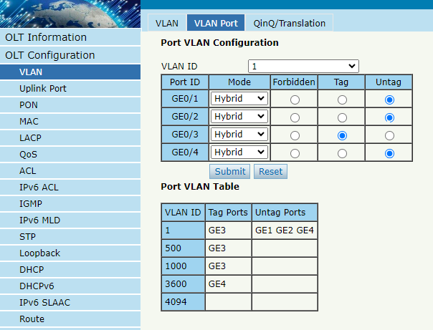
Figure 3.1-2: Add VLAN Port

3.1.3 QinQ/Translation
OLT ConfigurationVLANQinQ/Translation
In this user interface, VLAN QinQ and VLAN translation can be configured. VLAN QinQ and translation are effective for ingress.

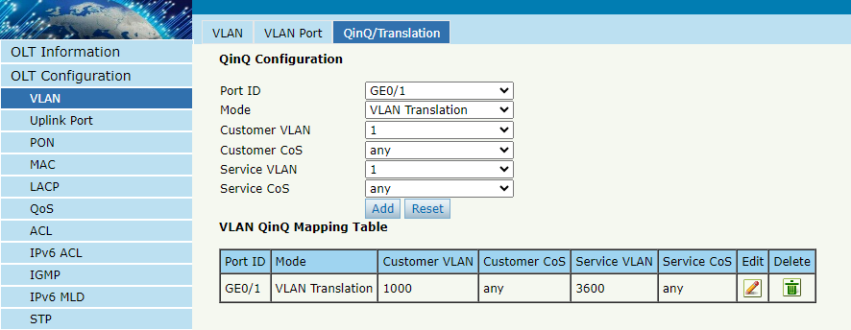
Figure 3.1-3: QinQ/Translation Configuration

3.2 Uplink Port
Uplink ports traffic statistics and basic configuration setting.

3.2.1 Information
OLT ConfigurationUplink PortInformation
This user interface displays traffic statistics of uplink ports.
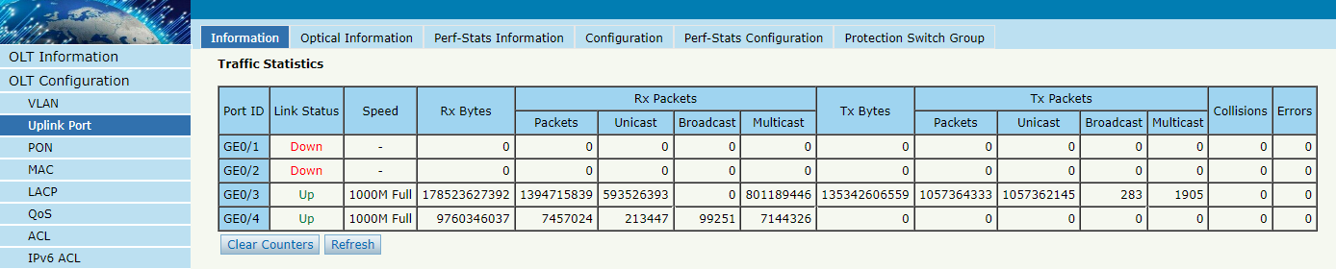
Figure3.2-1: Uplink Ports Traffic Statistics

3.2.2 Configuration
OLT ConfigurationUplink PortConfiguration
This user interface is used to configure port related functions and characteristic parameters of uplink port, such as port attributes, PVID, speed, rate limit, storm inhibition, port isolation and so on.

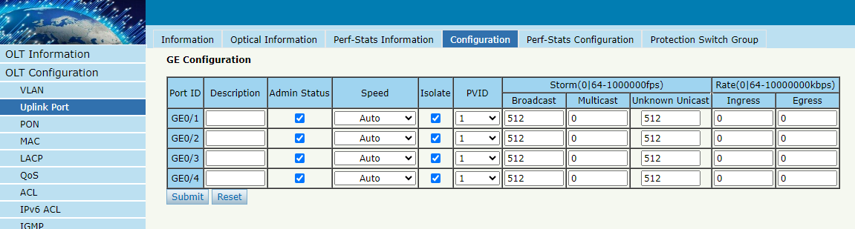
Figure3.2-2: Uplink Ports Configuration

Illustrations of each parameter:
Parameters | Illustration
Port ID | GE port has two types, fiber SFP (GE1 to GE2) and copper (GE3 to GE4).
Description | Descriptions or remarks of port.
Admin Status | Active or inactive status of port. It is Enabled by default.
Speed | Configuring Port Rate.
Isolate | Port isolation with each other.
PVID | Default VLAN ID of the port.
Broadcast | Broadcast storm inhibition.
Multicast | Multicast storm inhibition.
Unknown Unicast | Unknown unicast storm inhibition.
Ingress Rate | Port ingress rate.
Egress Rate | Port egress rate.

3.3 PON

3.3.1 Information
OLT ConfigurationPONInformation
This user interface is used to displays parameters of PON port, such as PON module port current Temperature, Voltage, Transmit power,Vendor Name,Vendor Revision,Vendor Serial Number.

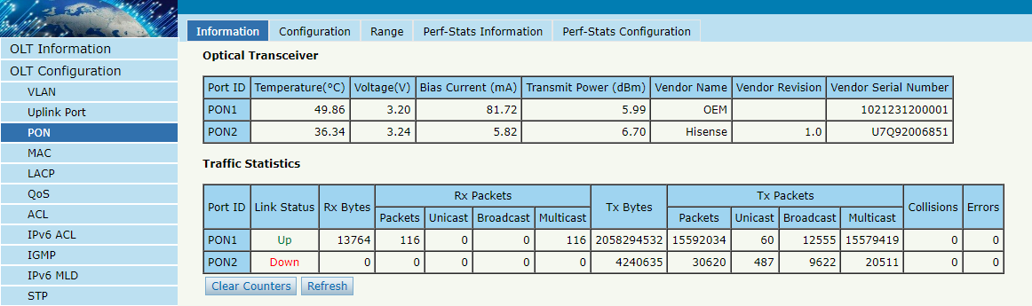
Figure3.3-1: PON Information

3.3.2 Configuration
OLT ConfigurationPONConfiguration
This user interface is used to configure rate limit, storm inhibition, port isolation and so on like uplink port.
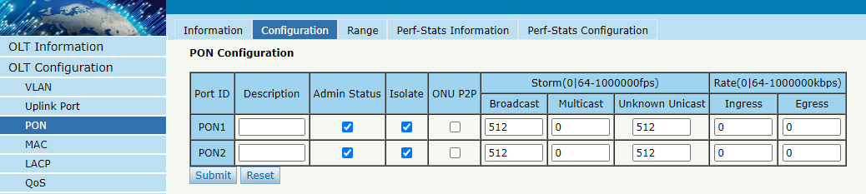
Figure3.3-2: PON configuration

3.3.3 Range
OLT ConfigurationPONRange
When ONU is more than 20km away from OLT, you need to configure PON distance range. The difference between minimum and maximum should not be more than 20km. The unit is 100m.
For example, ONU is 25km away from OLT, the minimum is 50 and the maximum is 250.
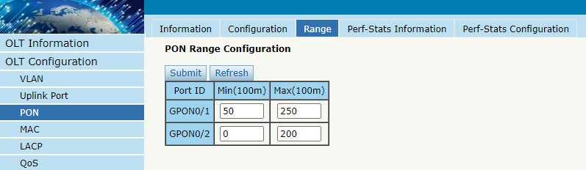
Figure3.3-3: PON Range Configuration

3.3.4 Perf-Stats Information
OLT ConfigurationPONPerf-Stats Information
This user interface is used to View the traffic statistics of the PON port within a period of time.
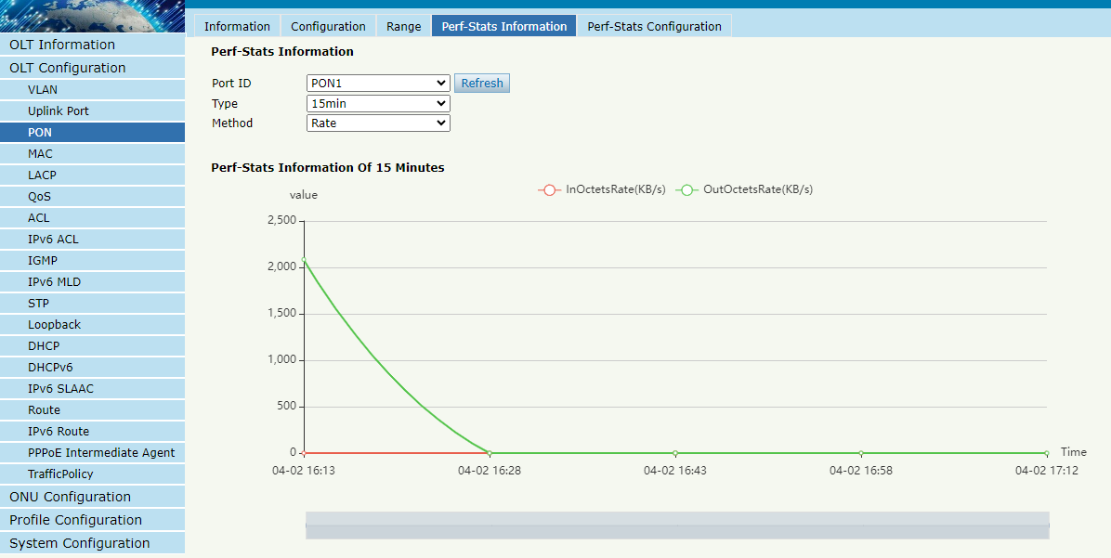
Figure3.3-4: PON Perf-Stats Information

3.3.5 Perf-Stats Configuration
This user interface is used to Set the sampling time and sampling times for traffic statistics.
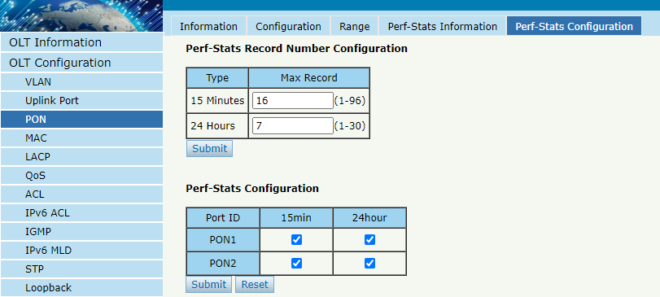
Figure3.3-5: PON Perf-Stats Configuration

3.4 MAC
In this section, you can check MAC address table of OLT, set MAC aging time and add MAC address manually.

3.4.1 MAC Table
OLT ConfigurationMACMAC Table
This table displays MAC addresses that OLT has learnt at PON ports and GE ports.
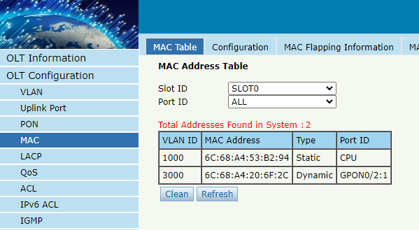
Figure3.4-1: MAC Address Table

3.4.2 Configuration
OLT ConfigurationMACConfiguration
The default MAC aging time of OLT is 300s, user can change the value between 10~1000000s. Also, user can add MAC address to the OLT manually.
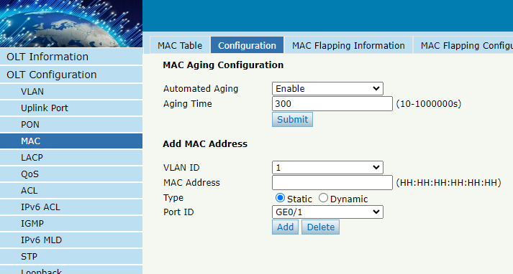
Figure 3.4-2: MAC Configuration

3.4.3 MAC Flapping Information
This interface displays information learned on multiple ports for the same MAC if you enable MAC Flapping switch.
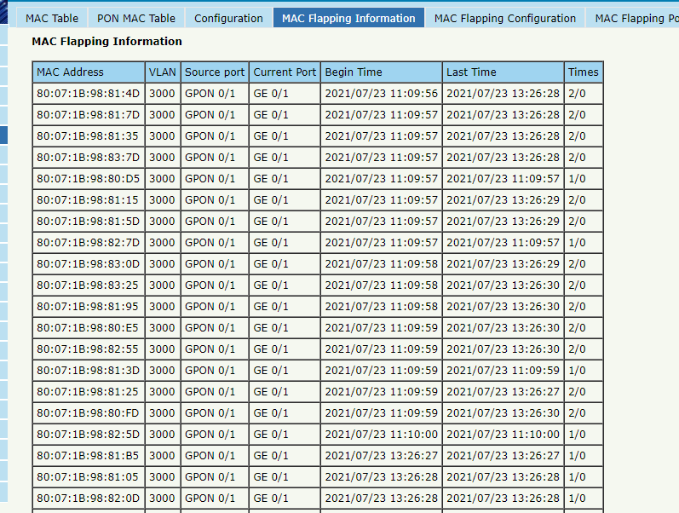
Figure 3.4-3: MAC Flapping Information

3.4.4 MAC Flapping Configuration
You can enable MAC Flapping Configuration in this interface.
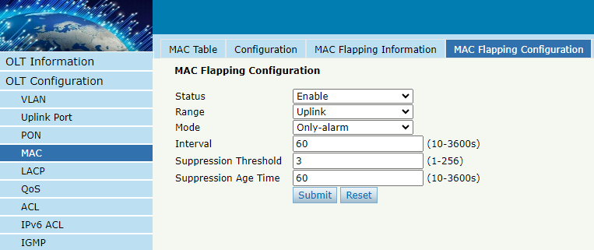
Figure 3.4-4: MAC Flapping Configuration

3.4.5 MAC Flapping Port Configuration
This user interface is used to enable MAC Flapping Configuration for specific port.
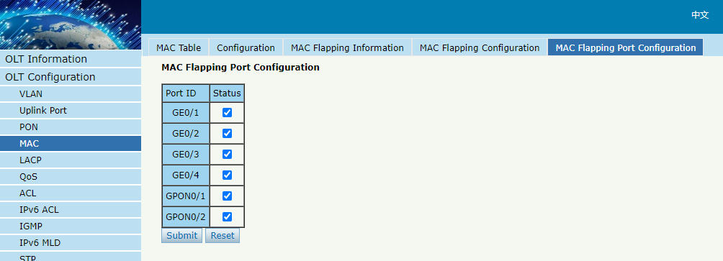
Figure 3.4-5: MAC Flapping Port Configuration

3.5 LACP

3.5.1 Static LACP
OLT ConfigurationLACPStatic LACP
To assign and configure an uplink physical interface to a channel group, select load balance for LACP function. When a traffic link can't be used suddenly, the traffic link will switch to another link automatically. The group range is from 1 to 4. Each group can add 4 ports maximally. Only GE ports can be added in the channel groups.
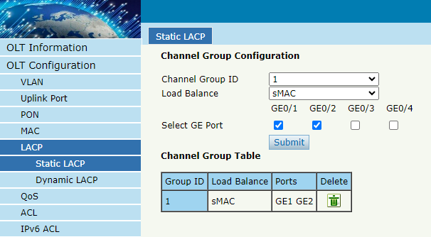
Figure 3.5-1: Create Static LACP

3.5.2 Dynamic LACP
OLT ConfigurationLACPDynamic LACP
This page displays dynamic LACP information. Only the port which is linkup can be shown in the table. OLT can detect how many devices the uplink ports connected to. If the ports are connected to the same device, they will be in a channel group, otherwise in different channel group.
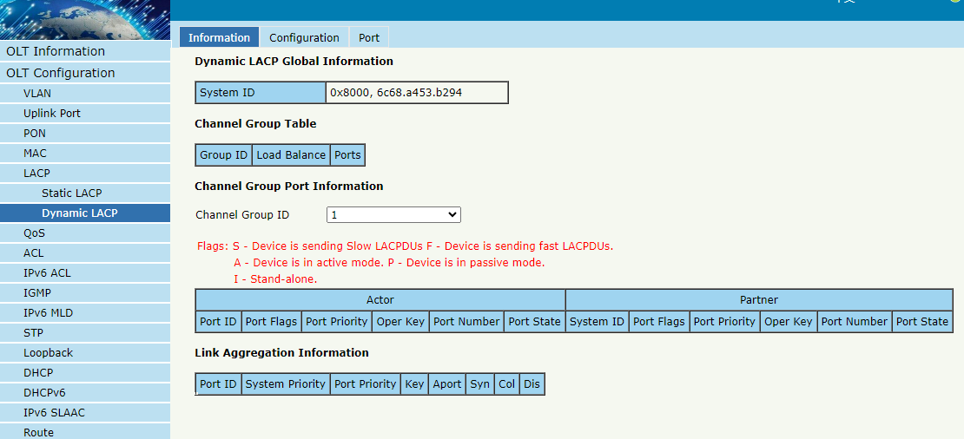
Figure 3.5-2: Dynamic LACP Information

3.6 QoS
OLT ConfigurationQoS
When bandwidth is not enough or there is congestion in the network, queue scheduling can make sure high priority data traffic passes through the device firstly. Traffic will map to queues according to their priorities and transmit in the queues.
OLT supports eight queues altogether. Queue scheduling mode includes strict priority (SP), weighted round robin (WRR) and hybrid mode (SP-WRR).
Strict priority scheduling guarantees high priority traffic occupy as much as bandwidth. The lower priority traffics pass though only when there is remaining bandwidth.
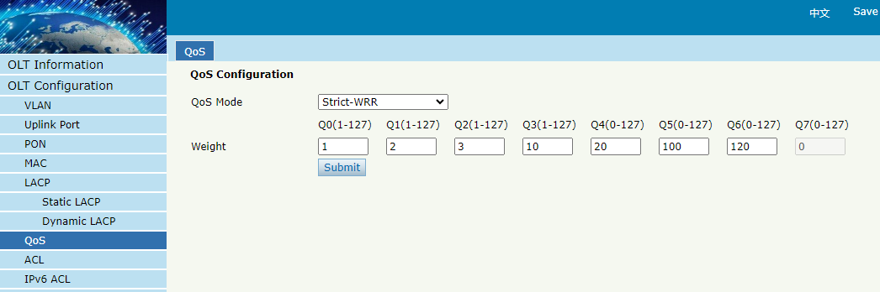
Figure 3.6-1: QoS Configuration

3.7 ACL
In order to filter data packages, network equipment need to setup a series of rules for identifying what need to be filtered. Only matched with the rules the data packages can be filtered. ACL can achieve this function. Matched conditions of ACL rules can be source address, destination address, Ethernet type, VLAN, protocol port, and so on. These ACL rules also can be used in other situations, such as classification of stream in QoS. An ACL rule may contain one or several sub-rules, which have different matched conditions.
This device supports the following types of ACL.

3.7.1 IP Filter
OLT ConfigurationACLIP Filter
The filter is basic on the IP address, including source IP address and destination IP address.
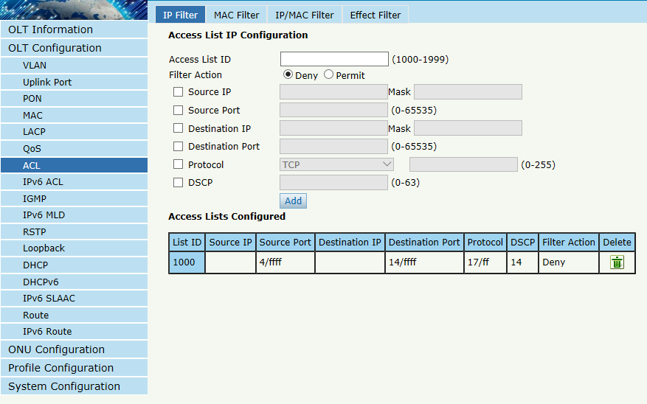
Figure 3.7-1: IP Filter

3.7.2 MAC Filter
OLT ConfigurationACLMAC Filter
The filter is basic on the MAC address, including source MAC address and destination MAC address.
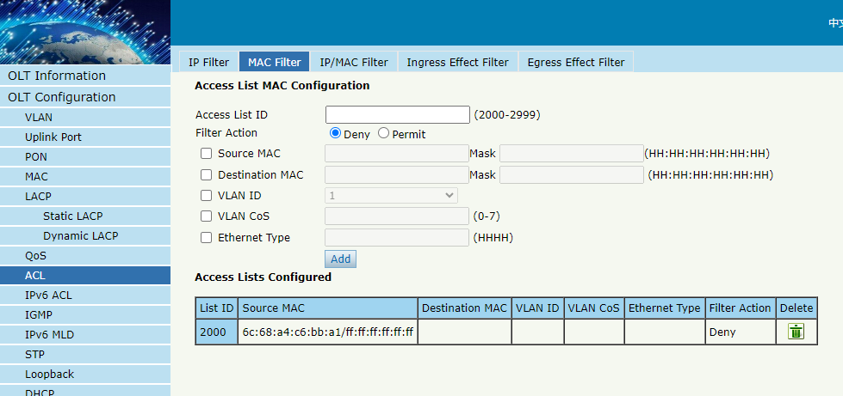
Figure 3.7-2: MAC Filter

3.7.3 IP/MAC Filter
OLT ConfigurationACLIP/MAC Filter
This filter mix the IP address and MAC address, include source MAC address and destination MAC address, source IP address and destination IP address.
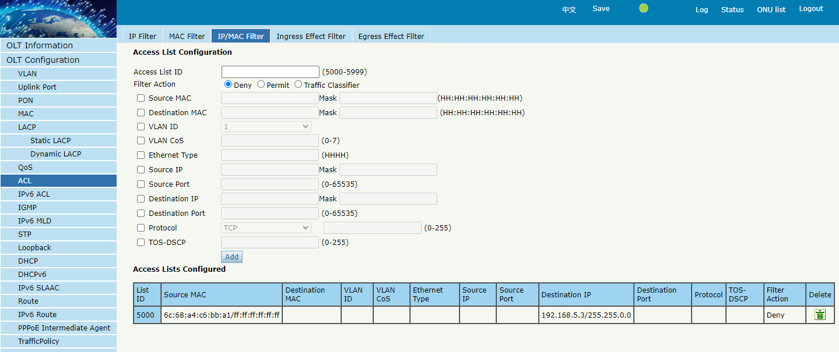
Figure 3.7-3: IP/MAC Filter

3.7.4 Ingress Effect Filter
OLT ConfigurationACLEffect Filter
Bind the access list to the ports then it can take effect. Each access list can be bound several ports.The inbound direction of port traffic is bound here.
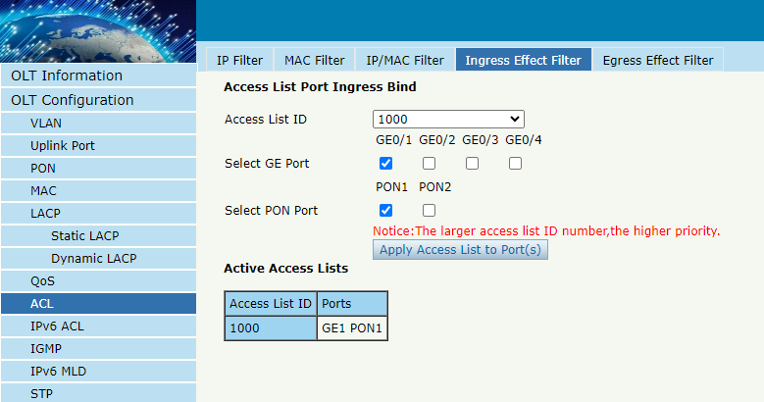
Figure 3.7-4: Bind Security Filter(Ingress)

3.7.5 Egress Effect Filter
OLT ConfigurationACLEffect Filter
Bind the access list to the ports then it can take effect. Each access list can be bound several ports.The outbound direction of port traffic is bound here.
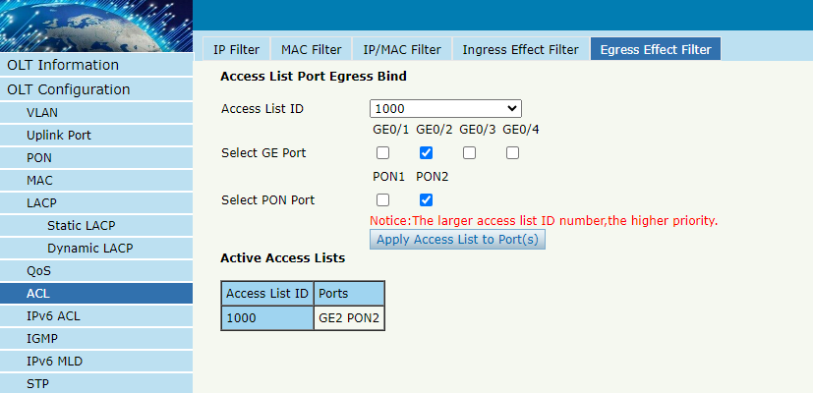
Figure 3.7-5: Bind Security Filter(Egress)

3.8 IPv6 ACL
This part is about IPv6 security configuration of OLT. IPv6 ACL can permit or deny data passing or accessing by IPv6 packets.

3.8.1 IPv6 Filter
OLT ConfigurationIPv6 ACL IPv6 Filter
The filter is based on the IPv6 address, including source IPv6 address and destination IPv6 address.
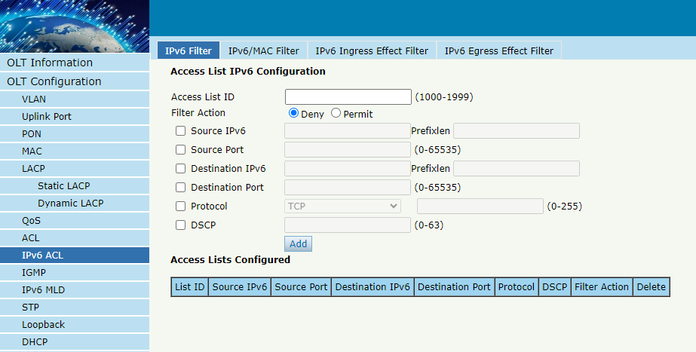
Figure 3.8-1: IPv6 Filter

3.8.2 IPv6/MAC Filter
OLT ConfigurationIPv6 ACLIPv6/MAC Filter
This filter mixes IPv6 address, MAC address and other parameters, including source IPv6 address and destination IPv6 address, source MAC address and destination MAC address, VLAN, Ethernet type, protocol, TCP/UDP port, and so on.
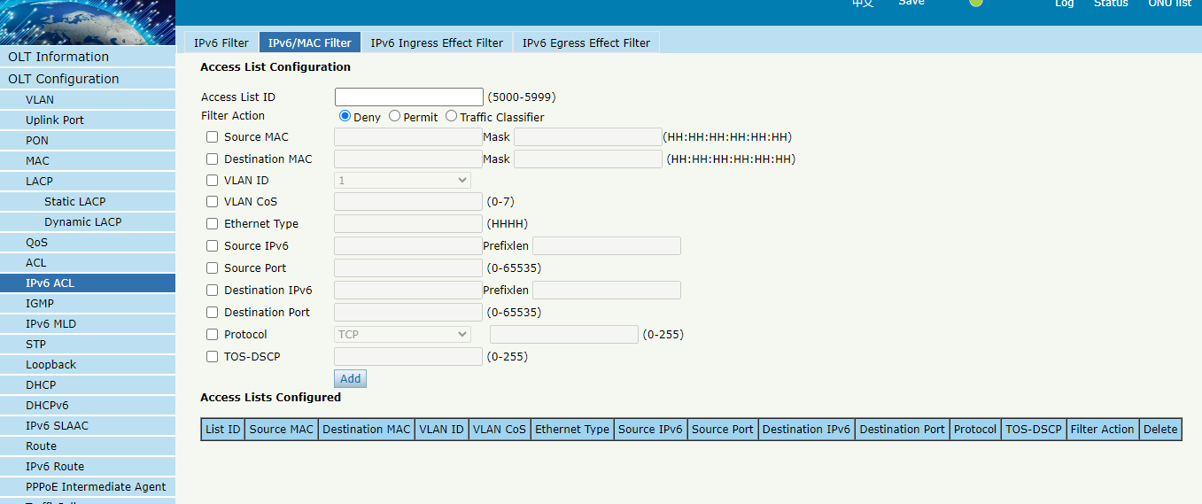
Figure 3.8-2: IPv6/MAC Filter

3.8.3 IPv6 Ingress Effect Filter
OLT Configuration IPv6 ACL IPv6 Ingress Effect Filter
Bind access list to ports so that the ACL rules can take effect. Each access list can be bound to several ports.The inbound direction of port traffic is bound here.
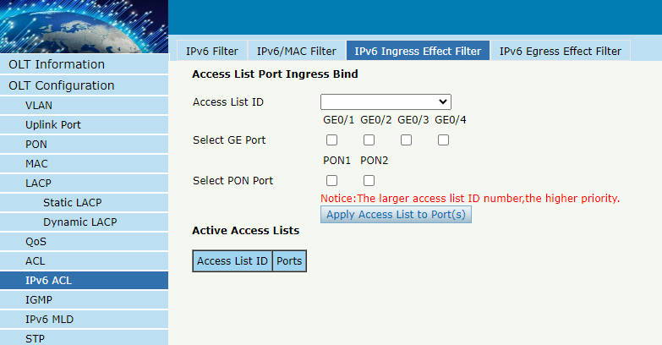
Figure 3.8-3: Bind IPv6 Security Filter(Ingress)

3.8.4 IPv6 Egress Effect Filter
OLT Configuration IPv6 ACL IPv6 Egress Effect Filter
Bind access list to ports so that the ACL rules can take effect. Each access list can be bound to several ports.The outbound direction of port traffic is bound here.
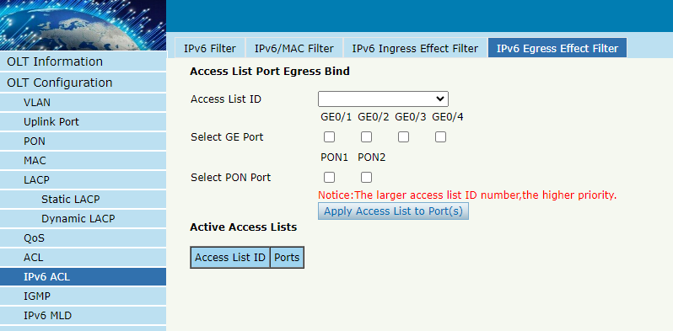
Figure 3.8-4: Bind IPv6 Security Filter(Egress)

3.9 IGMP

3.9.1 Group Member
OLT ConfigurationIGMPGroup Member
When there is a multicast group produced, the group will display in this table.
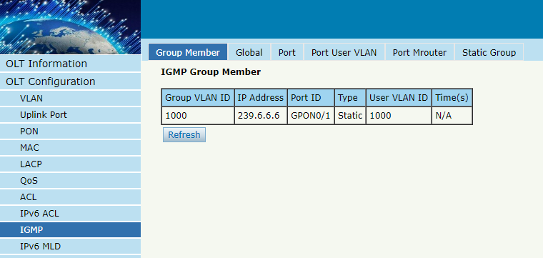
Figure 3.9-1: Group Member

3.9.2 Global
OLT Configuration IGMPGlobal
IGMP basic configuration mainly contains parameters of query packet. When IGMP status is enabled, OLT works at IGMP snooping mode. IGMP snooping is the process of listening to Internet Group Management Protocol (IGMP) network traffic. The feature allows a network switch to "listen in" on the IGMP conversation between hosts and routers. By listening to these conversations, the switch maintains a map of which devices need which IP multicast streams. Multicasts may be filtered from the ports which do not need them and thus controls which ports receive specific multicast traffic. When IGMP status is disabled, OLT works at transparent mode.
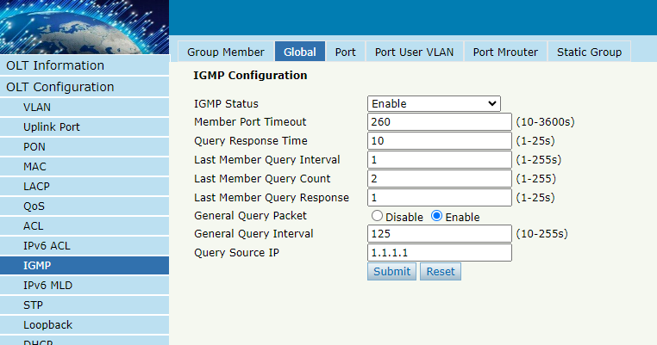
Figure 3.9-2: IGMP Global

3.9.3 Port
OLT Configuration IGMPPort
This configuration is used to set the maximum number of multicast groups, filter and fast leave mode.
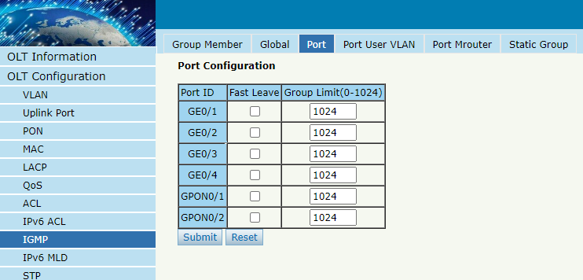
Figure 3.9-3: IGMP Port

3.9.4 Port User VLAN
OLT Configuration IGMPPort User VLAN
This configuration is used to configure IGMP VLAN for OLT. Generally, PON ports should be configured, and user VLAN and group VLAN are the same. If user VLAN and group VLAN are different, multicast VLAN will be translated.
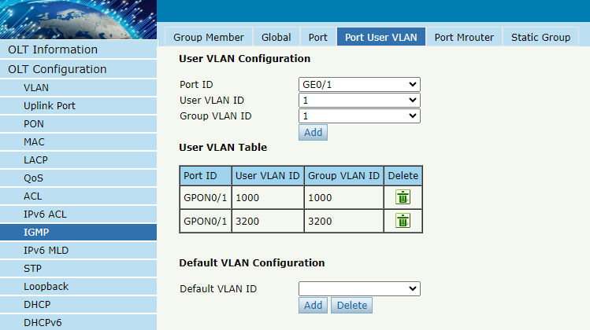
Figure 3.9-4: IGMP Port User VLAN

3.9.5 Port Mrouter
OLT Configuration IGMPPort Mrouter
Multicast router port is used to transmit IGMP signal messages. Generally, OLT uplink ports should be set as multicast router ports.
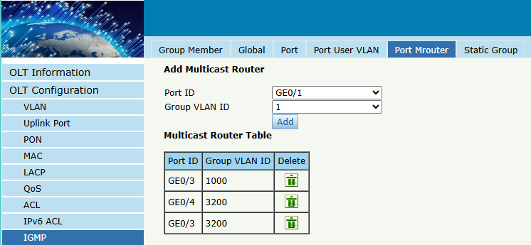
Figure 3.9-5: IGMP Port Mroute

3.9.6 Static Group
OLT Configuration IGMPStatic Group
This configuration is used to bind multicast IP address and VLAN ID.
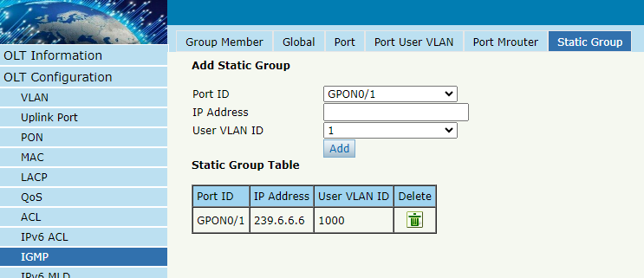
Figure 3.9-6: IGMP Static Group

3.10 IPv6 MLD

3.10.1 Group Member
OLT Configuration IPv6 MLD Group Member
This page displays IPv6 multicast group member ports.
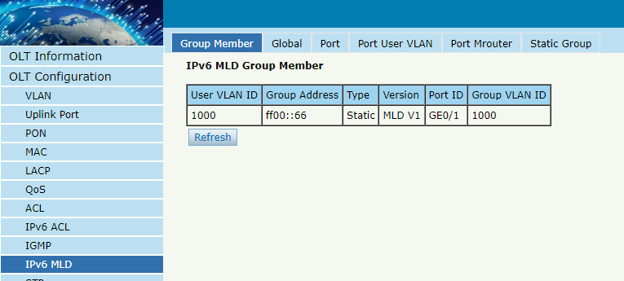
Figure 3.10-1: IPv6 MLD Group Member

3.10.2 Global
OLT Configuration IPv6 MLD Global
This page is used to enable IPv6 MLD and set IPv6 MLD related parameters.
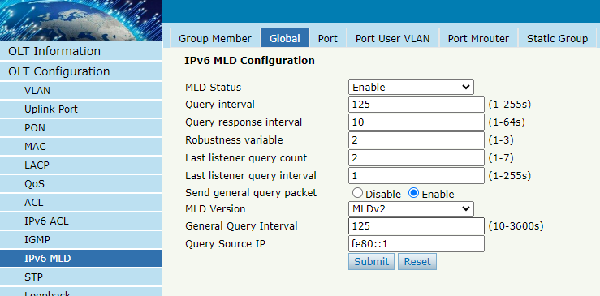
Figure 3.10-2: IPv6 MLD Global

3.10.3 Port
OLT Configuration IPv6 MLD Port
This page is used to configure group limit value, fast leave for each port.
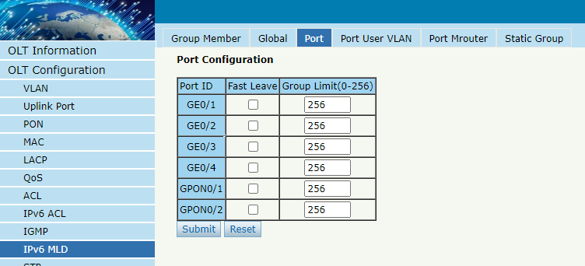
Figure 3.10-3: IPv6 MLD Port

3.10.4 Port User VLAN
OLT ConfigurationIPv6 MLDPort User VLAN
This page is used to configure MLD VLAN for OLT.
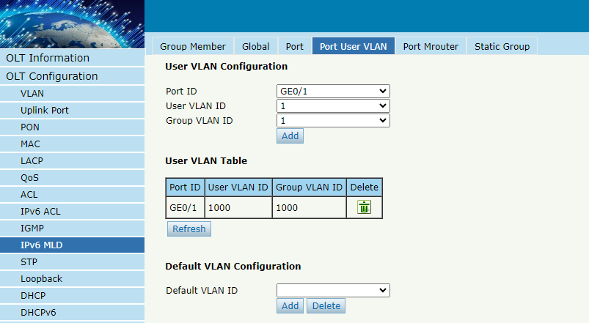
Figure 3.10-4: IPv6 Port User VLAN

3.10.5 Port Mrouter
OLT Configuration IPv6 MLD Port Mrouter
This page is used to set a port as IPv6 multicast router port.
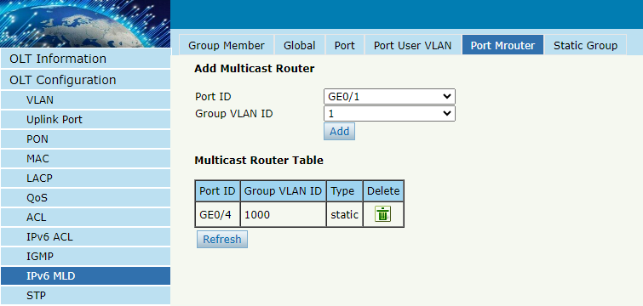
Figure 3.10-5: IPv6 MLD Port Mrouter

3.10.6 Static Group
OLT Configuration IPv6 MLD Static Group
This configuration is used to bind multicast IPv6 address and VLAN ID.
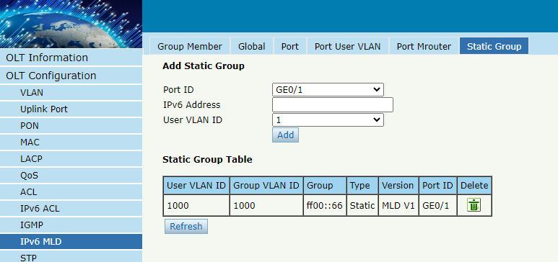
Figure 3.10-6: MLD Static Group

3.11 STP
Spanning Tree Protocol is layer2 protocol, which is used to eliminate network loop by blocking network redundant links selectively. It has the feature of link backup as well.

3.11.1 Information
OLT ConfigurationSTPInformation
Global information mainly displays STP parameters of root bridge device.
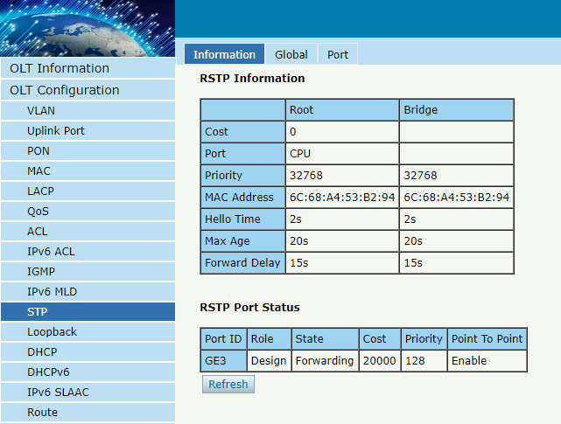
Figure 3.11-1: STP Information

3.11.2 Global
OLT ConfigurationSTPGlobal
This configuration is used to set STP parameters of the device, which contains STP switch, priority, hello time, max age, forward delay and MAC address.
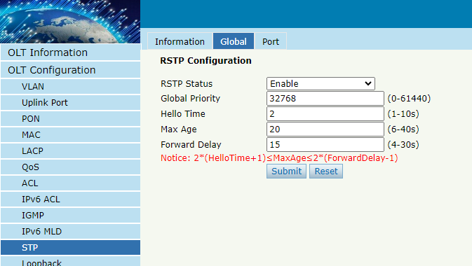
Figure 3.11-2: STP Global Setup

3.11.3 Port
OLT ConfigurationSTPPort
This user interface is used to set port STP parameters which contain STP switch, priority, cost, edge port and p2p port.
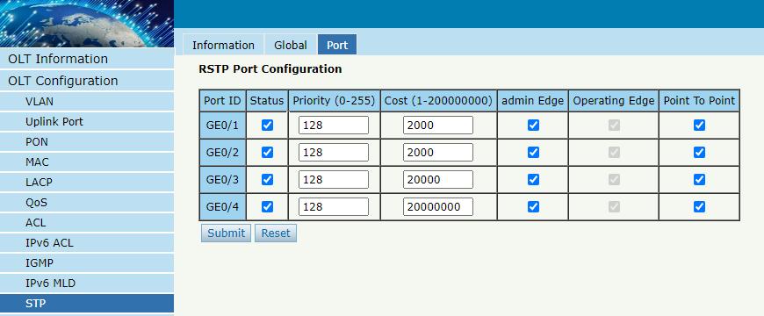
Figure 3.11-3: STP Port Settings

3.12 Loopback
Loopback can detect loop ports and process loop ports.

3.12.1 Information
OLT ConfigurationLoopbackInformation
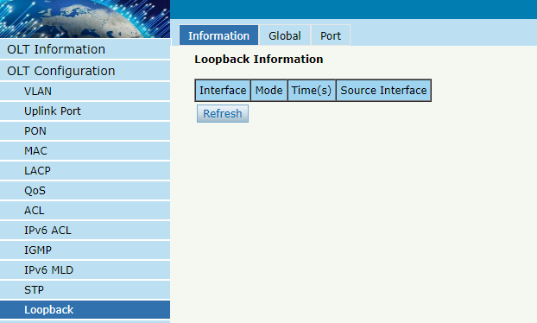Figure 3.12-1: Loopback Information

3.12.2 Global
OLT ConfigurationLoopbackGlobal
This page is used to enable or disable loopback detect and configure loopback mode, age time.
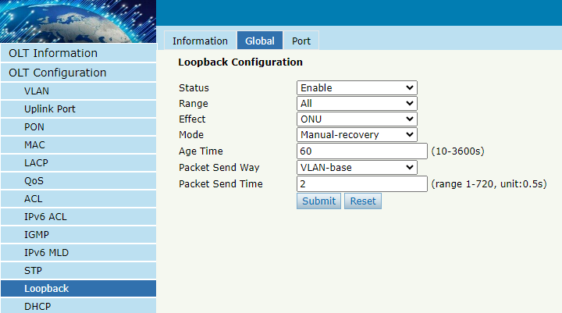Figure 3.12-2: Loopback Global

3.12.3 Port
OLT ConfigurationLoopbackPort
Loopback port configuration is used to specify the port range of loopback function. Loopback will take effect on the port when it is checked.
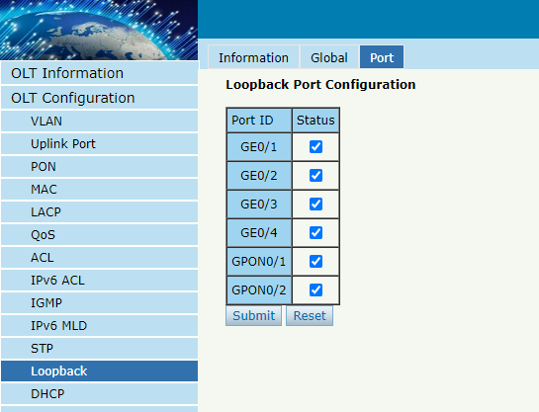
Figure 3.12-3: Loopback Port

3.13 DHCP
OLT can support the following DHCP functions.
- DHCP Server
- DHCP Relay
- DHCP Snooping

3.13.1 DHCP Server

3.13.1.1 DHCP Bind Information
OLT ConfigurationDHCPDHCP ServerDHCP Bind Information
This table displays the MAC addresses, host name and IP addresses, lease time assigned to them.
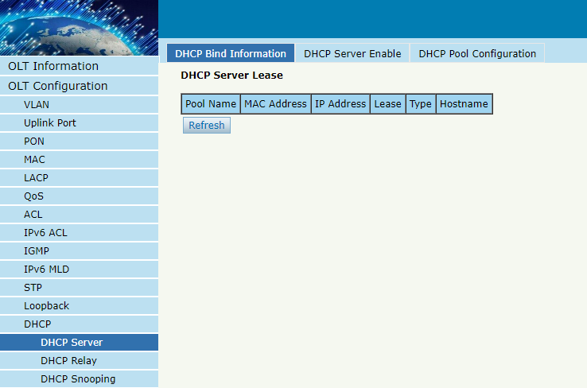
Figure 3.13-1: DHCP Bind Information

3.13.1.2 DHCP Server Enable
OLT ConfigurationDHCPDHCP ServerDHCP Server Enable
This parameter is used to configure different DHCP servers for different VLAN ID.
Before enabling DHCP server, you must configure IP address for the VLAN.
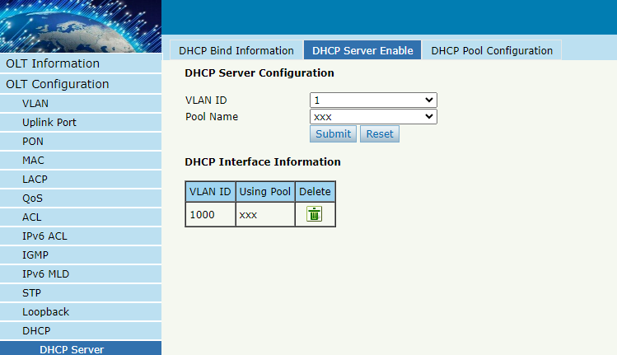
Figure 3.13-2: DHCP Server Enable

3.13.1.3 DHCP Pool Configuration
OLT ConfigurationDHCPDHCP ServerDHCP Pool Configuration
This page is used to configure basic information about the DHCP server, including Pool Name, Lease Time, and Gateway.
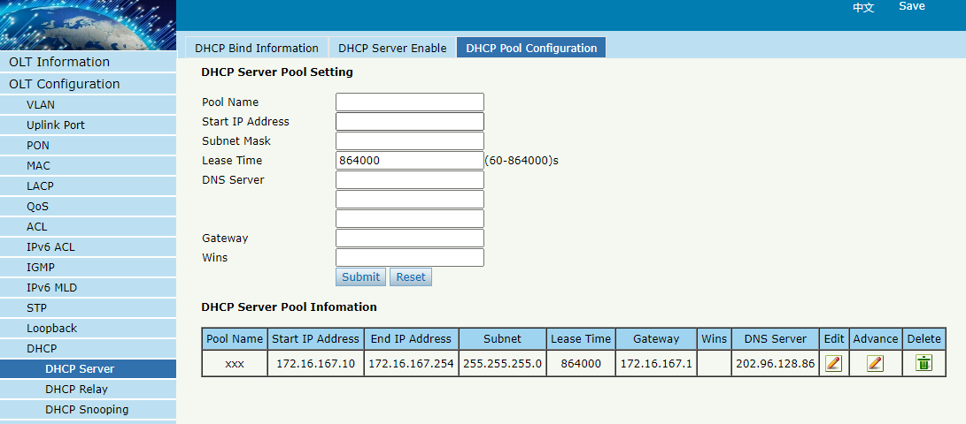
Figure 3.13-3: DHCP Pool Configuration

3.13.2 DHCP Relay

3.13.2.1 Configuration
OLT ConfigurationDHCPDHCP RelayConfiguration
Because the DHCP service exists in one broadcast domain, the server and the client are usually in the same network segment. DHCP relay can solve the issue that DHCP server and client do not exist in the same network segment.
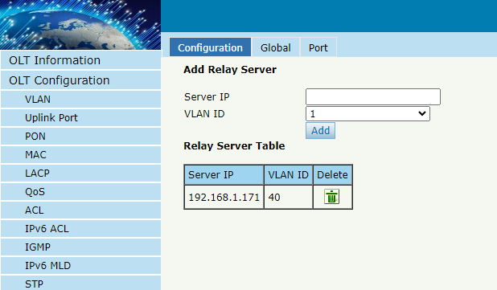
Figure 3.13-4: DHCP Relay Configuration

3.13.2.2 Global
OLT ConfigurationDHCPDHCP RelayGlobal

The global configuration of DHCP relay mainly includes option 82 settings, including switches and processing modes.
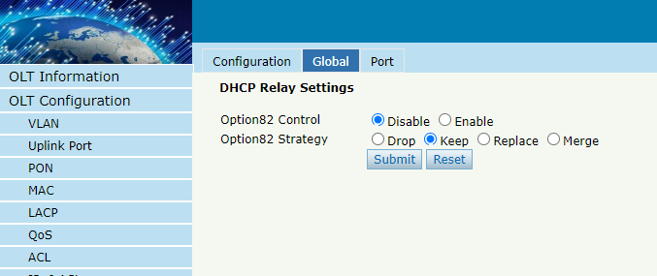
Figure 3.13-5: DHCP Relay Global

3.13.2.3 Port
OLT ConfigurationDHCPDHCP RelayPort
This user interface is used to configure the parameters "Option 82 Circuit ID" and "Option 82 Remote ID" for option 82.
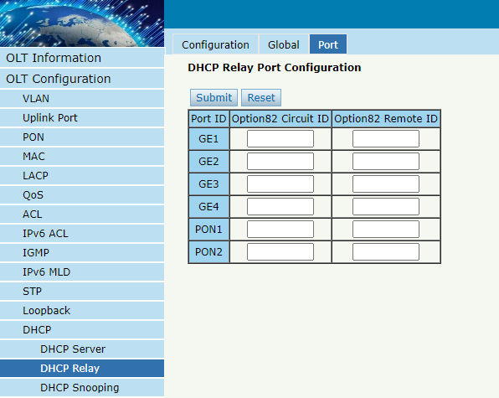
Figure 3.13-6: DHCP Relay Port

3.13.3 DHCP Snooping

3.13.3.1 Bind List
OLT ConfigurationDHCPDHCP SnoopingBind List
The static bind of the DHCP Snooping will be shown in the table.
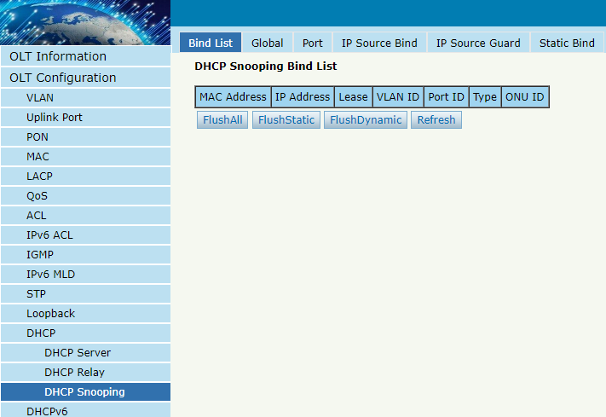
Figure 3.13-7: DHCP Snooping Bind List

3.13.3.2 Global
OLT ConfigurationDHCPDHCP SnoopingGlobal
DHCP Snooping is used to prevent the DHCP message attacking and guarantee network to get a correct IP address.
DHCP snooping global configuration mainly contains option 82 settings, DHCP traffic rate limit and snooping VLAN.
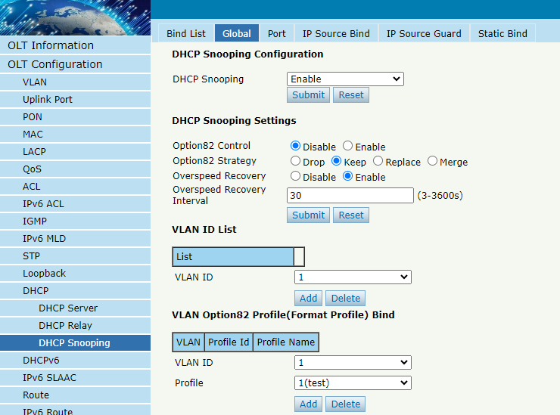
Figure 3.13-8: DHCP Snooping Global

3.13.3.3 Port
OLT ConfigurationDHCPDHCP SnoopingPort
This user interface is used to configure DHCP snooping parameters of ports which contain port type, option 82 parameters and rate limit.
All the ports are untrust ports by default. Option82 parameters, “Option 82 Circuit ID” and “Option 82 Remote ID”, are effective for untrust ports. “Limit Rate” is the ports’ max speed of receiving DHCP packets.
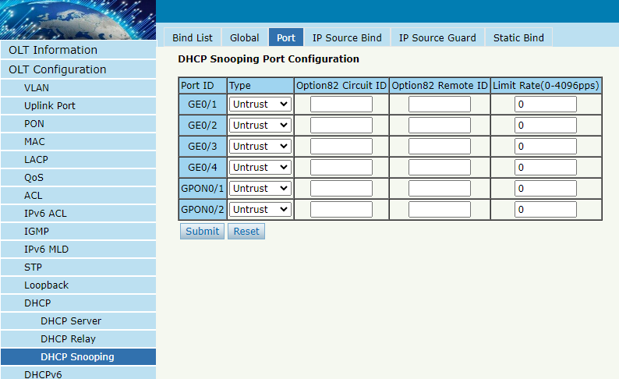
Figure 3.13-9: DHCP Snooping Port Setup

3.13.3.4 Static Bind
OLT ConfigurationDHCPDHCP SnoopingStatic Bind
DHCP snooping binding is useful when a host needs a fixed IP address assigned by DHCP server from the specific port.
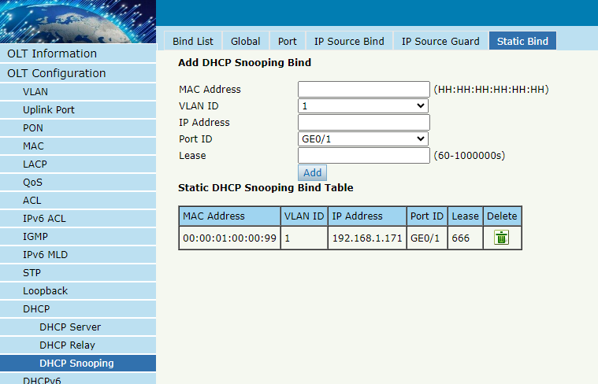
Figure 3.13-10: DHCP Snooping Static Bind

3.13.3.5 IP Source Guard
Only GPON OLT-B Series supports this feature.
OLT ConfigurationDHCPDHCP SnoopingIP Source Guard
This function is actually based on the DHCP Snooping Bind List to restrict access to the external network .That means that an issue outside the list cannot access the external network
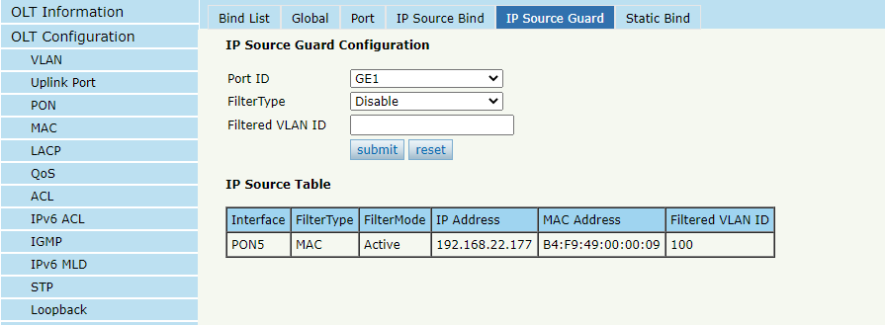
Figure 3.13-11: DHCP Snooping IP Source Guard

3.13.3.6 IP Source Bind
Only GPON OLT-B Series supports this feature.
OLT ConfigurationDHCPDHCP SnoopingIP Source Bind
If you configure a rule in IP Source Guard, a dynamic rule is displayed in IP Source Bind Table.You can add a static rule manually on this page.It works as described in the previous section.
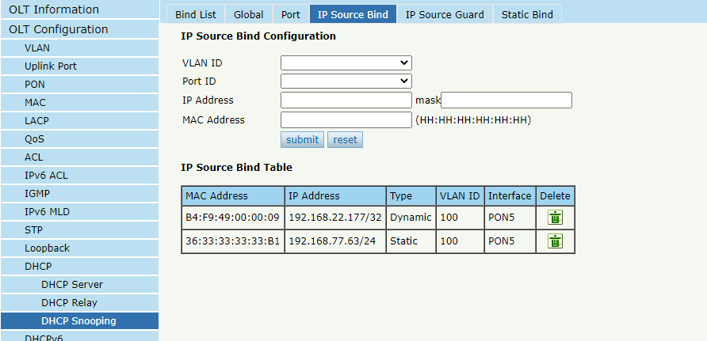
Figure 3.13-12: DHCP Snooping IP Source Bind

3.14 DHCPv6

3.14.1 DHCPv6 Server
DHCPv6 is a network protocol that used to configure IPv6 address, IPv6 prefix, DNS, domain and other network parameters for a host which operating on an IPv6 network.

3.14.1.1 DHCPv6 Bind Information
OLT Configuration DHCPv6 DHCPv6 Server DHCPv6 Bind Information
DHCPv6 bind information displays IPv6 addresses which have been assigned to hosts.
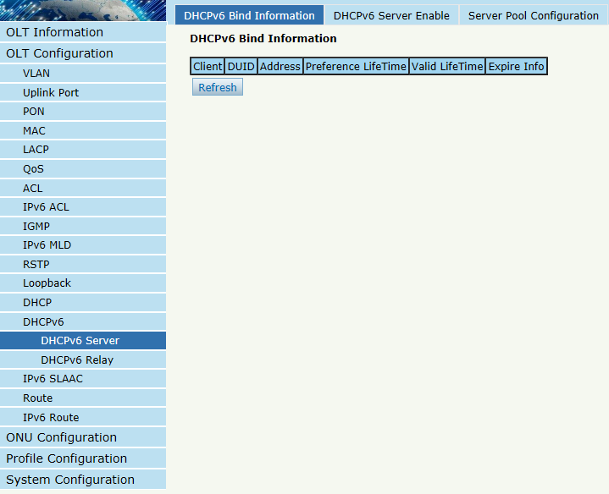
Figure 3.14-1: DHCPv6 Bind Information

3.14.1.2 DHCPv6 Server Enable
OLT Configuration DHCPv6 DHCPv6 Server DHCPv6 Server Enable
Select VLAN and fill in DHCPv6 pool name, enable DHCPv6 server, then the VLAN will be added into the table. Before enabled DHCPv6 server, VLAN IPv6 address and server pool are required.
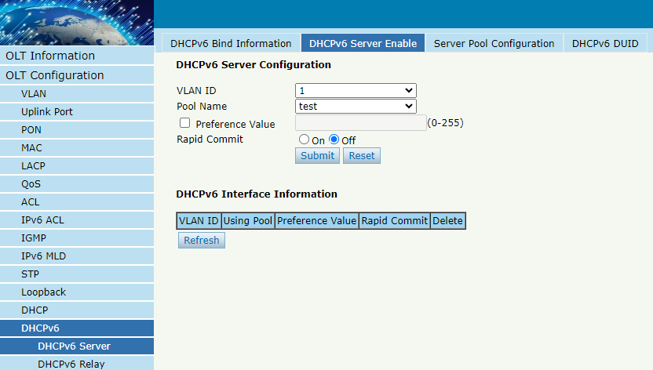
Figure 3.14-2: DHCPv6 Server

3.14.1.3 Server Pool Configuration
OLT Configuration DHCPv6 DHCPv6 Server Server Pool Configuration
DHCPv6 pool specifies the range of assigned IPv6 address. Life time, DNS and domain also can be specified here for DHCPv6 client.
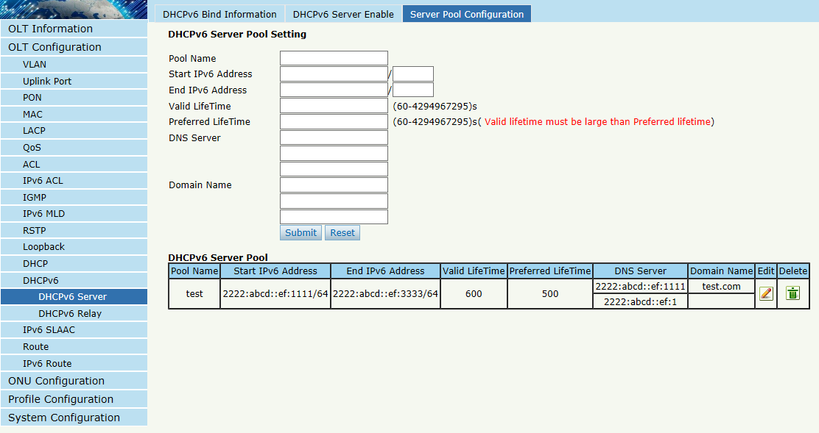
Figure 3.14-3: DHCPv6 Pool

3.14.1.4 DHCPv6 DUID
OLT Configuration DHCPv6 DHCPv6 Server DHCPv6 DUID
This page is used to configure DHCPv6 DUID types, Enterprise Number and Identifier.
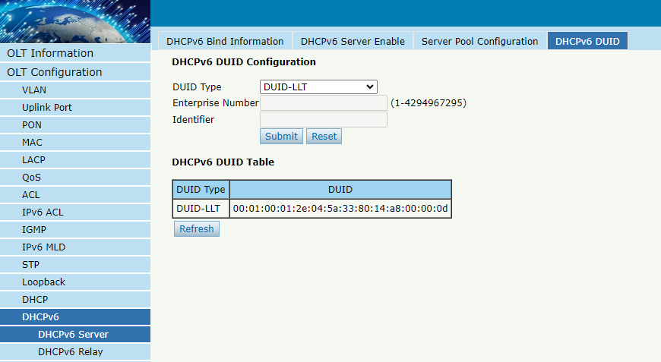
Figure 3.14-4: DHCPv6 DUID

3.14.2 DHCPv6 Relay
OLT Configuration DHCPv6 DHCPv6 Relay Configuration
During the process of obtaining the IPv6 address/prefix and other network configuration parameters dynamically through the DHCPv6 relay, the DHCPv6 client and the DHCPv6 server are processed in the same way as when the DHCPv6 relay is not processed.
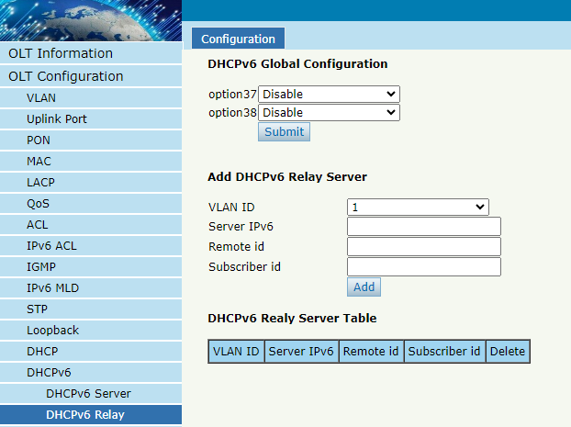
Figure 3.14-5: DHCPv6 Relay

3.15 IPv6 SLAAC
IPv6 network uses the ICMPv6 route discovery protocol. When an IPv6 host connects to the network for the first time, it automatically configures it according to the information got by route discovery/prefix discovery. Route discovery/prefix discovery is that when a host is connected to IPv6 network, it can discover local router and obtain neighbor information, prefix of current network and other configuration parameters from route advertisement (RA) packets.

3.15.1 IPv6 SLAAC
OLT Configuration IPv6 SLAAC IPv6 SLAAC
When IPv6 host use SLAAC (Stateless Address AutoConfiguration), OLT will send a route advertisement (RA) packet to it. This page is used to configure parameters of the route advertisement packet.
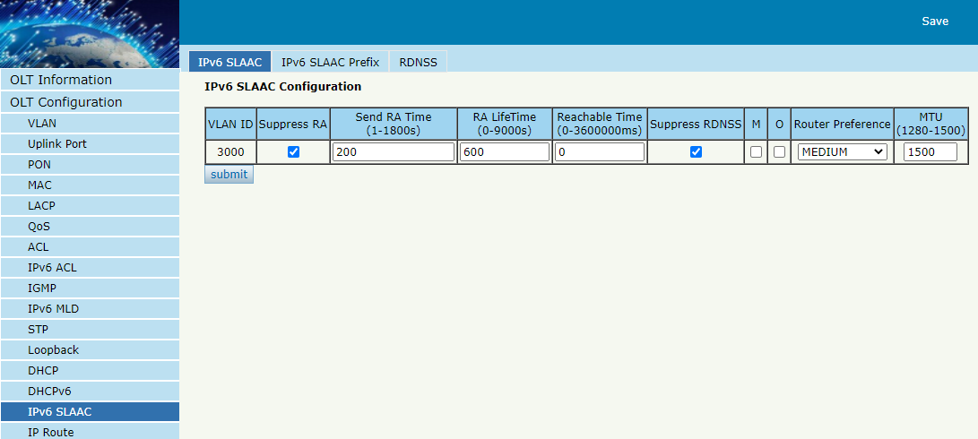
Figure 3.15-1: IPv6 SLAAC

3.15.2 IPv6 SLAAC Prefix
OLT Configuration IPv6 SLAAC IPv6 SLAAC Prefix
When IPv6 host uses stateless address auto configuration, OLT can provide IPv6 prefix. The host will generate an IPv6 address with the prefix.
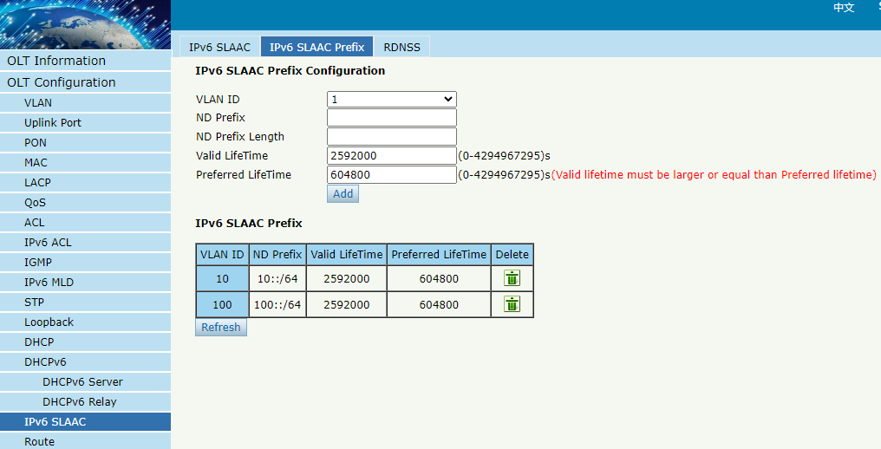
Figure 3.15-2: IPv6 SLAAC Prefix

3.15.3 RDNSS
OLT Configuration IPv6 SLAAC RDNSS
OLT will send the route advertisement packet with the DNS parameters you configured.
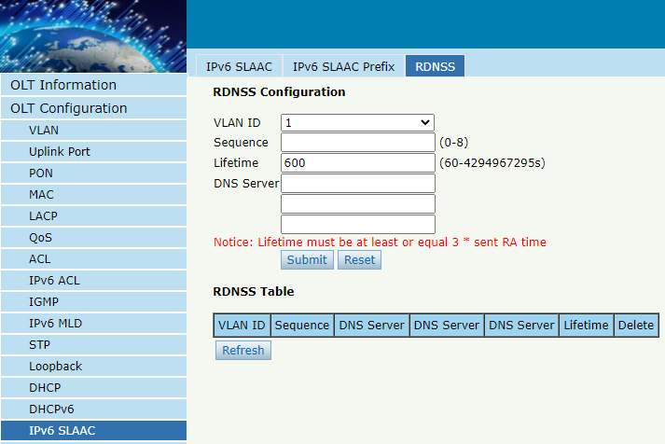
Figure 3.15-3: RDNSS

3.16 Route

3.16.1 IP

3.16.1.1 VLAN IP
OLT ConfigurationRouteIPVLAN IP
This configuration is used to configure IP address for VLAN. When the VLAN is added to a port, you can access OLT by the IP address from the port.
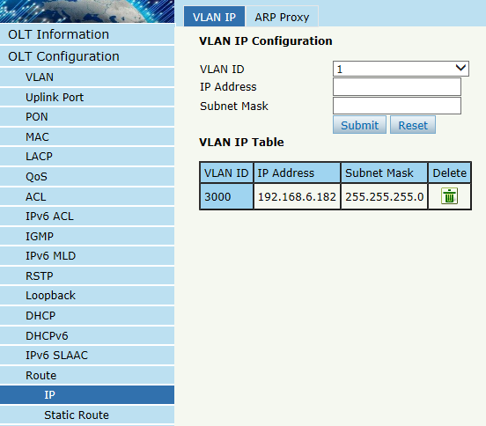
Figure 3.16-1: VLAN IP

3.16.1.2 ARP Proxy
ARP Proxy is a technique by which a device on a given network answers the ARP queries for a network address that is not on that network. The ARP Proxy is aware of the location of the traffic's destination, and offers its own MAC address as (ostensibly final) destination. The "captured" traffic is then typically routed by the Proxy to the intended destination via another interface or via a tunnel.
The process which results in the node responding with its own MAC address to an ARP request for a different IP address for proxying purposes is sometimes referred to as 'publishing'. Not all OLT models support ARP Proxy.

OLT ConfigurationRouteIPARP Proxy
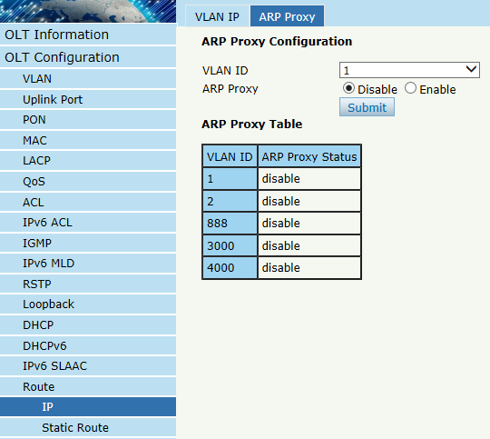
Figure 3.16-2: ARP proxy configuration

3.16.2 Static Route
Static route is a form of routing that a router uses a manually-configured routing entry. In many cases, static routes are manually configured by a network administrator. Unlike dynamic routing, static routes are fixed and do not change if the network is changed or reconfigured.
The OLT only supports static route. After configured VLAN IP address, add static routes to make the network on the different network segment communicate with each other.
OLT ConfigurationRouteStatic Route
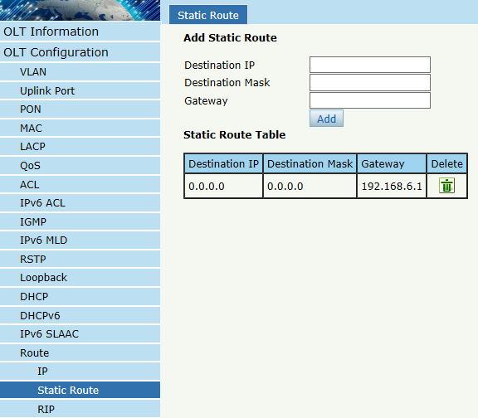
Figure 3.16-3: Static Route

3.16.3 RIP
RIP (Routing Information Protocol) is a simple internal gateway protocol, which is based on the D-V algorithm and uses hop count to represent metric. The hop count is the number of routers that a datagram must pass through. RIP only support maximum 15 hops; hence it is fit for a small network.

3.16.3.1 RIP Information
OLT Configuration Route RIP RIP Information
This page displays RIP information.
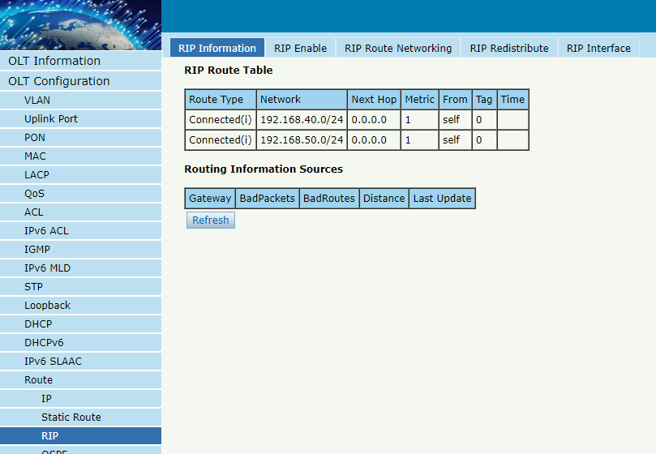
Figure 3.16-4: RIP Information

3.16.3.2 RIP Enable
OLT Configuration Route RIP RIP Enable
Enable RIP protocol and configure RIP parameters.
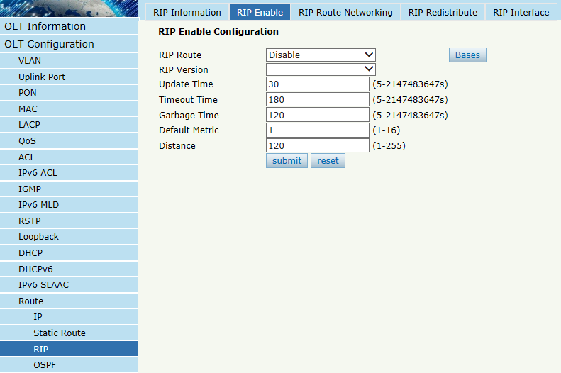
Figure 3.16-5: RIP Enable

3.16.3.3 RIP Route Networking
OLT Configuration Route RIP RIP Route Networking
This page is used to add RIP route networking. VLAN IP address must be set before adding the VLAN to RIP route networking table.
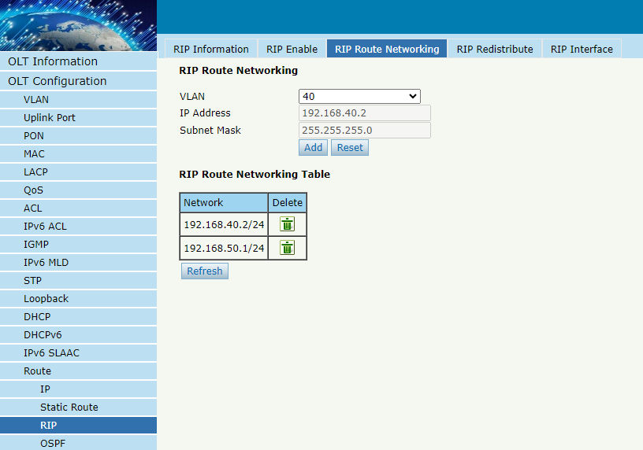
Figure 3.16-6: RIP Route Networking

3.16.3.4 RIP Redistribute
OLT Configuration Route RIP RIP Redistribute.
This page is used to enable or disable route redistribute and choose redistribute mode.
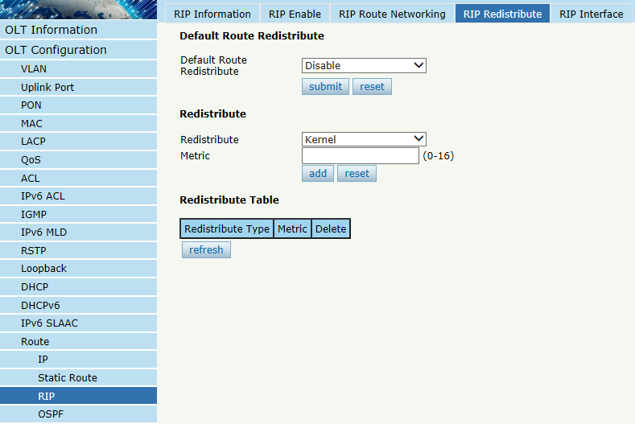
Figure 3.16-7: RIP Redistribute

3.16.3.5 RIP Interface
OLT Configuration Route RIP RIP Interface
This page is used to configure RIP interface and its authentication type. VLAN IP address must be set before configuring RIP interface. And auth chain should be set on page Key Chain, refer to section 3.16.5.
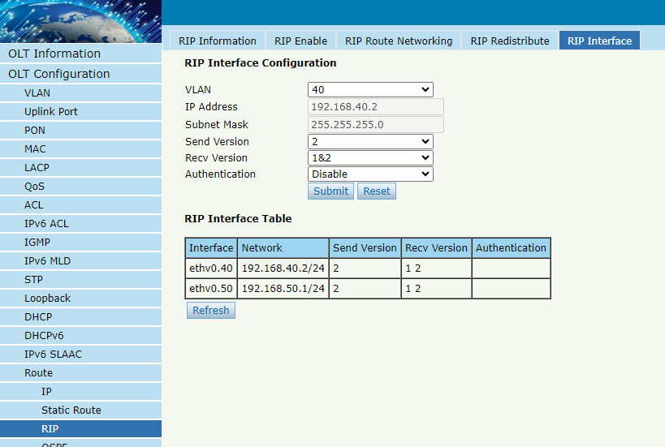
Figure 3.16-8: RIP Interface

3.16.4 OSPF
OSPF (Open Shortest Path First) is an internal gateway protocol based on link state routing protocol. This protocol uses the Dijkstra algorithm to calculate the shortest path to each network, and performs the algorithm to quickly converge to the new loop-free topology when detecting changes in the link (such as link failure).

3.16.4.1 OSPF Information
OLT Configuration Route OSPF OSPF Information
This page displays OSPF information, including neighbor information and OSPF routing information.
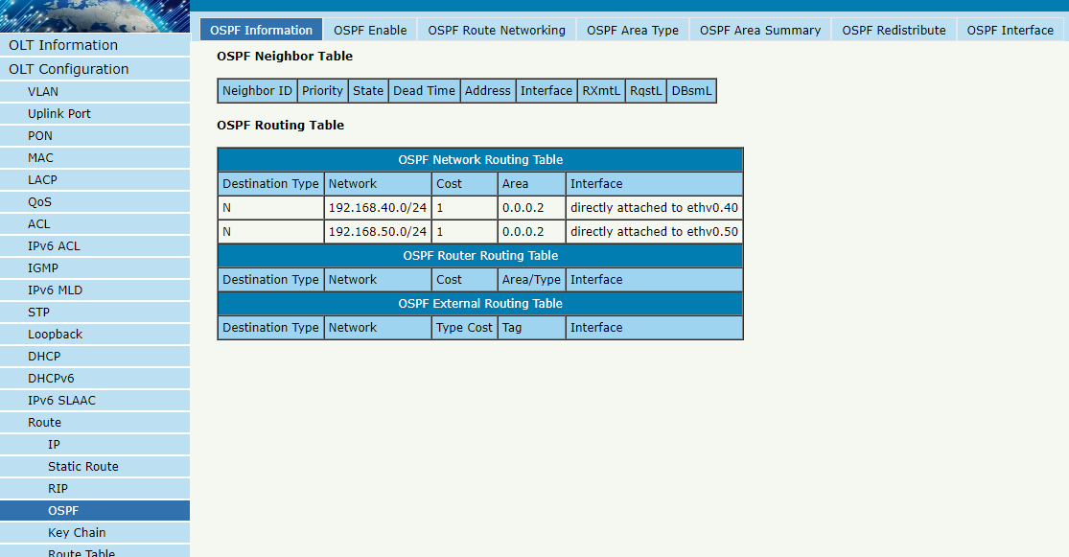
Figure3.16-9: OSPF Information

3.16.4.2 OSPF Enable
OLT Configuration Route OSPF OSPF Enable
This page is used to enable OSPF. Fill in route ID and let it blank, enable OSPF. OLT will use the biggest IP address as route ID if it’s blank.
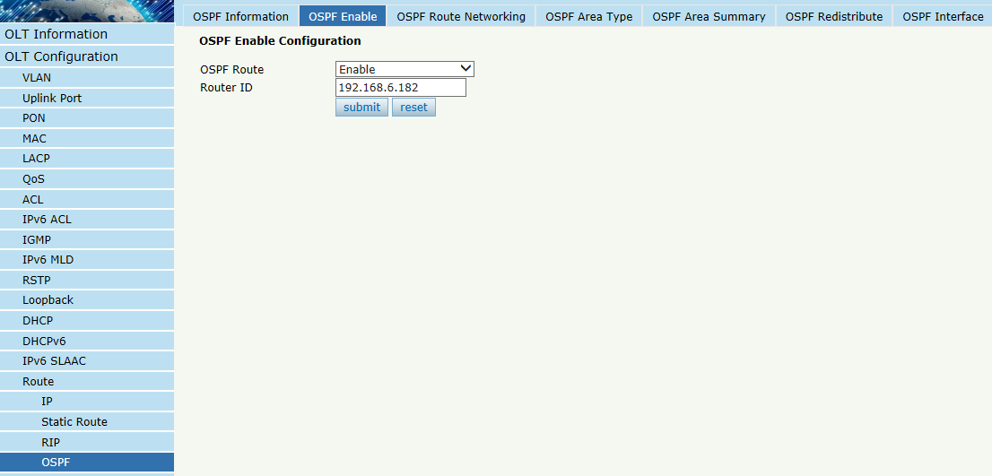
Figure 3.16-10: OSPF Enable

3.16.4.3 OSPF Route Networking
OLT Configuration Route OSPF OSPF Route Networking
This page is used to configure area number for VLAN where OSPF protocol is operating.
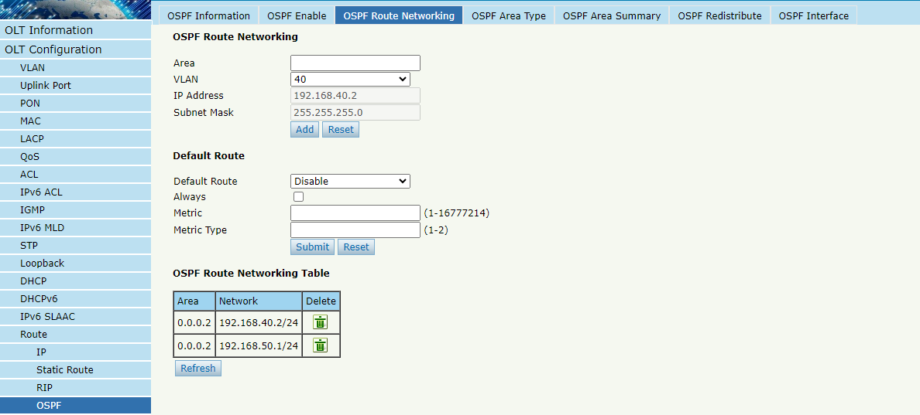
Figure 3.16-11: OSPF Route Networking

3.16.4.4 OSPF Area Type
OLT Configuration Route OSPF OSPF Area Type
This page is used to configure area type. Backbone area will not display on this page.
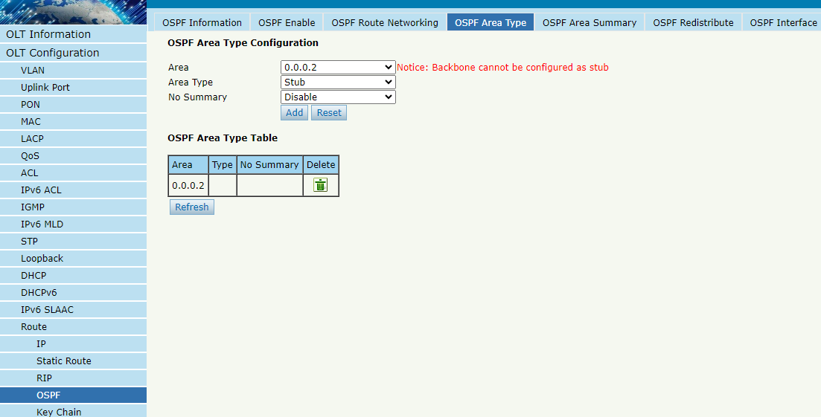
Figure 3.16-12: OSPF Area Type

3.16.4.5 OSPF Area Summary
OLT Configuration Route OSPF OSPF Area Summary
This page is used to configure area IP address summary.
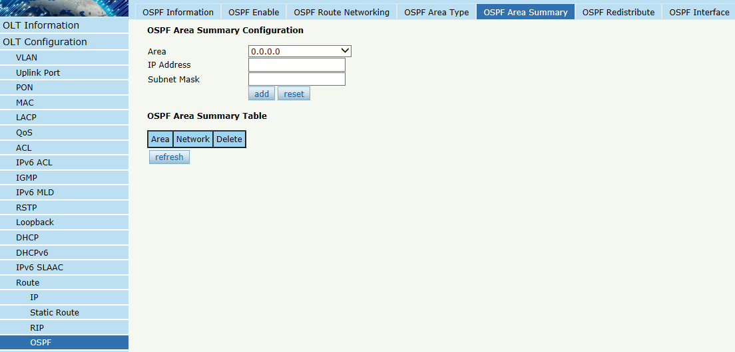
Figure 3.16-13: OSPF Area Summary

3.16.4.6 OSPF Redistribute
The router can use route redistribution to broadcast the OSPF routing it learns through another routing protocol so that several routing protocols can cooperate with each other in a network.
OLT Configuration Route OSPF OSPF Redistribute
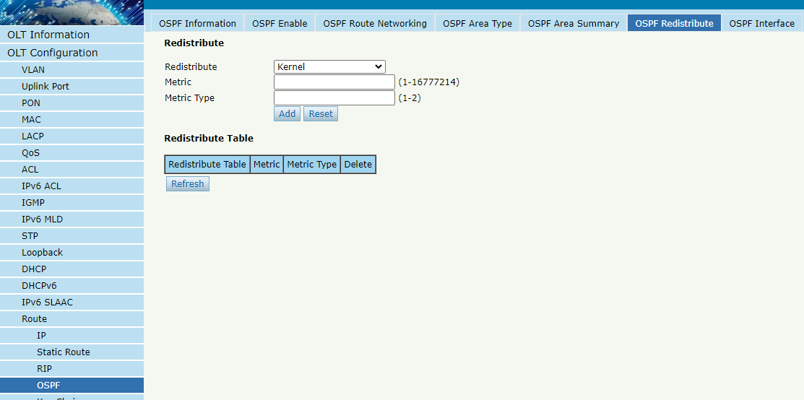
Figure 3.16-14: OSPF Redistribute

3.16.4.7 OSPF Interface
OLT Configuration Route OSPF OSPF Interface
This page is used to OSPF interface parameters such as cost, time, priority, authentication, and so on.
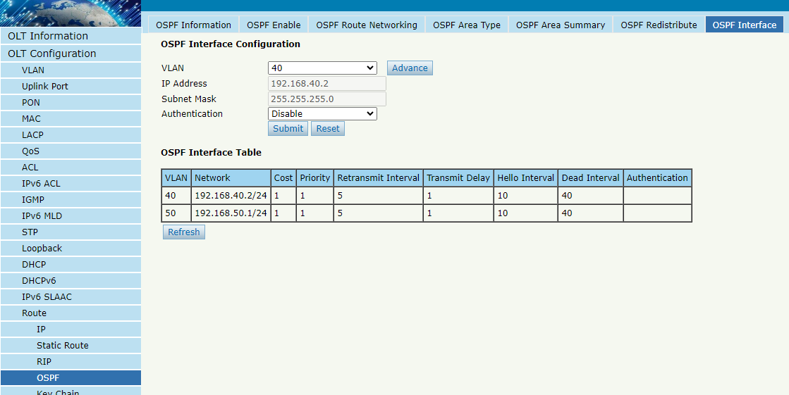
Figure 3.16-15: OSPF Interface

3.16.5 Key Chain
Key management is a method of controlling the authentication key used by routing protocols. The authentication key is available for EIGRP and RIP version 2. To manage the authentication key needs a key chain. Each key has its own key identifier, which is stored locally. The combination of the key identifier and the interface associated with the message uniquely identifies the authentication algorithm and MD5 authentication key in use.
OLT Configuration Route Key Chain
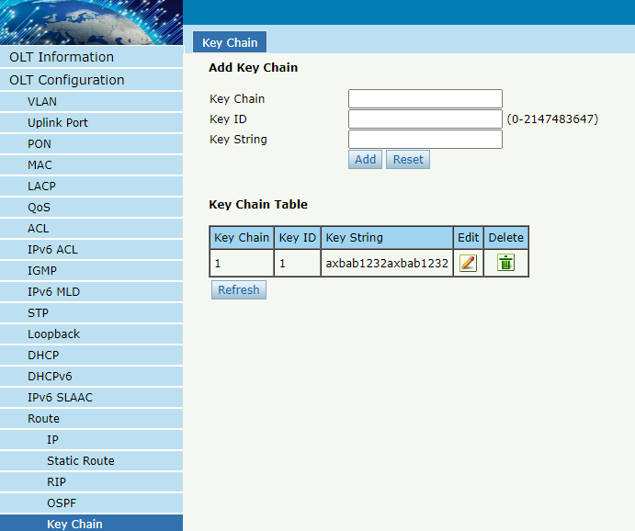
Figure 3.16-16: Key Chain

3.16.6 Route Table
OLT Configuration Route Route Table
This page displays routing items of OLT.
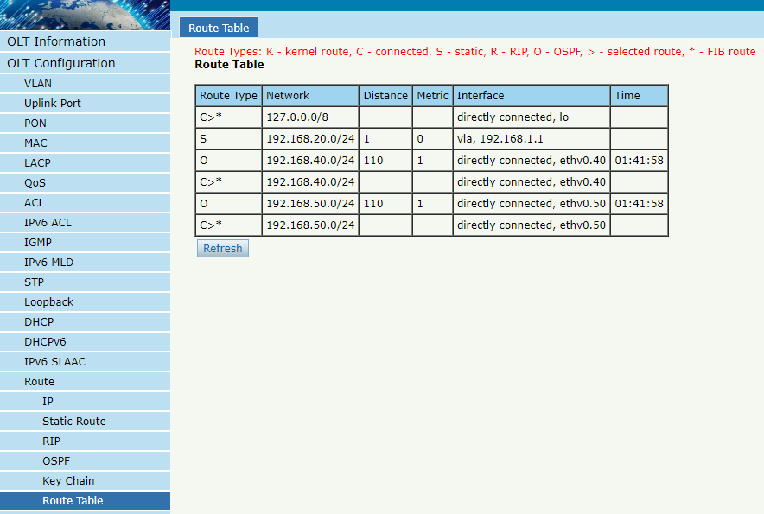
Figure 3.16-17: Route Table

3.17 IPv6 Route

3.17.1 IPv6
OLT Configuration IPv6 Route IPv6 VLAN IPv6
Configure IPv6 address for VLAN that has been created.
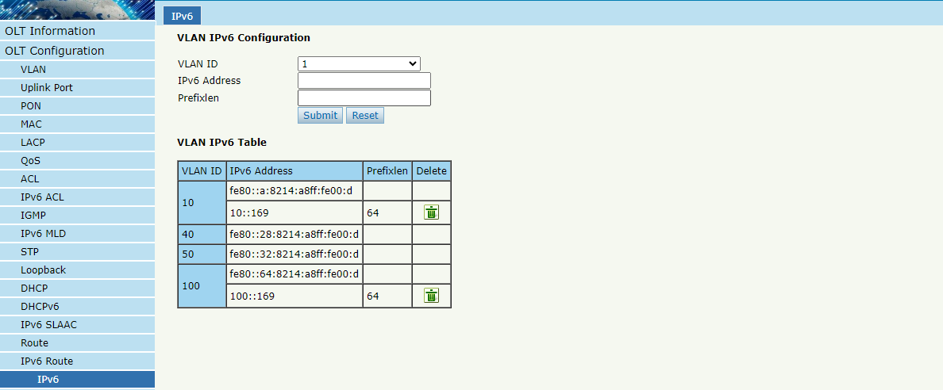
Figure 3.17-1: VLAN IPv6

3.17.2 IPv6 Static Route
Static route is added manually. It will not change even the situation and network topology has been changed.
OLT Configuration IPv6 Route IPv6 Static Route
Add IPv6 static route item one by one.
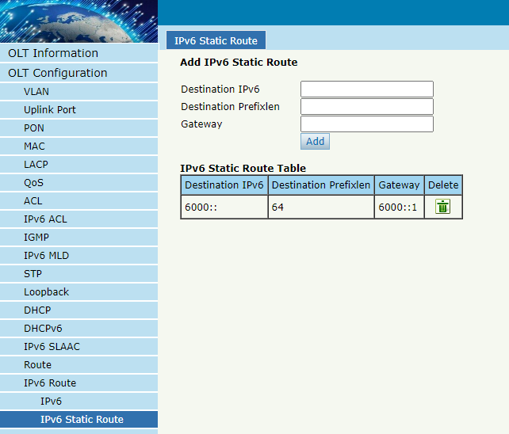
Figure 3.17-2: IPv6 Static Route

3.17.3 RIPng
RIPng is the next generation of RIP, which uses the IPv6 protocol on top of RIP.

3.17.3.1 RIPng Information
OLT Configuration IPv6 Route RIPng RIPng Information
This page displays RIPng information.
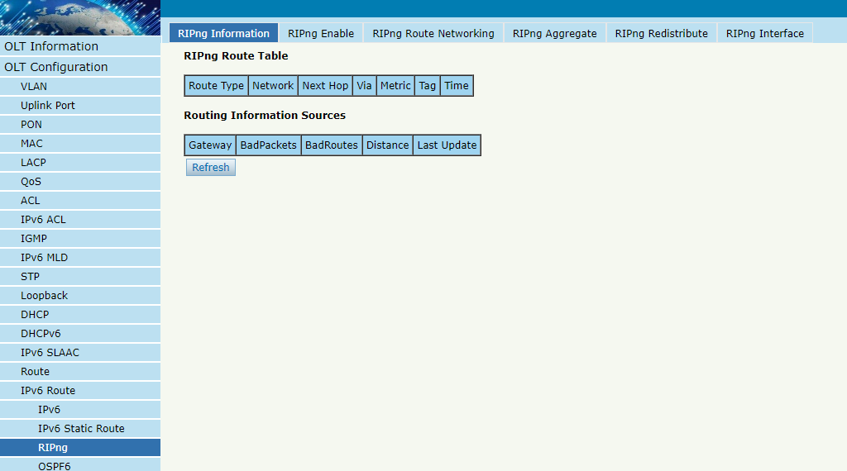
Figure 3.17-3: RIPng Information

3.17.3.2 RIPng Enable
OLT Configuration IPv6 Route RIPng RIPng Enable
Enable RIPng protocol and configure RIPng parameters.
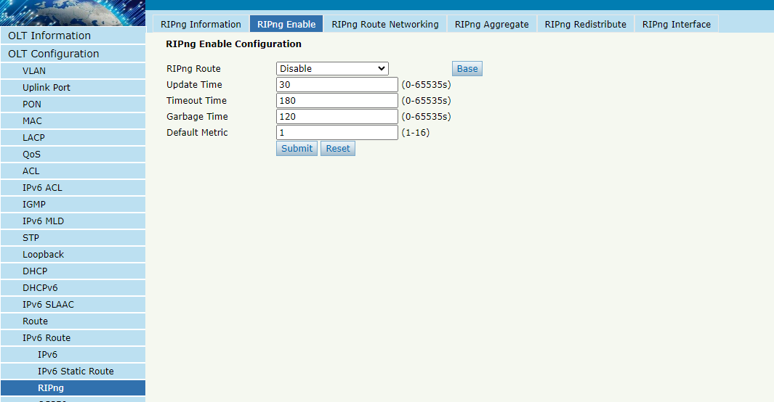
Figure 3.17-4: RIPng Enable

3.17.3.3 RIPng Route Networking
OLT Configuration IPv6 Route RIPng RIPng Route Networking
This page is used to add RIPng route networking. VLAN IP address must be set before adding the VLAN to RIPng route networking table.
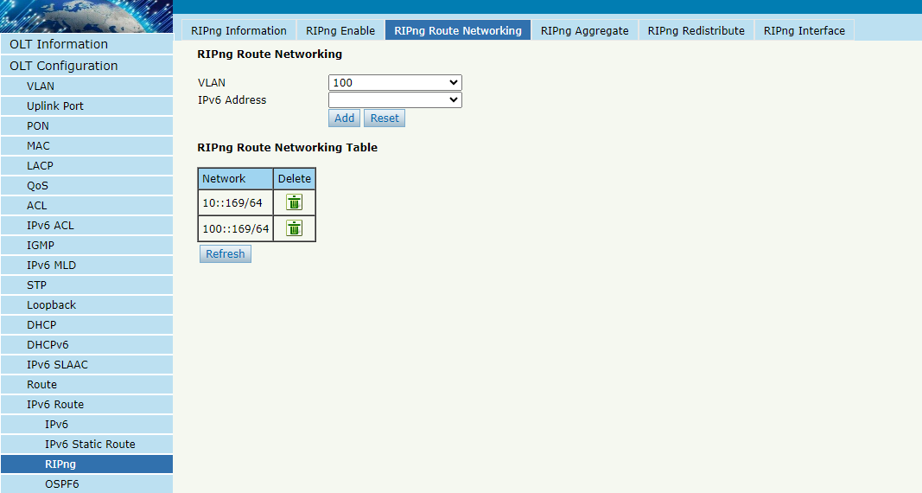
Figure 3.17-5: RIPng Route Networking

3.17.3.4 RIPng Aggregate
OLT Configuration IPv6 Route RIPng RIPng Aggregate.
This page is used to aggregate routes of the same network segment with different prefixes.
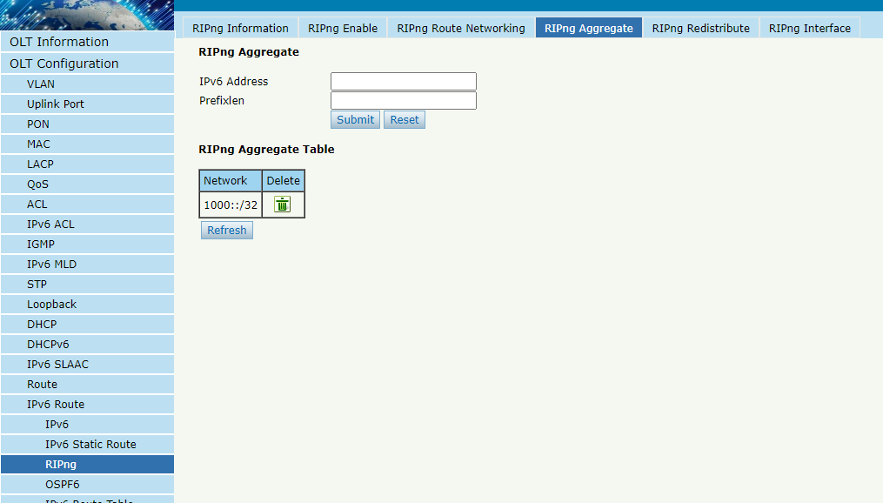
Figure 3.17-6: RIPng Aggregate

3.17.3.5 RIPng Redistribute
OLT Configuration IPv6 Route RIPng RIPng Redistribute.
This page is used to enable or disable route redistribute and choose redistribute mode.
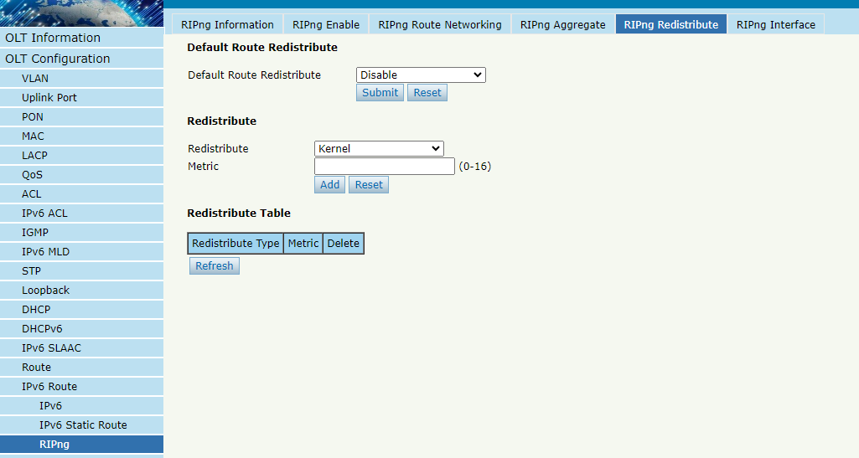
Figure 3.17-7: RIPng Redistribute

3.17.3.6 RIPng Interface
OLT Configuration IPv6 Route RIPng RIPng Interface
This page is used to configure the RIPng interface's modes, including split-horizon, split-horizon, and poisoned-reverse mixed mode selection.
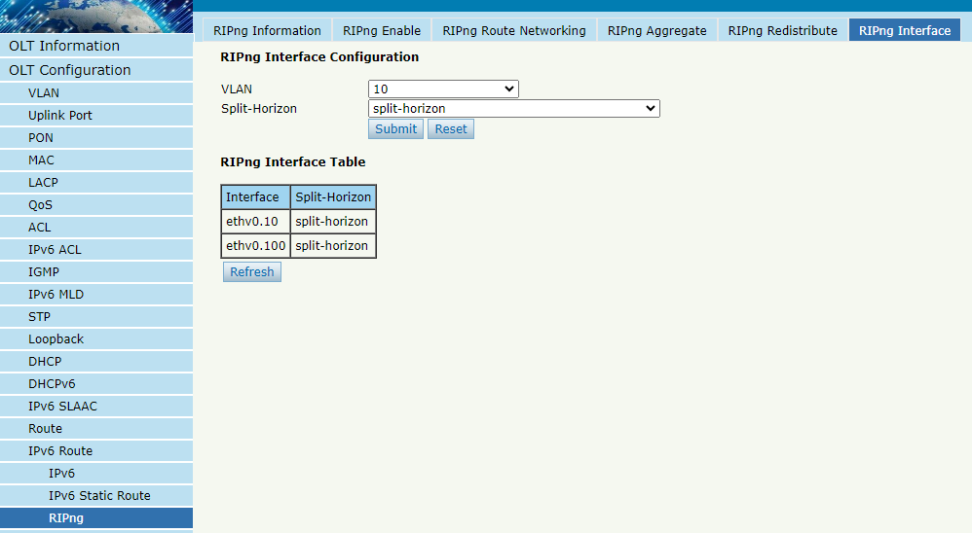
Figure 3.17-8: RIPng Interface

3.17.4 OSPF6
OSPF6 is the next generation of OSPF, which uses the IPv6 protocol on top of OSPF.

3.17.4.1 OSPF6 Information
OLT Configuration IPv6 Route OSPF6 OSPF6 Information
This page displays OSPF6 information, including neighbor information and OSPF6 routing information.
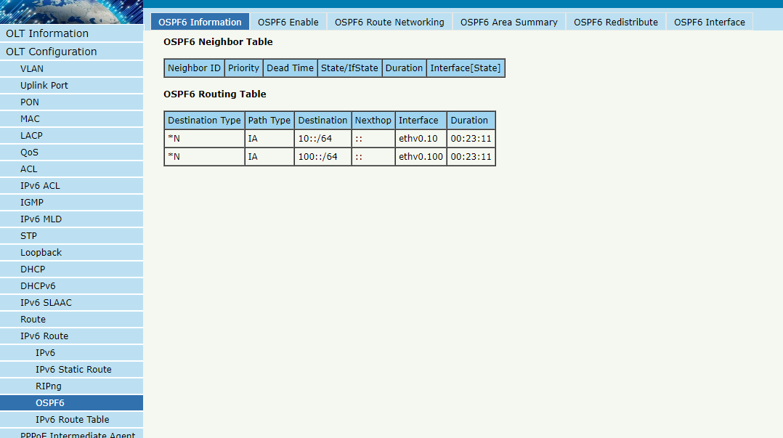
Figure3.17-9: OSPF6 Information

3.17.4.2 OSPF6 Enable
OLT Configuration IPv6 Route OSPF6 OSPF6 Enable
This page is used to enable OSPF6. Fill in route ID and let it blank, enable OSPF6. OLT will use the biggest IPv6 address as route ID if it’s blank.
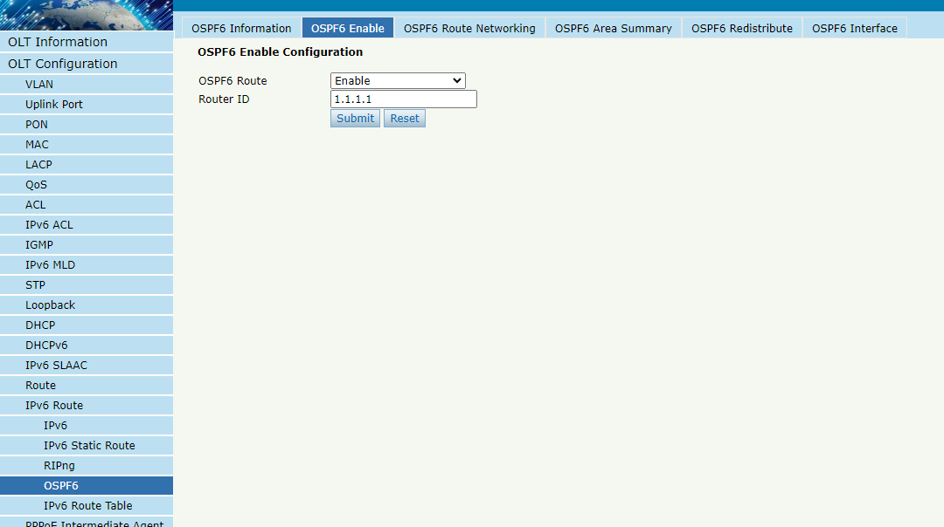
Figure 3.17-10: OSPF6 Enable

3.17.4.3 OSPF6 Route Networking
OLT Configuration IPv6 Route OSPF6 OSPF6 Route Networking
This page is used to configure area number for VLAN where OSPF6 protocol is operating.
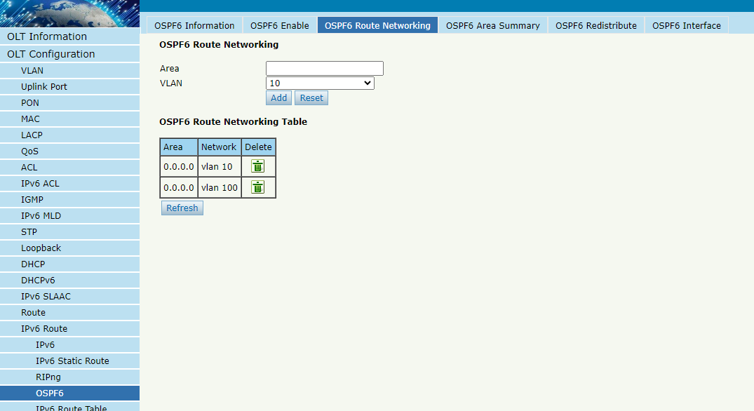
Figure 3.17-11: OSPF6 Route Networking

3.17.4.4 OSPF6 Area Summary
OLT Configuration IPv6 Route OSPF6 OSPF6 Area Summary
This page is used to configure area IPv6 address summary.
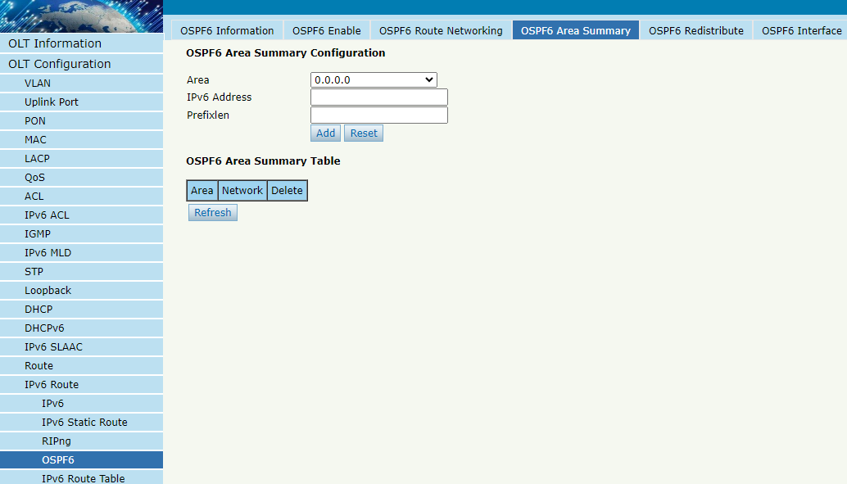
Figure 3.17-12: OSPF6 Area Summary

3.17.4.5 OSPF6 Redistribute
The router can use route redistribution to broadcast the OSPF6 routing it learns through another routing protocol so that several routing protocols can cooperate with each other in a network.
OLT Configuration IPv6 Route OSPF6 OSPF6 Redistribute
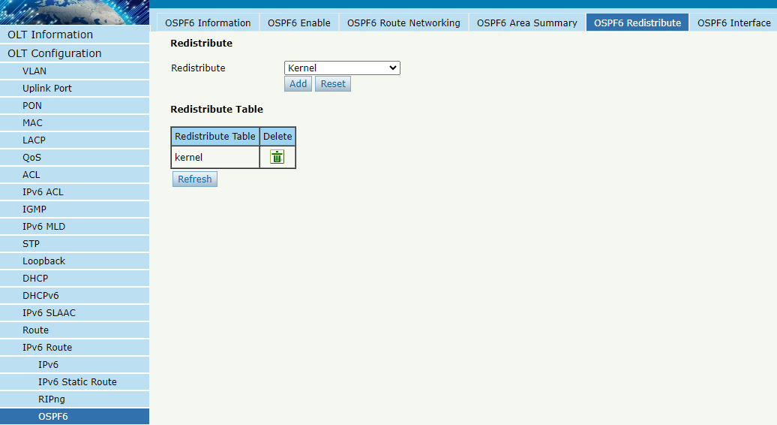
Figure 3.17-13: OSPF6 Redistribute

3.17.4.6 OSPF6 Interface
OLT Configuration IPv6 Route OSPF6 OSPF6 Interface
This page is used to OSPF6 interface parameters such as cost, time, priority, authentication, and so on.
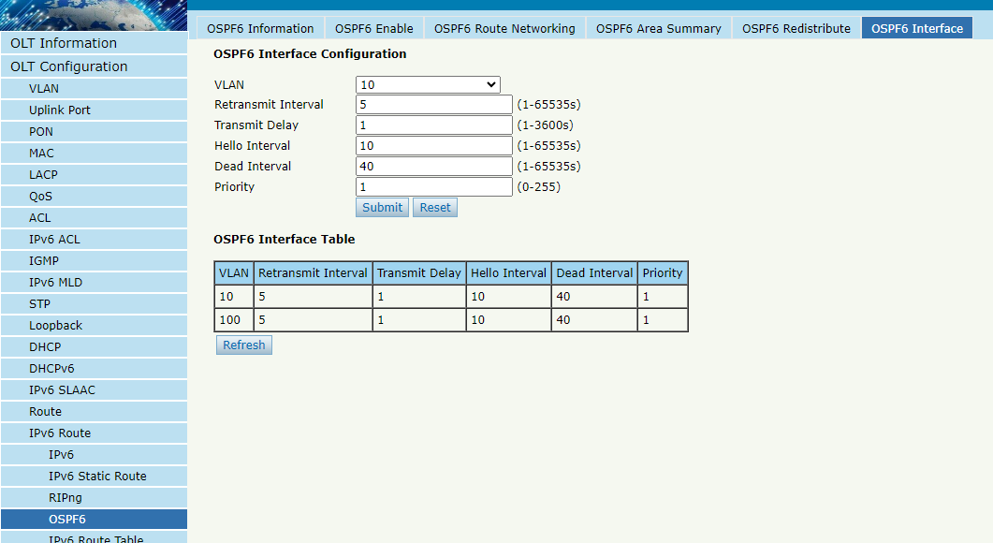
Figure 3.17-14: OSPF6 Interface

3.17.5 IPv6 Route Table
OLT Configuration IPv6 Route IPv6 Route Table
This table displays all IPv6 route items of the device, including static route and dynamic route.
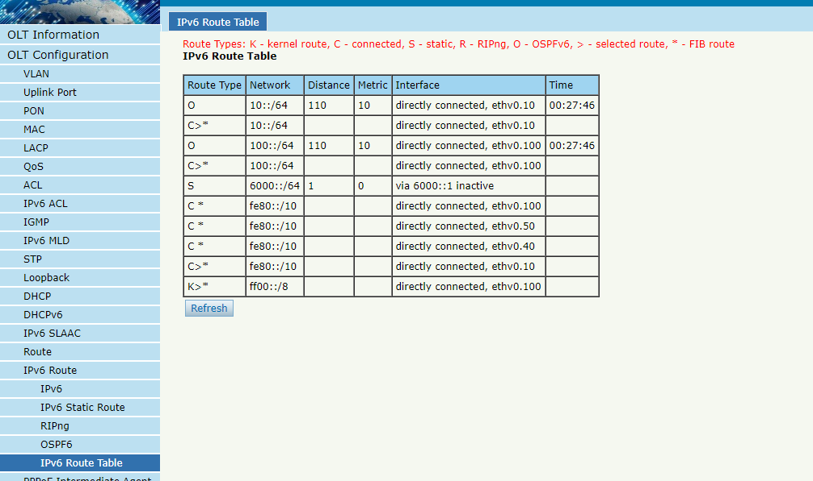
Figure 3.17-15: IPv6 Route Table

3.18 PPPoE Intermediate Agent
The PPPoE Intermediate Agent intercepts the PPPoE client's PPPoE message and adds port information (such as slot number/sub card number/interface number, VLAN, MAC address, etc.) for the end user's host access to it. It then forwards it to the PPPoE Server through PAD (PPPoE Active Discovery) to achieve binding authentication between the end user's user account and the access port.

3.18.1 PPPoE Intermediate Agent
OLT Configuration PPPoE Intermediate Agent PPPoE Intermediate Agent
This page is used to configure the PPPoE Intermediate Agent's switches, bound VLANs, and other parameter information.
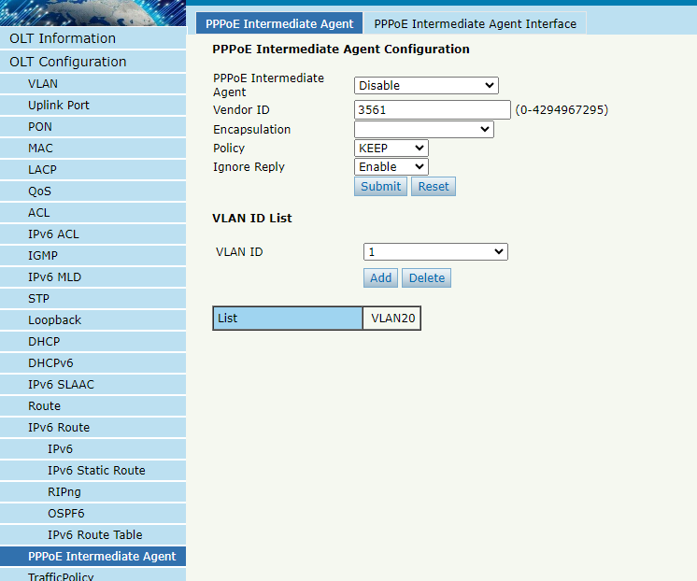
Figure 3.18-1: PPPoE Intermediate Agent

3.18.2 PPPoE Intermediate Agent Interface
OLT Configuration PPPoE Intermediate Agent PPPoE Intermediate Agent Interface
This page is used to configure whether the port is trusted, as well as the values of Circuit ID and Remote ID.
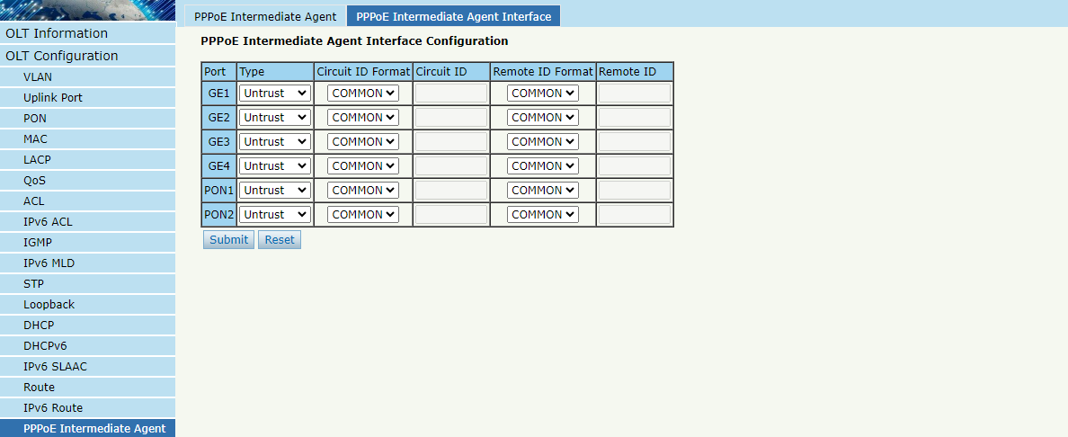
Figure 3.18-2: PPPoE Intermediate Agent Interface

3.19 Traffic Policy

3.19.1 Policy
OLT Configuration Traffic Policy Policy
This page is used to bind flow classifier and flow behavior to flow policy.
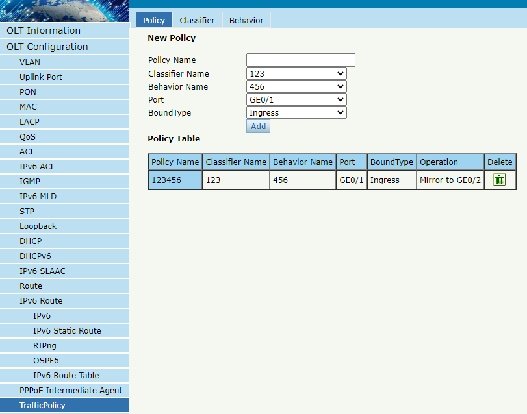
Figure 3.19-1: Policy

3.19.2 Classifier
OLT Configuration TrafficPolicy Classifier
This page is used to configure flow classifier, It is created based on ACL.
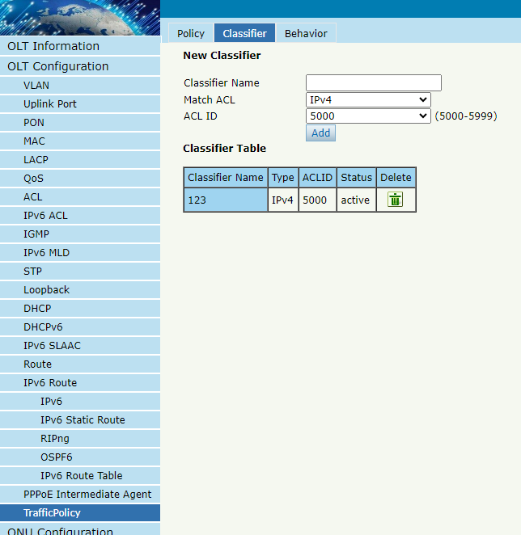
Figure 3.19-2: Classifier

3.19.3 Behavior
OLT Configuration TrafficPolicy Behavior
This page is used to configure flow behavior, here subsequent operations can be specified, such as mirroring, speed limits, and data statistics.
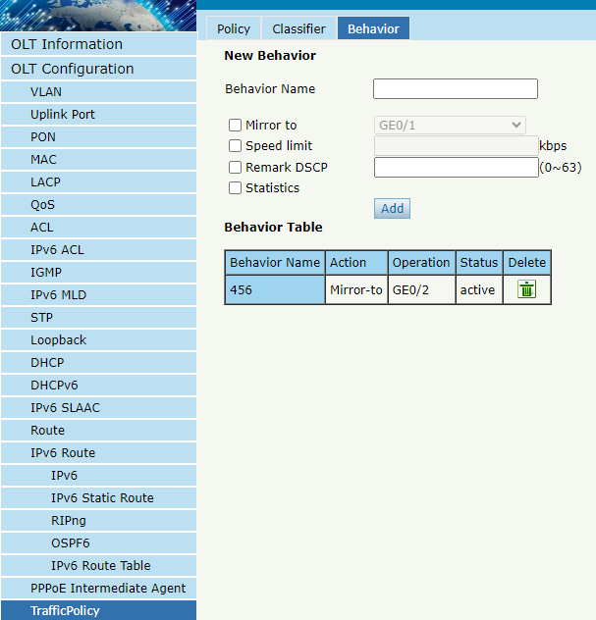
Figure 3.19-3: Behavior

Chapter 4 ONU Configuration
This chapter is about the ONU management by OLT.

4.1 ONU AuthList

4.1.1 ONU List
ONU ConfigurationONU AuthListONU List
Select PON port ID, all ONUs will be displayed in this interface. You can check ONU using profile, Registration mode and do some operations to every ONU.
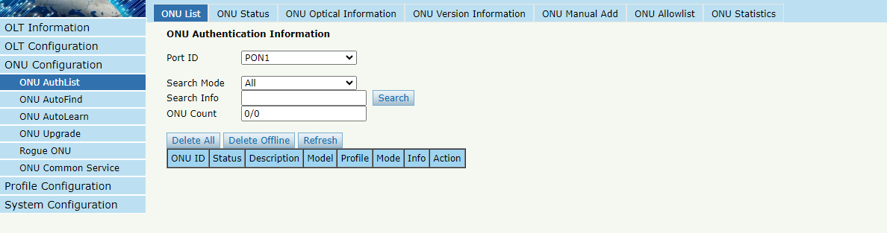
Figure 4.1-1: ONU List

4.1.1.1 Config
ONU ConfigurationONU AuthListONU ListConfig
Configure ONU parameter information which you selected.
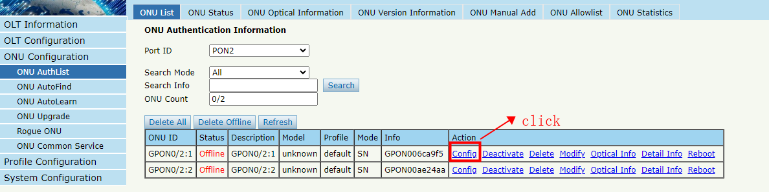
Figure 4.1-2: Configure ONU

4.1.1.1.1 Tcont
ONU ConfigurationONU AuthListONU ListConfigTcont
Create tcont ID and bind DBA profile. Tcont name is optional.
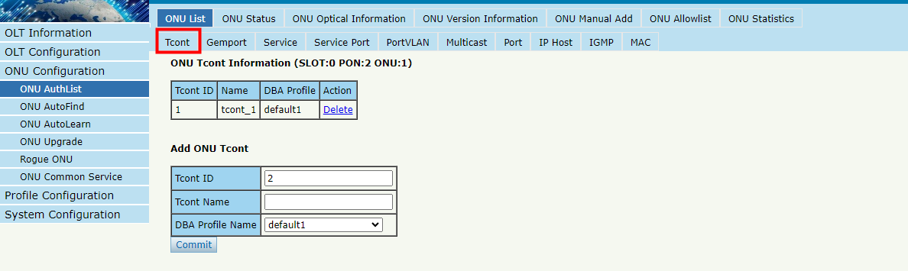
Figure 4.1-3: Create Tcont

4.1.1.1.2 Gemport
ONU ConfigurationONU AuthListONU ListConfigGemport
Create gemport ID and bind tcont ID.
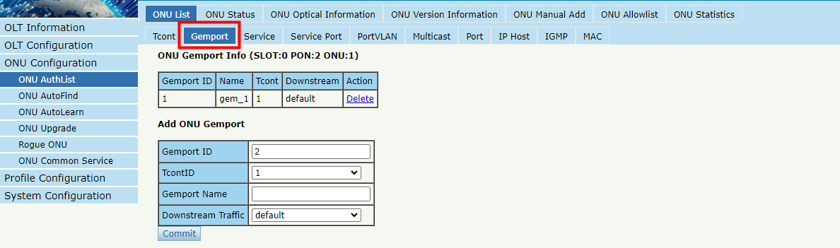
Figure 4.1-4: Create gemport

4.1.1.1.3 Service
ONU ConfigurationONU AuthListONU ListConfigService
Create a service, set the VLAN and VLAN mode and bind one gemport ID.
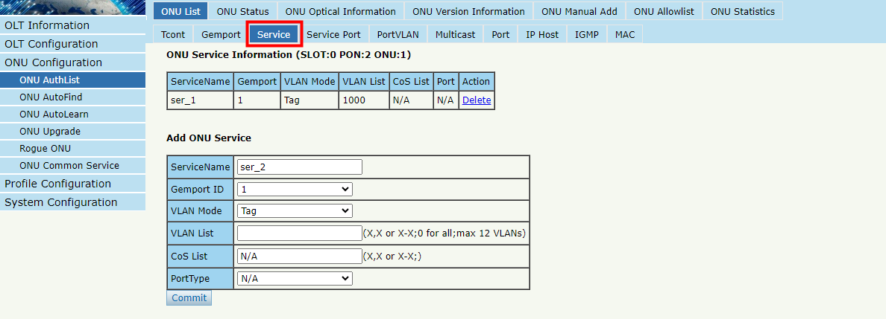
Figure 4.1-5: Create service

4.1.1.1.4 Service Port
ONU ConfigurationONU AuthListONU ListConfigService Port
Create a service port, set the user VLAN and translate VLAN and bind one gemport ID. If don’t need VLAN translation, just set translate VLAN the same as user VLAN.
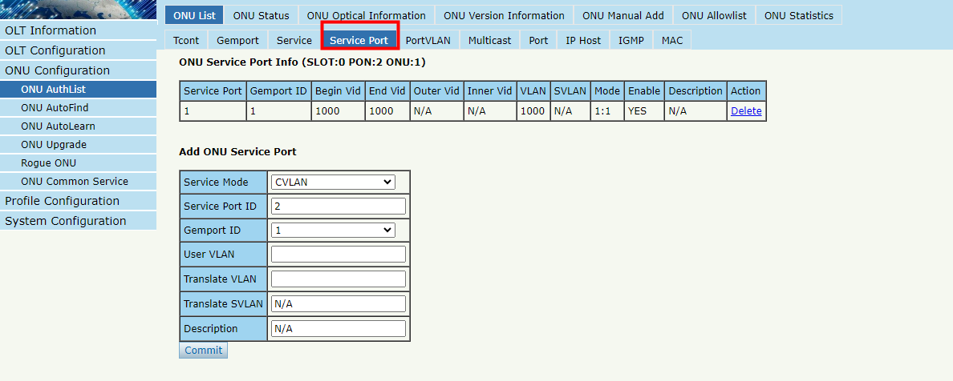
Figure 4.1-6: Create service port

4.1.1.1.5 PortVlan
ONU ConfigurationONU AuthListONU ListConfig PortVlan
Set the VLAN mode of the ONU’s port. For HGU, need to configure veip 1 transparent; for SFU, configure Ethernet port directly.
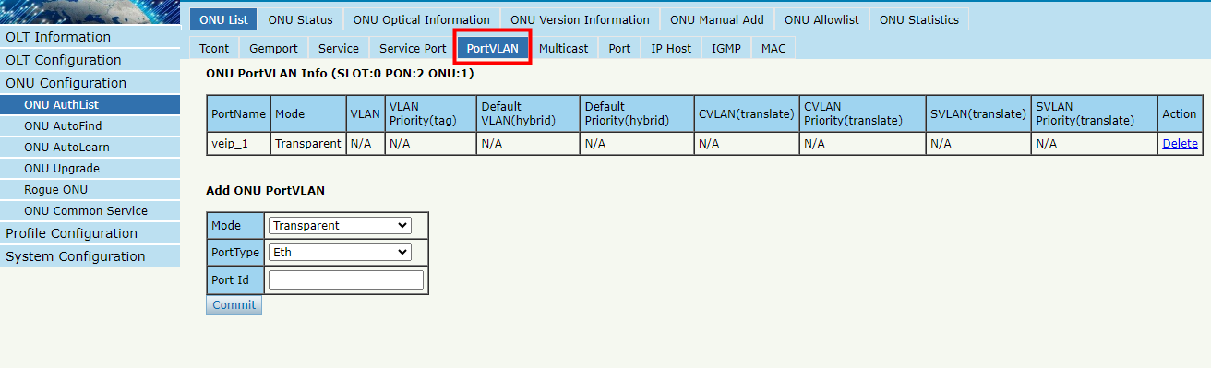
Figure 4.1-7: Configure port VLAN mode

4.1.1.1.6 Multicast
ONU ConfigurationONU AuthListONU ListConfig Multicast
Set the Multicast VLAN of ONU and the Multicast VLAN mode of ONU’s port.
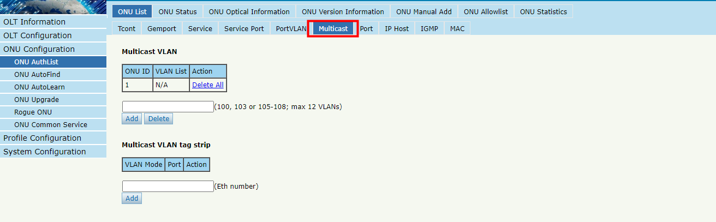
Figure 4.1-8: Configure multicast VLAN

4.1.1.1.7 Port
ONU ConfigurationONU AuthListONU ListConfigPort
Set attribute of ONU LAN port.
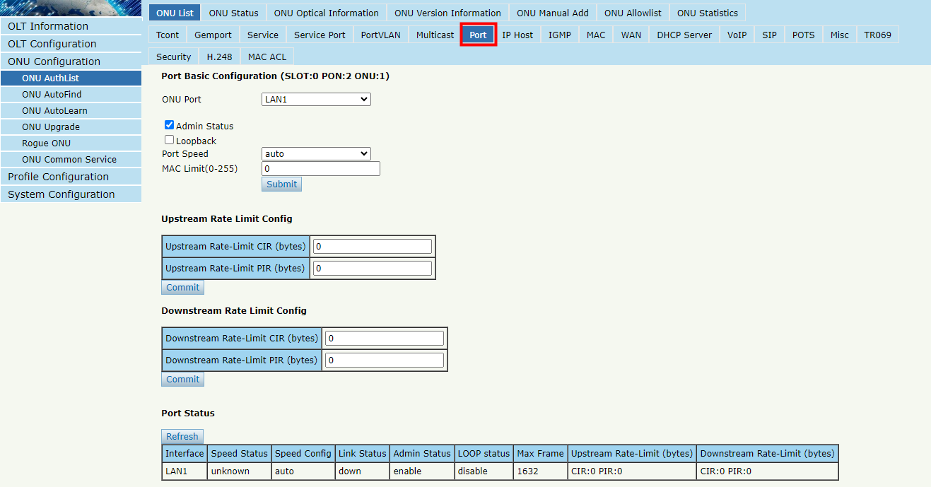
Figure 4.1-9: ONU port attibute

4.1.1.1.8 Iphost
ONU ConfigurationONU AuthListONU ListConfigIphost
Create Iphost for ONU wan connection. It is used for ONU management.
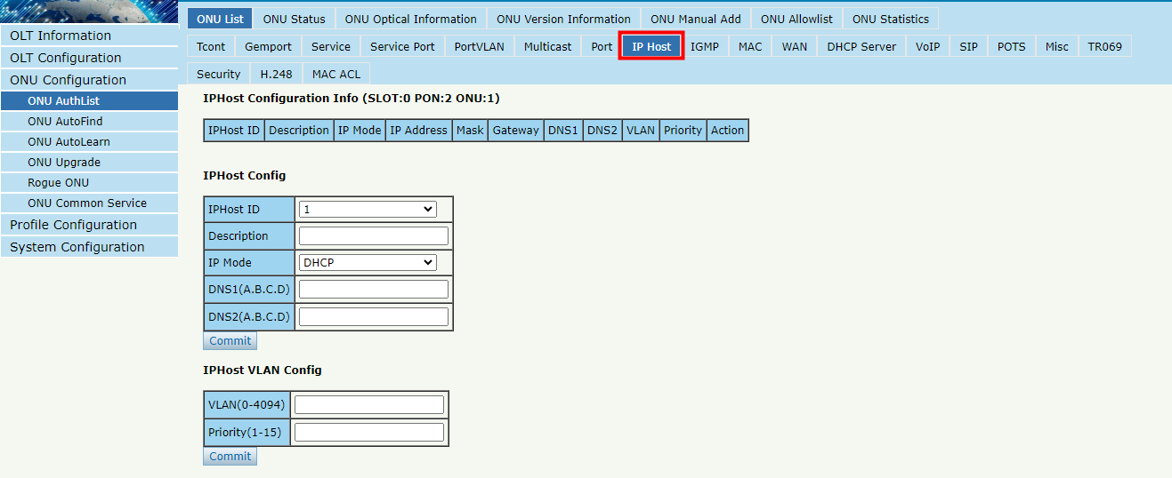
Figure 4.1-10: Configure IPhost

4.1.1.1.9 WAN
ONU ConfigurationONU AuthListONU ListConfigWAN
ONU WAN connection is configured by private OMCI between OLT and ONU. When the connected ONU supports this function, the option "WAN" can be shown on this page.
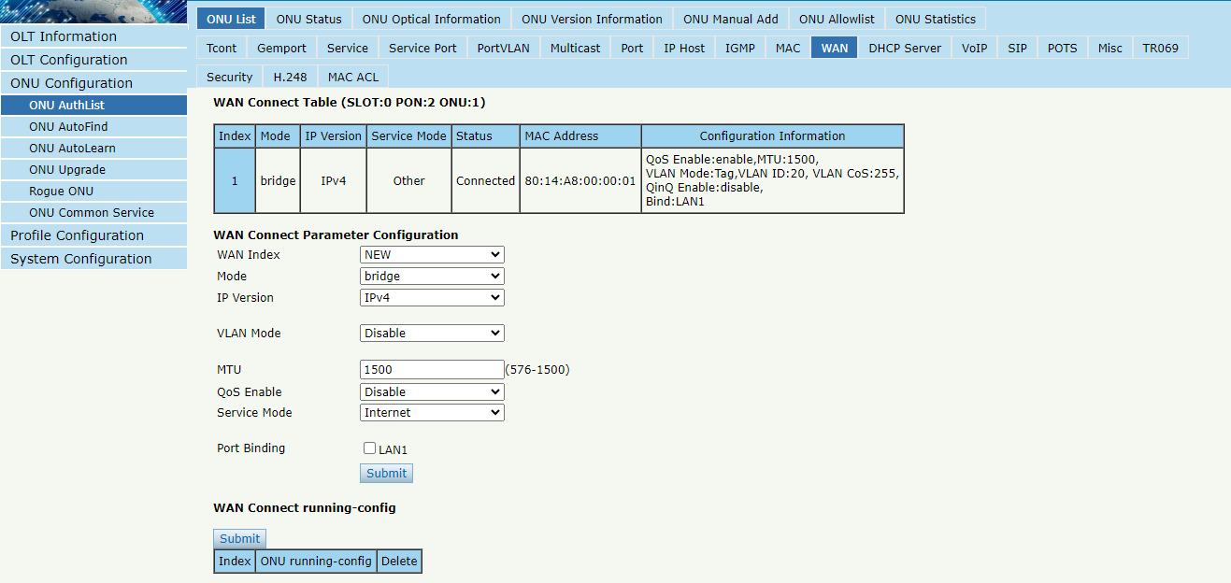Figure 4.1-11: Configure WAN

4.1.1.1.10 DHCP Server
ONU ConfigurationONU AuthListONU ListConfigDHCP Server
ONU LAN and DHCP server are configured by private OMCI between OLT and ONU. When the connected ONU supports this function, the option "DHCP Server" can be shown on this page.
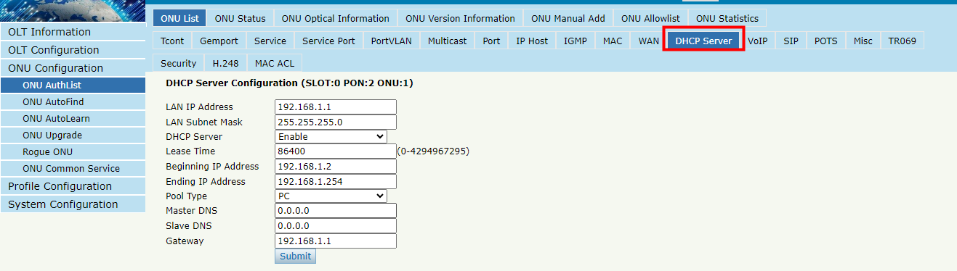
Figure 4.1-12: ONU DHCP Server

4.1.1.1.11 Bind Mode
ONU ConfigurationONU AuthListONU ListConfigBIND Mode
ONU LAN bind mode is configured by private OMCI between OLT and ONU. When the connected ONU supports this function, the option "Bind Mode" can be shown on this page.
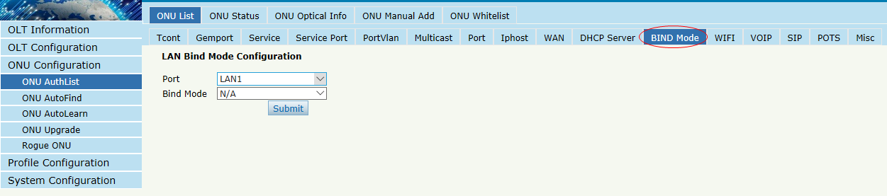
Figure 4.1-13: LAN Bind Mode Configuration

4.1.1.1.12 WIFI
ONU ConfigurationONU AuthListONU ListConfigWIFI
ONU WIFI is configured by private OMCI between OLT and ONU. When the connected ONU supports this function, the option "WIFI" can be shown on this page.
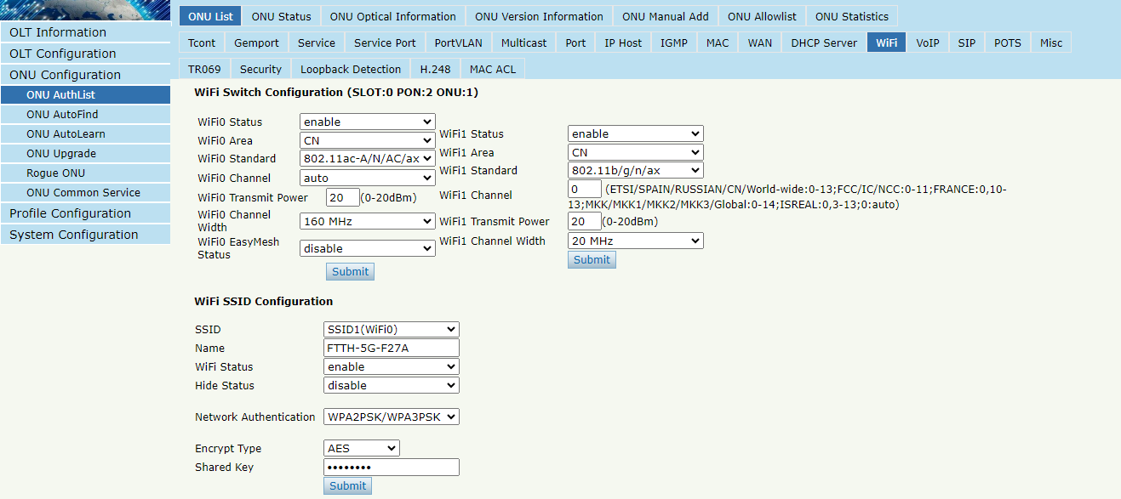
Figure 4.1-14: WIFI Configuration

4.1.1.1.13 VOIP
ONU ConfigurationONU AuthListONU ListConfigVOIP
This page shows WAN information of VOIP service, including IP address and VLAN. You can also operate VOIP module on this page. When the connected ONU supports VOIP, the option "VOIP" can be shown on this page.
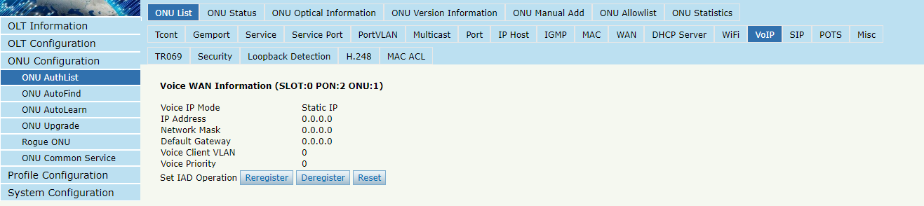
Figure 4.1-15: Voice Wan Information

4.1.1.1.14 SIP
ONU ConfigurationONU AuthListONU ListConfigSIP
ONU VoIP SIP parameter can be configured on this page, including SIP server, proxy server, digit map and so on. When the connected ONU supports VOIP, the option "SIP" can be shown on this page.

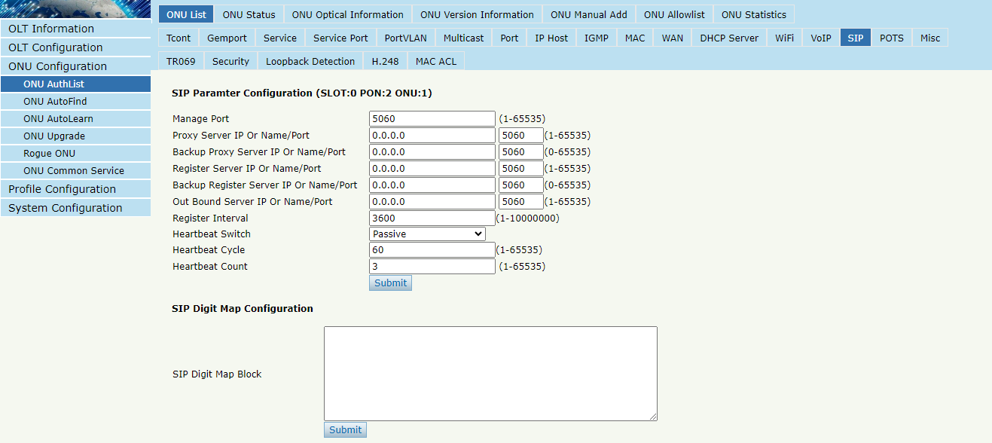
Figure 4.1-16: SIP Parameter

4.1.1.1.15 POTS
ONU ConfigurationONU AuthListONU ListConfigPOTS
ONU VoIP POTS account, password and other VOIP parameters of POTS can be configured on this page; the length of SIP account can't be more than 16 bits. When the connected ONU supports VOIP, the option "POTS" can be shown on this page.
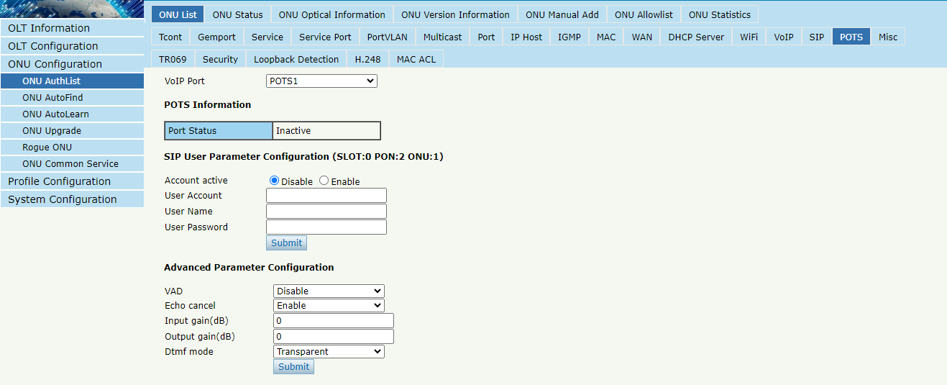
Figure 4.1-17: POTS Configuration

4.1.1.1.16 Misc
ONU ConfigurationONU AuthListONU ListConfigMisc
Misc includes other features of ONU which are configured by private OMCI.
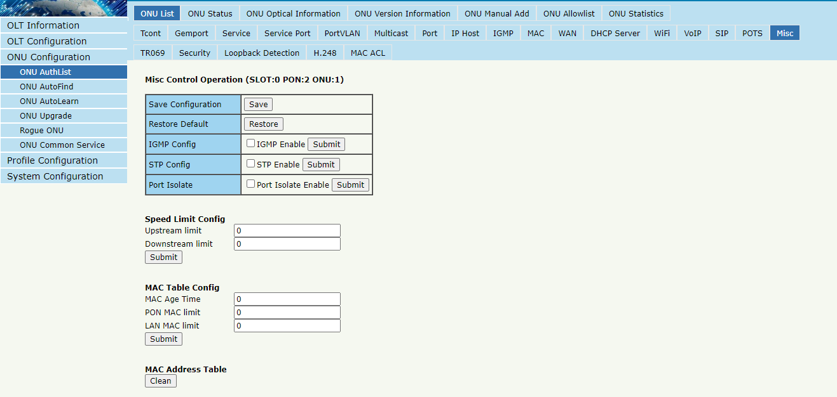
Figure 4.1-18: Misc Configuration

4.1.1.2 Deactivate
ONU ConfigurationONU AuthListONU ListDeactivate (Activate)
Deactivate ONU which you selected, the ONU will be disabled and the registration failed. Activate selected ONU, this ONU will register successfully.
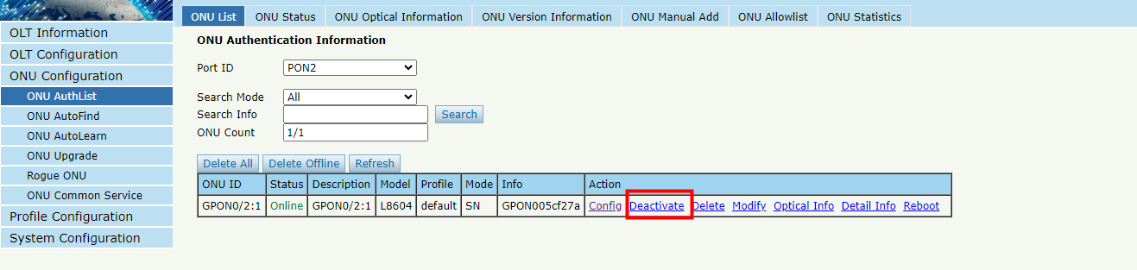
Figure 4.1-19: Deactivate/Activate ONU

4.1.1.3 Delete
ONU ConfigurationONU AuthListONU ListDelete
Delete ONU which you selected, the ONU will be deleted and the registration failed. All the configurations related this ONU will be deleted as well.
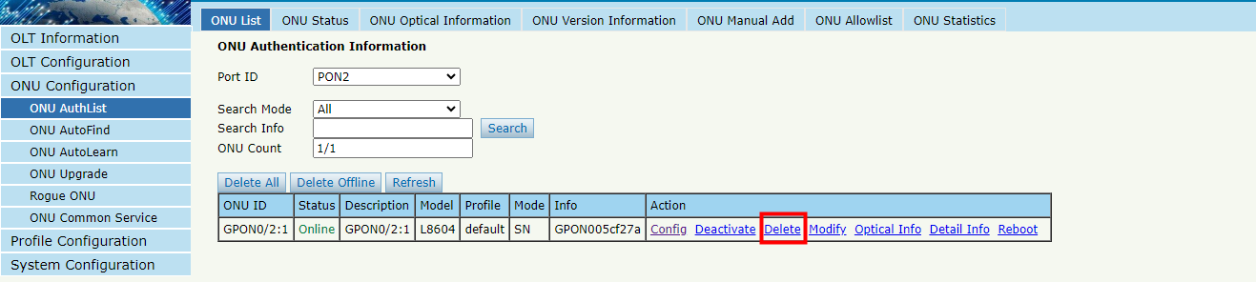
Figure 4.1-20: Delete ONU

4.1.1.4 Modify
ONU ConfigurationONU AuthListONU ListModify
This is used to modify ONU authentication mode.
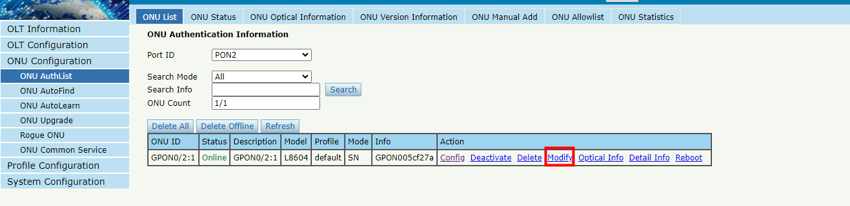
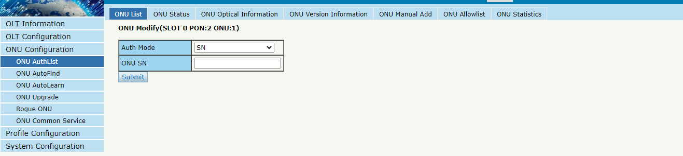
Figure 4.1-21: Modify ONU Authentication mode

4.1.1.5 Optical Info
ONU ConfigurationONU AuthListONU ListOptical Info
Check the Optical Information of ONU PON module which you selected.
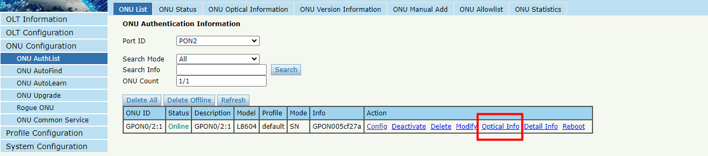
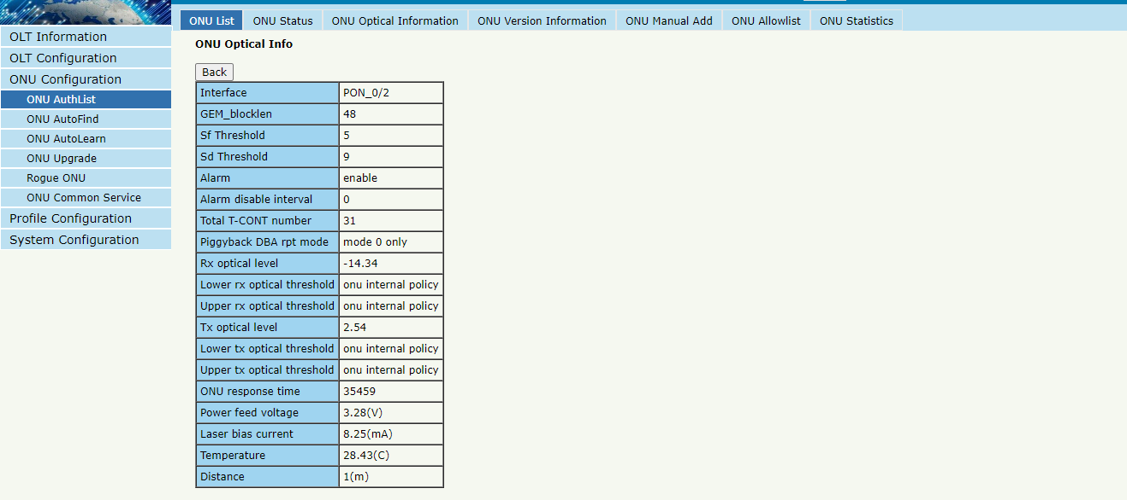
Figure 4.1-22: Optical info of ONU

4.1.1.6 Detail Info
ONU ConfigurationONU AuthListONU ListDetail Info
Check the Detail Info of ONU which you selected.
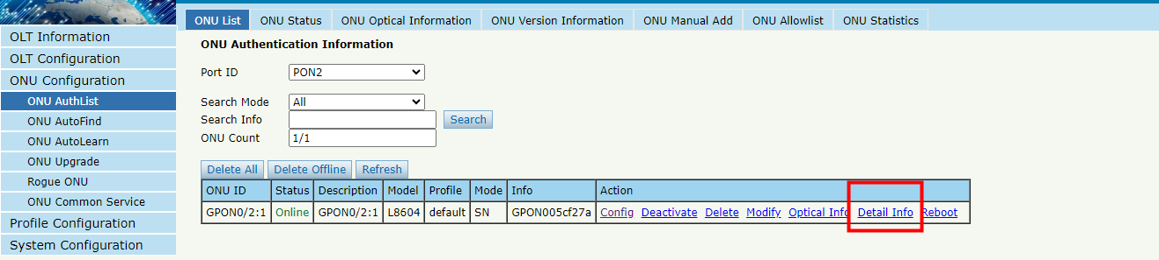
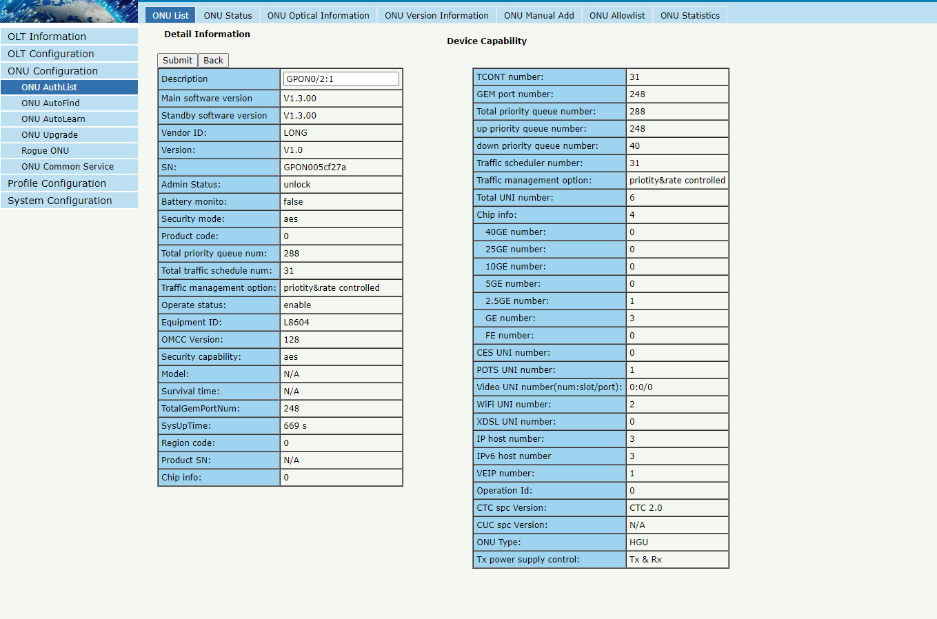
Figure 4.1-23: Detail info of ONU

4.1.1.7 Reboot
ONU ConfigurationONU AuthListONU ListReboot
Reboot ONU which you selected.
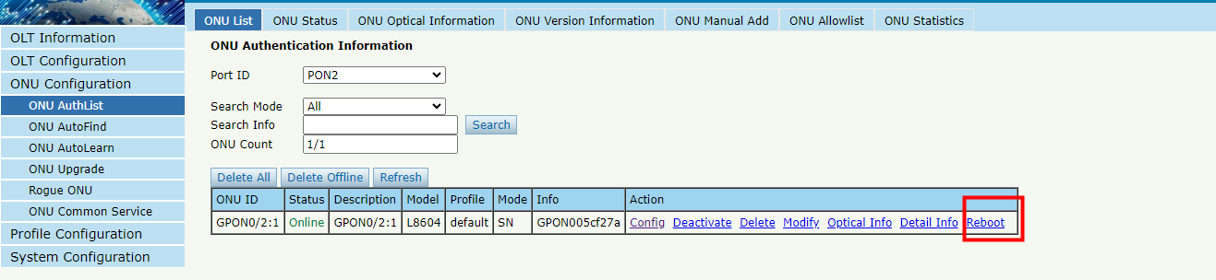
Figure 4.1-24: Reboot ONU

4.1.2 ONU Status
ONU ConfigurationONU AuthListONU Status
This pages shows the ONU information of the activity. User can check "Last Register Time”, "Last Deregister Reason" and "Active Time" of each ONU.
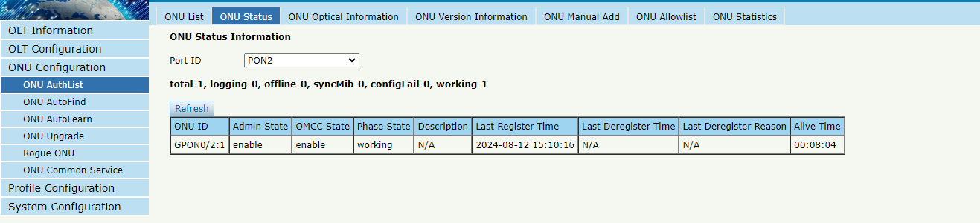
Figure 4.1-25: ONU Status

4.1.3 ONU Optical Info
ONU ConfigurationONU AuthListONU Optical Info
This page displays ONU Rx and Tx power. A batch of ONU optical power information can be shown in a list. Clearly to check the register power when register issue happens.
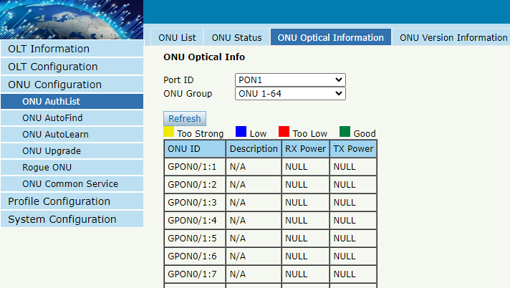
Figure 4.1-26: ONU Optical Info

4.1.4 ONU Version Information
ONU ConfigurationONU AuthListONU Version Information
This page allows you to view the optical power information of all online ONU.
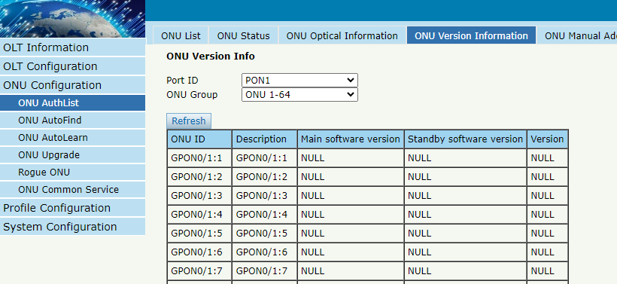Figure 4.1-27: ONU Version Information

4.1.5 ONU Manual Add
ONU ConfigurationONU AuthListONU Manual Add
You can manually add ONU to a selected PON port. ONU will appear in the ONU list after you added.
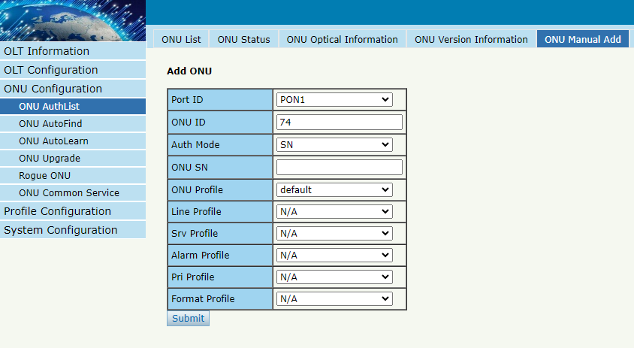Figure 4.1-28: Add ONU Manually

4.1.6 ONU Allowist
ONU ConfigurationONU AuthListONU Allowist
You can set up Allowist on this page.
Whitelist can limit illegal ONU to register. Only the GPON SN in the Allowist can register, but only effective for the ONU which has not been added to OLT.
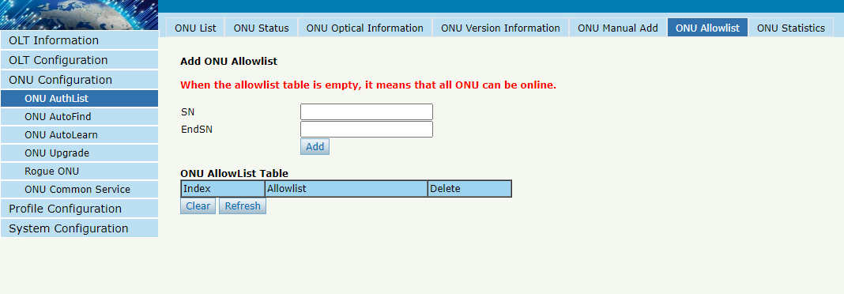
Figure 4.1-29: ONU Allowist

4.1.7 ONU Statistics
ONU ConfigurationONU AuthListONU Statistics
This page displays the information of package count about ONU ports.
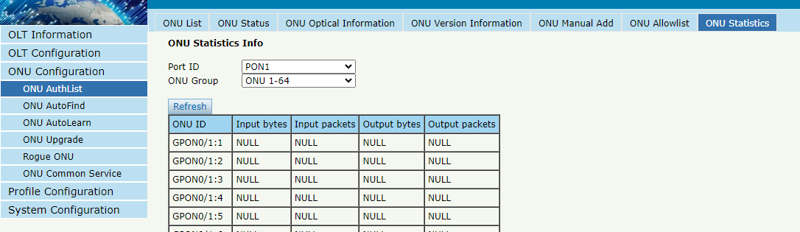
Figure 4.1-30: ONU Statistics

4.2 ONU AutoFind

4.2.1 Automatic Discovery
ONU ConfigurationONU AutoFind Automatic Discovery
After selecting PON port number, all ONUs which are authenticated failed or not authenticated will be displayed in this interface. You can check the serial number of ONUs.
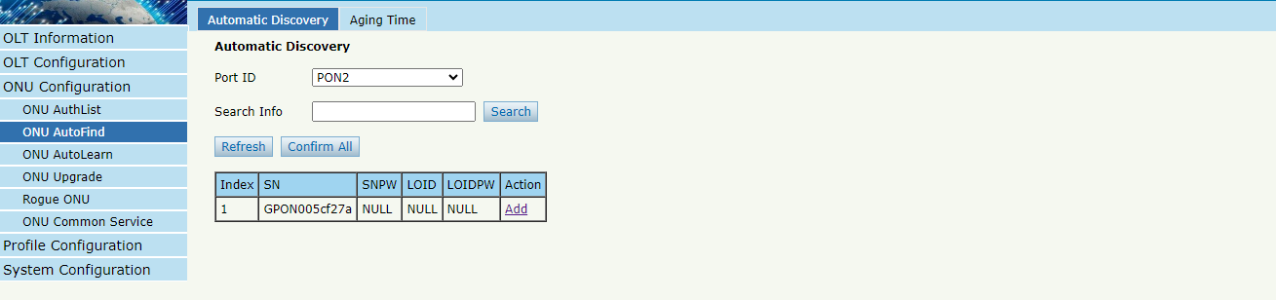
Figure4.2-1: Automatic Discovery
Figure 4.2-2: Detail info

4.2.2 Aging Time
ONU ConfigurationONU AutoFind Aging Time
Through this page, you can modify the aging time after discovering ONU through the PON port.
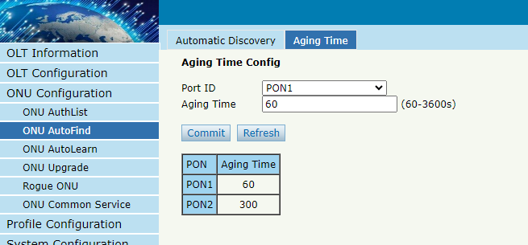
Figure4.2-3: Aging Time

4.3 ONU AutoLearn

4.3.1 ONU AutoLearn
ConfigurationAutoLearnONU AutoLearn
ONU can be authenticated automatically after enabling PON port automatic learning.
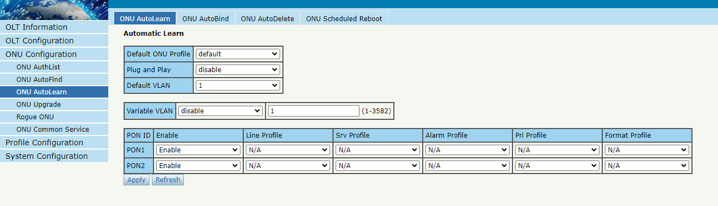
Figure 4.3-1: Automatic learn

4.3.2 ONU AutoBind
ConfigurationAutoLearnONU AutoBind
Input the Equipment ID and bind the profile you need
Note: you must create profile first.
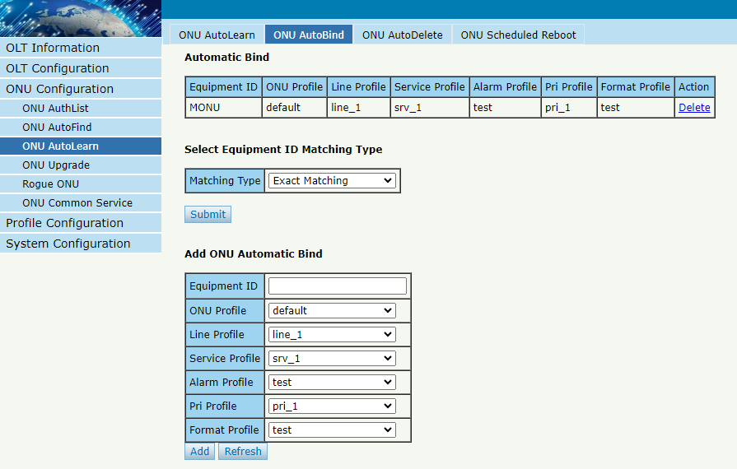
Figure 4.3-2: Bind profile

4.3.3 ONU AutoDelete
ConfigurationAutoLearnONU AutoDelete
After this function is enabled, ONU registrations that are offline but remain offline for a certain period of time will be deleted.
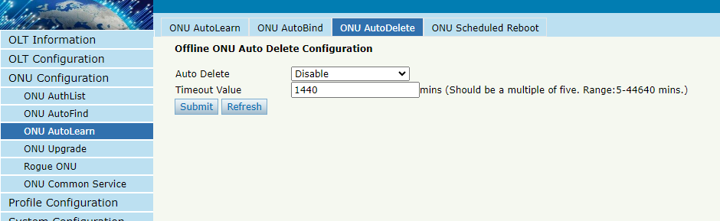Figure 4.3-3: ONU AutoDelete

4.3.4 ONU Scheduled Reboot
ConfigurationAutoLearnONU Scheduled Reboot
Through this page, you can set the scheduled restart function of ONU, it can specify one or more ONU to restart at a certain time.
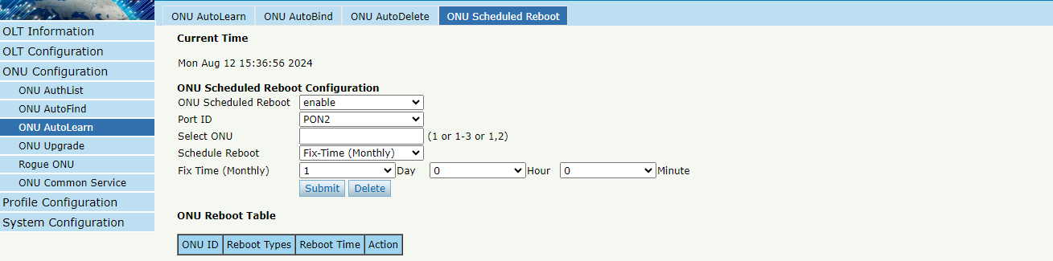
Figure 4.3-4: ONU Scheduled Reboot

4.4 ONU Upgrade
ONU firmware can be upgraded by OLT. OLT supports manual upgrade and automatic upgrade.

4.4.1 UpLoad Image
ConfigurationONU UpgradeONU Image
Upload ONU firmware image which you need, the image will upload to OLT’s RAM.
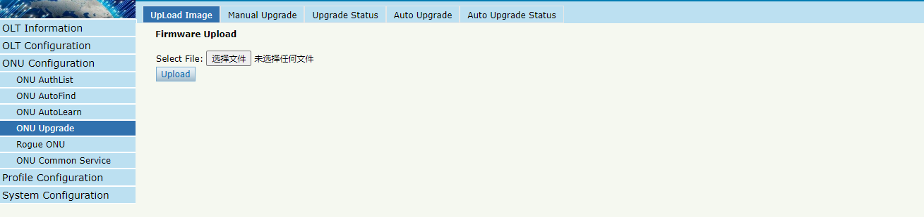
Figure 4.4-1: Upload image

4.4.2 Manual Upgrade
ConfigurationONU UpgradeManual Upgrade
Select the ONU image and the ONU that need upgrade, click commit button to start upgrading. You can upgrade the ONU under one PON port everytime.
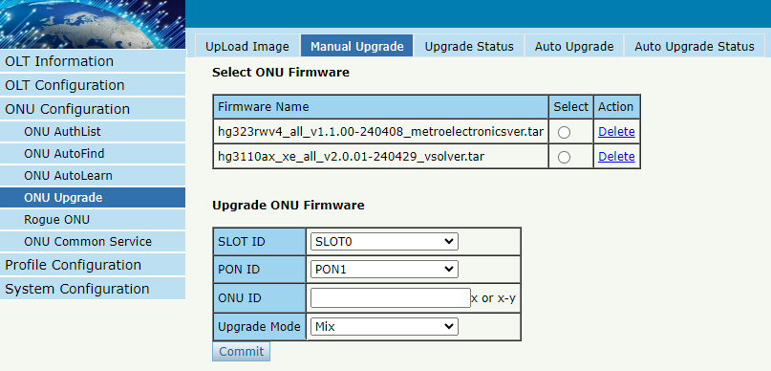Figure 4.4-2: Manual Upgrade

4.4.3 Upgrade Status
ConfigurationONU UpgradeUpgrade Status
When ONU is upgrading, the upgrading status will be shown on this page.
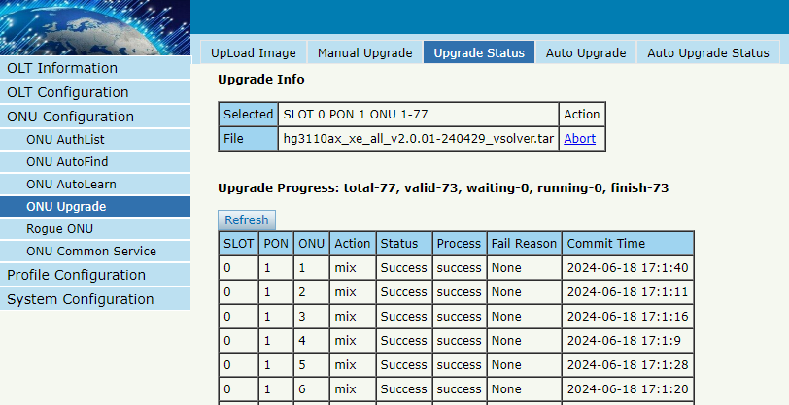
Figure 4.4-3: ONU Upgrade Status

4.4.4 Auto Upgrade
ConfigurationONU UpgradeAuto Upgrade
After uploaded the ONU firmware image, configured automatic upgrade conditions, once the ONU which has the same equipment ID and different software version come online, they will be upgraded automatically.
Each ONU has its own equipment ID, which you can check in ONU detail info. Software version is the firmware image version which has uploaded to the OLT.
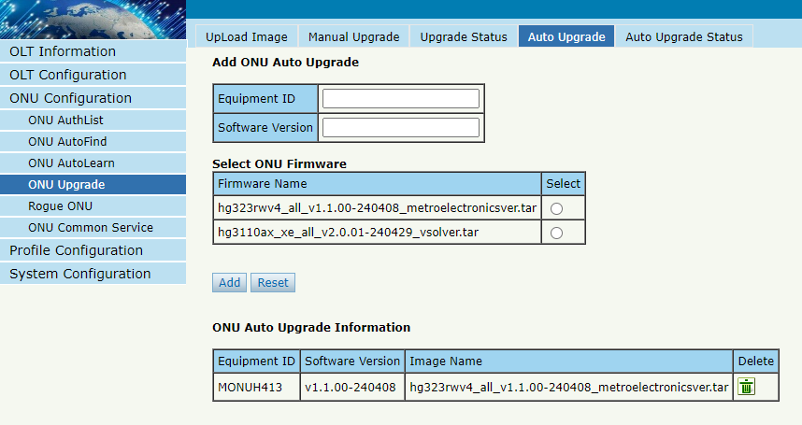
Figure 4.4-4: Auto Upgrade

4.4.5 Auto Upgrade Status
ConfigurationONU UpgradeAuto Upgrade Status
When ONU is auto upgrading, the upgrading status will be shown on this page.
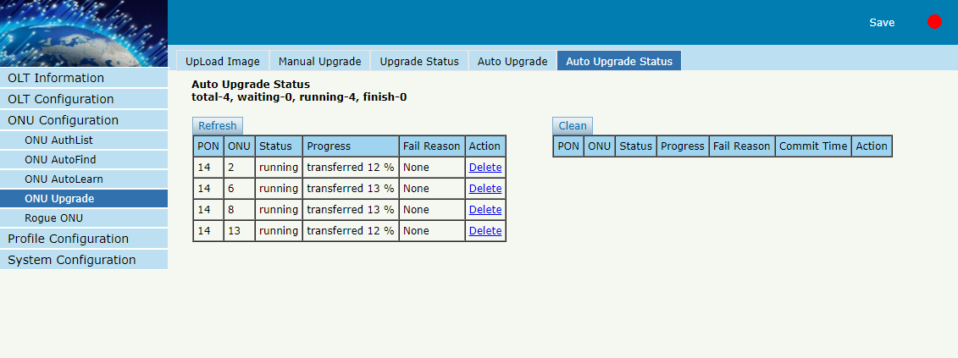

Figure 4.4-5: Auto Upgrade Status

4.5 Rogue ONU
ONU ConfigurationRogue ONU
After enabled rogue ONU detect, if there is a rogue ONU trying to register, it will appear in the list.
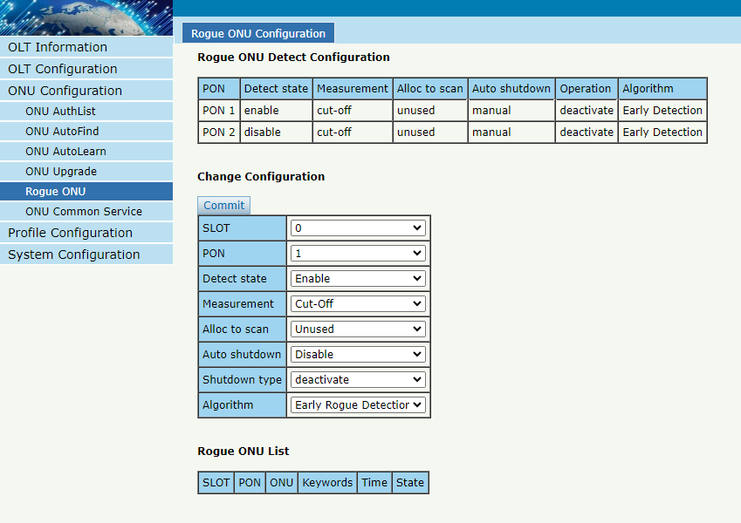
Figure 4.5-1: Rogue ONU detect

4.6 ONU Common Service
ONU ConfigurationONU Common Service
You have more flexibility to create TCONT ID, Gemport, Service, Service port and Port Vlan for the specified ONU you select.
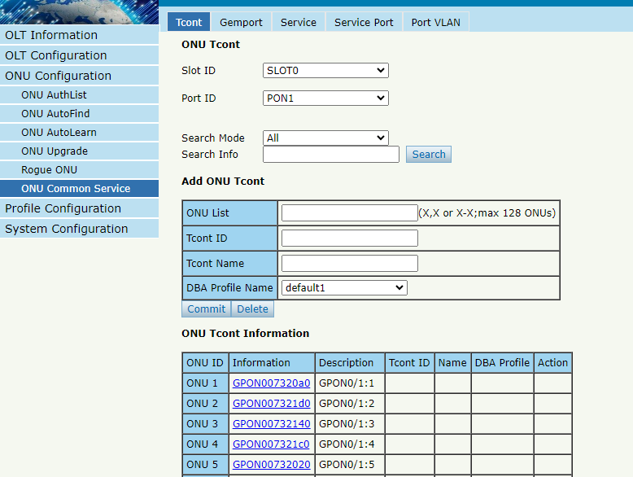
Figure 4.6-1: Create TCONT ID

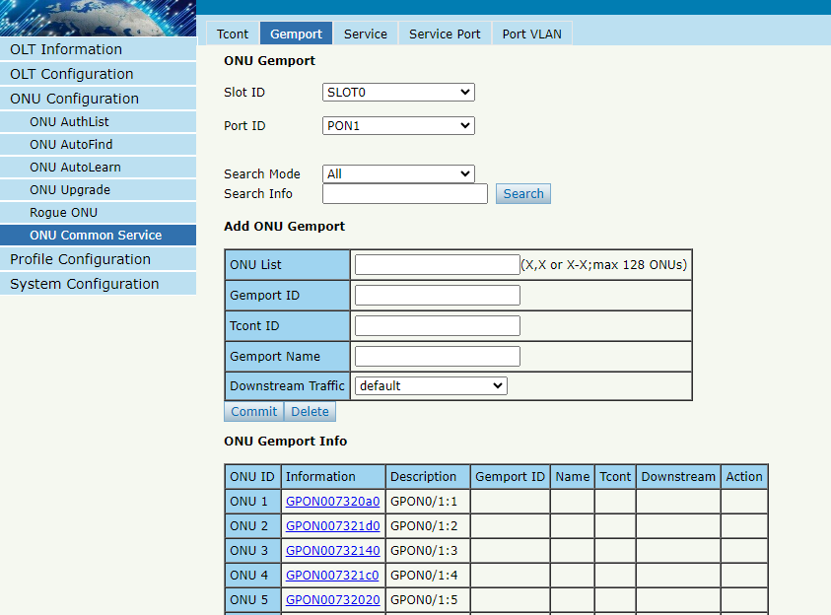
Figure 4.6-2: Create Gemport

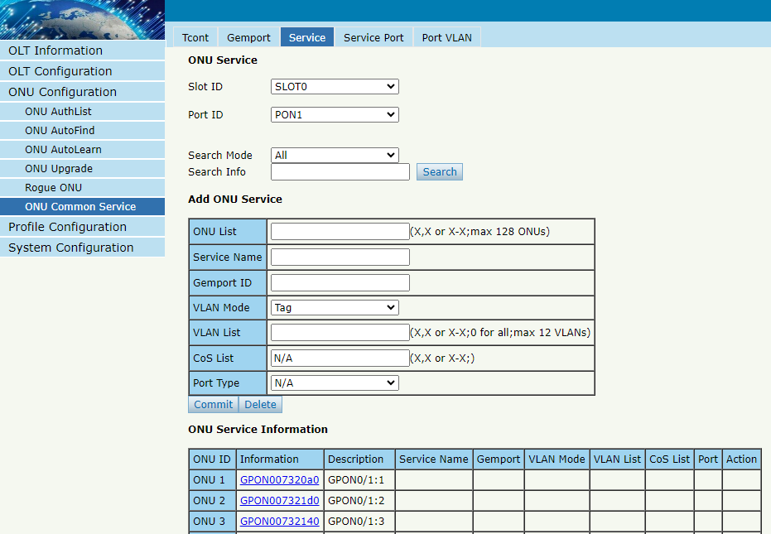
Figure 4.6-3: Create Service
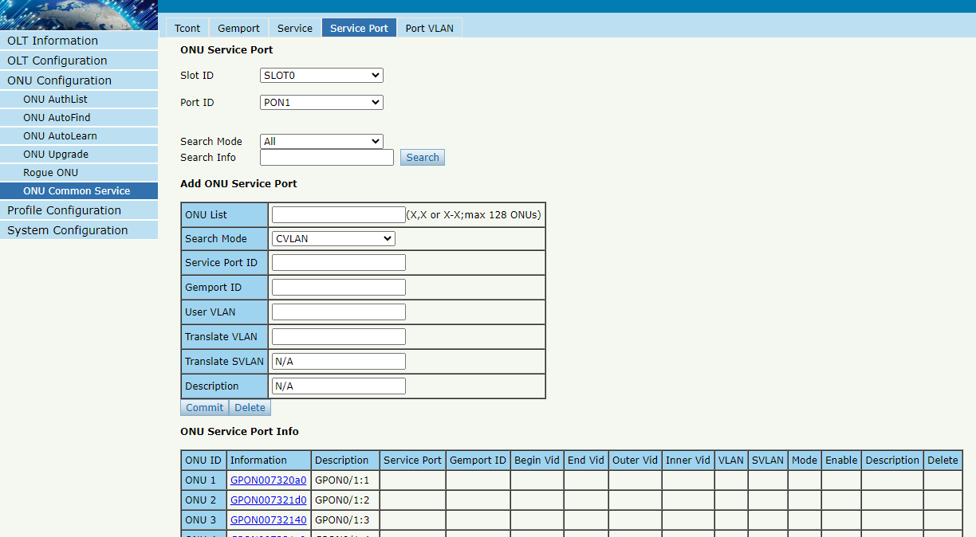
Figure 4.6-4: Create Service port

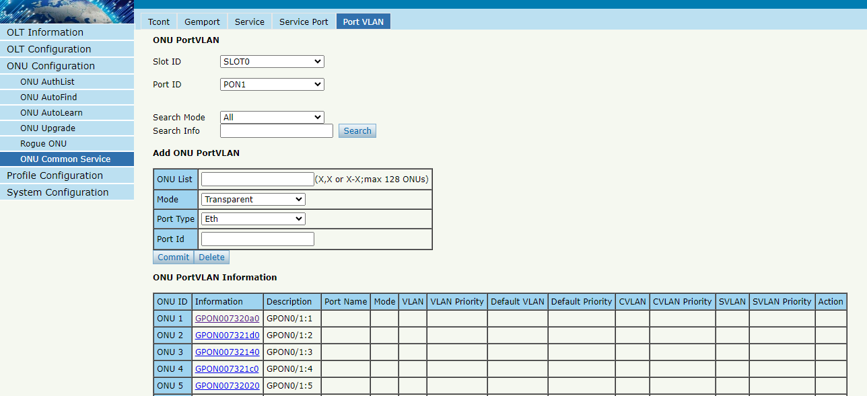
Figure 4.6-5: Create Port Vlan

Chapter 5 Profile Configuration
This chapter is about the ONU profile configuration. It is designed for batch ONU management by OLT.

5.1 ONU Profile
The ONU profile is used for ONU authorization, and each ONU must specify only one ONU profile when authorization. The ONU profile specifies the capability of this ONU.

5.1.1 Information
Profile Configuration ONU profileInformation
The table displays ONU profile list. You can also do some operations, such as delete and check details info.
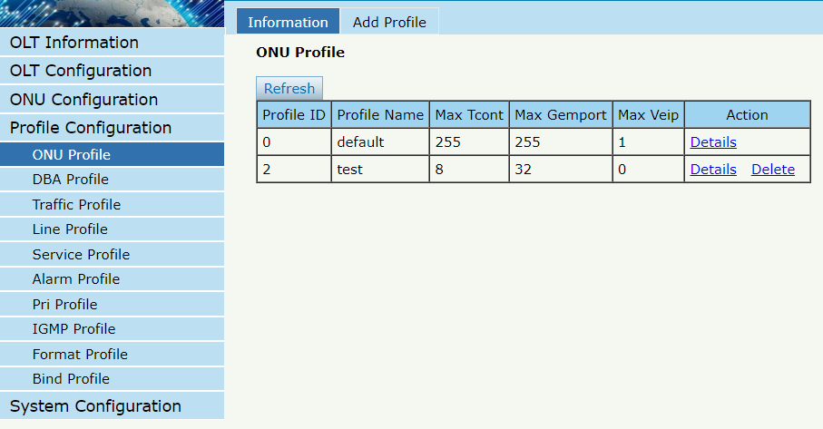
Figure 5.1-1: ONU profile list

5.1.2 Add profile
Create a new ONU profile what you need. Generally, ONU has two different modes.
SFU mode (only using bridge mode):
Usually, only need to set correct eth port and POTS port number of ONU, others can be kept default.
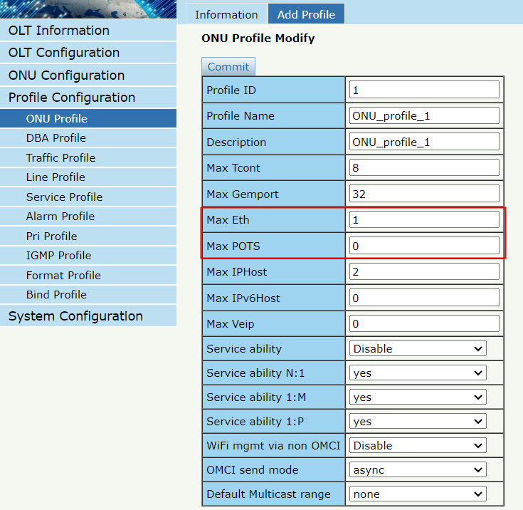
Figure 5.1-2: Add SFU profile
HGU mode (with the routing wan connection mode):
For HGU mode, need to set correct eth port and POTS port number and set veip to be 1, keep others default.
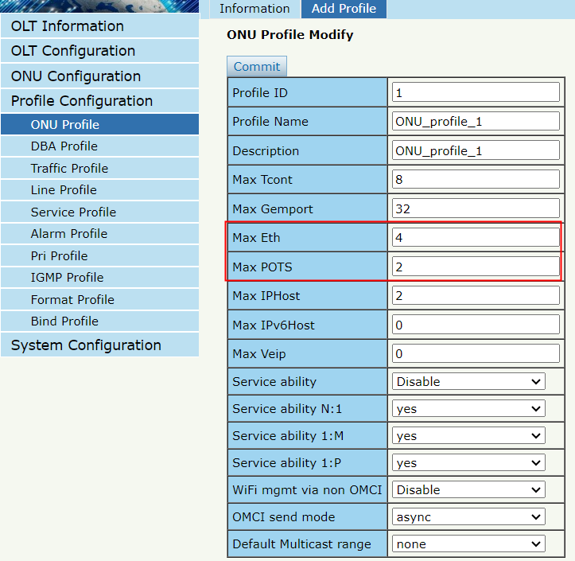
Figure 5.1-3: Add HGU profile

5.2 DBA Profile
DBA is a bandwidth allocation strategy that changes uplink bandwidth assigned to each T-CONT in real time according to the instant service status of each ONU. There are five BW types supported and make sure that fixed <= assured <= max.

5.2.1 DBA profiles
Profile ConfigurationDBA Profile DBA Profiles
The table displays DBA profile list. You can also do some operations, such as delete and modify.Default1 Profile defines bandwidth allocation for each of the three modes.
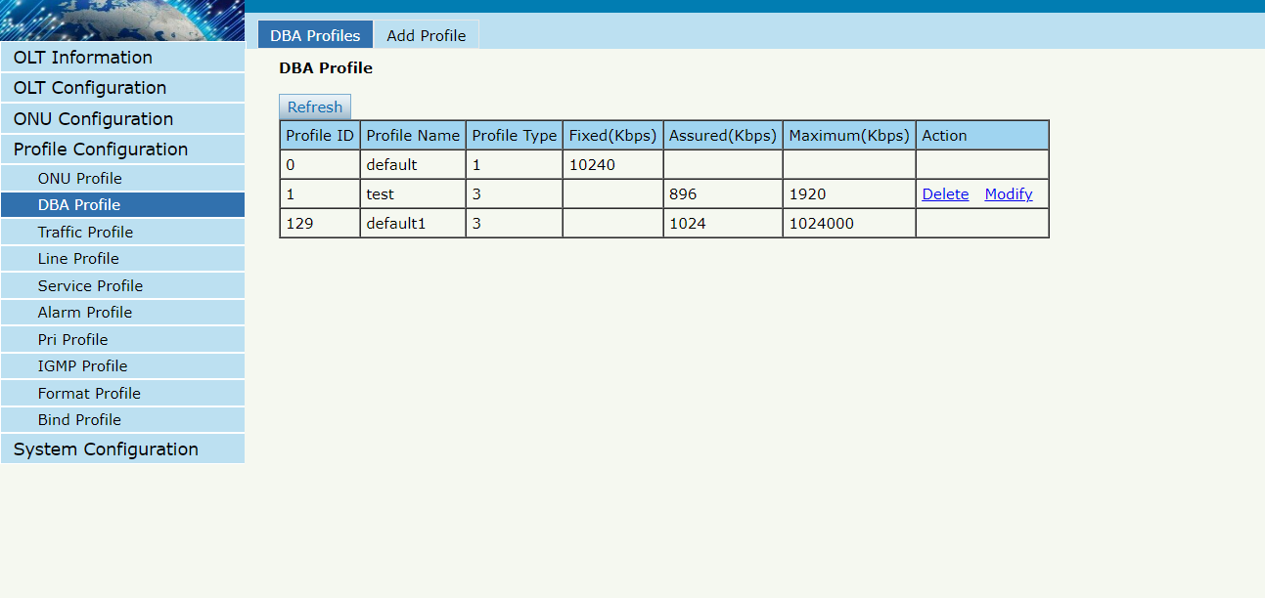
Figure 5.2-1: DBA profile list

5.2.2 Add profile
Profile ConfigurationDBA Profile Add profile
There are five types of DBA profile. In general, we use type3.
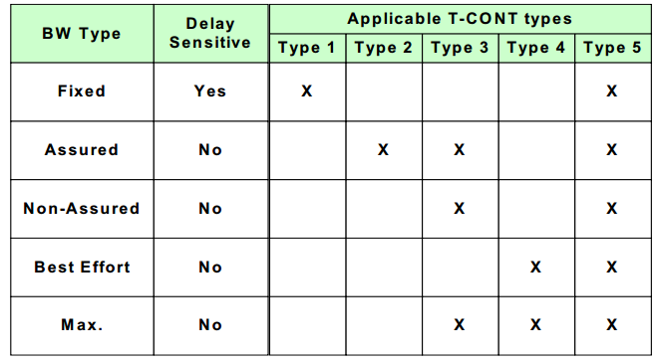
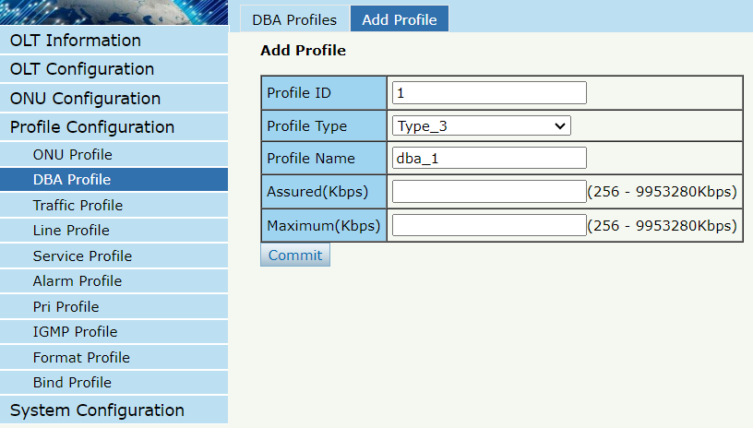
Figure 5.2-2: Add a DBA profile

5.3 Traffic Profile
Traffic profile is used by gemport to specify the upstream/downstream bandwidth.

5.3.1 Traffic profiles
Profile ConfigurationTraffic Profile Traffic Profiles
The table displays Traffic profile list. You can also do some operation, such as delete and modify.
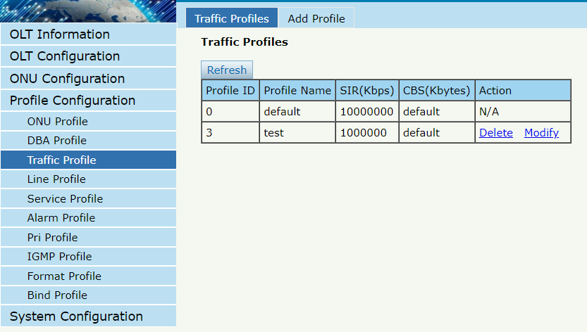
Figure 5.3-1: Traffic Profile list

5.3.2 Add profile
Profile ConfigurationTraffic Profile Add Profile
Configure gemport to specify the upstream/downstream bandwidth.
SIR: Committed Information Rate
CBS: Committed Burst Size
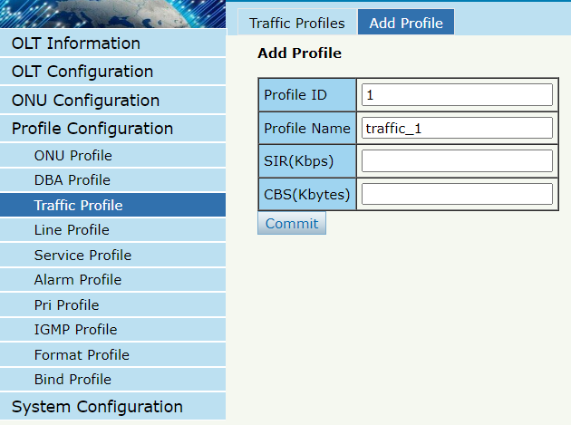
Figure 5.3-2: Add a traffic Profile

5.4 Line Profile
Line profile is used to configure the ANI side services of ONU such as t-cont, gem-port, service-port, and so on.

5.4.1 Line profile
Profile ConfigurationLine Profile Line Profile
The table displays Line profile list. You can also do some operations, such as delete and modify.
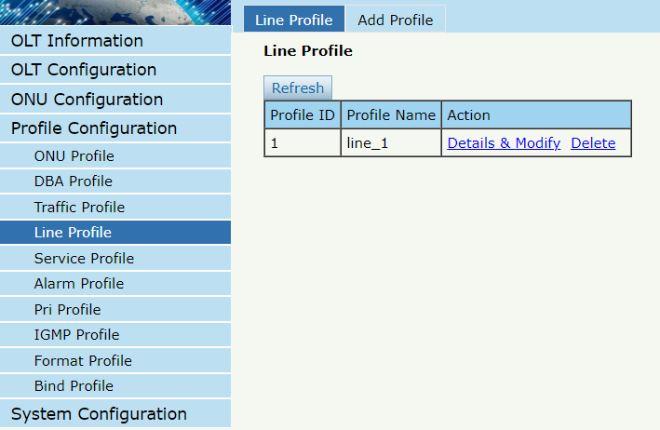
Figure 5.4-1: Line Profile list

5.4.2 Add profile
Profile ConfigurationLine profileAdd profile
Create a new line profile.
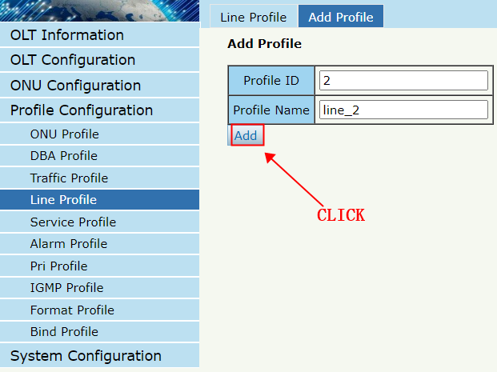
Figure 5.4-2: Add Line Profile
Modify the line profile parameters.
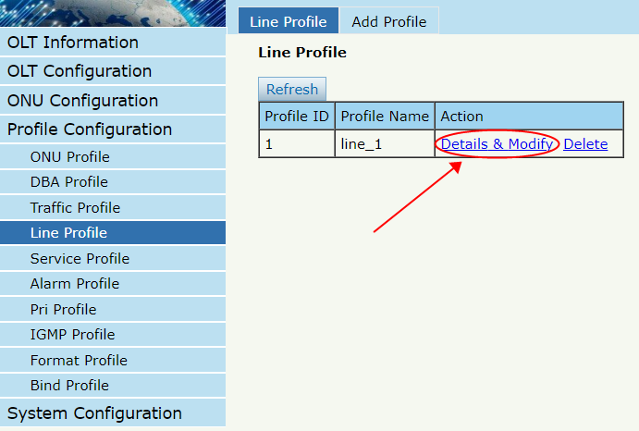
Figure 5.4-3: Modify Line Profile

5.4.2.1 Tcont
Add tcont ID and bind DBA profile.
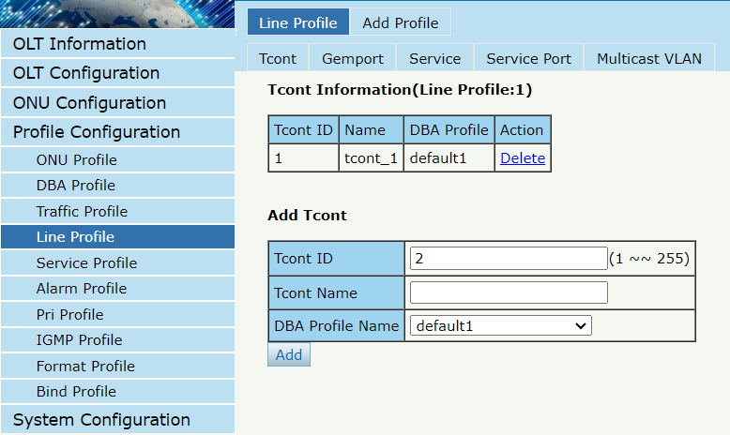
Figure 5.4-4: Add Tcont

5.4.2.2 Gemport
Add gemport ID and bind tcont ID.
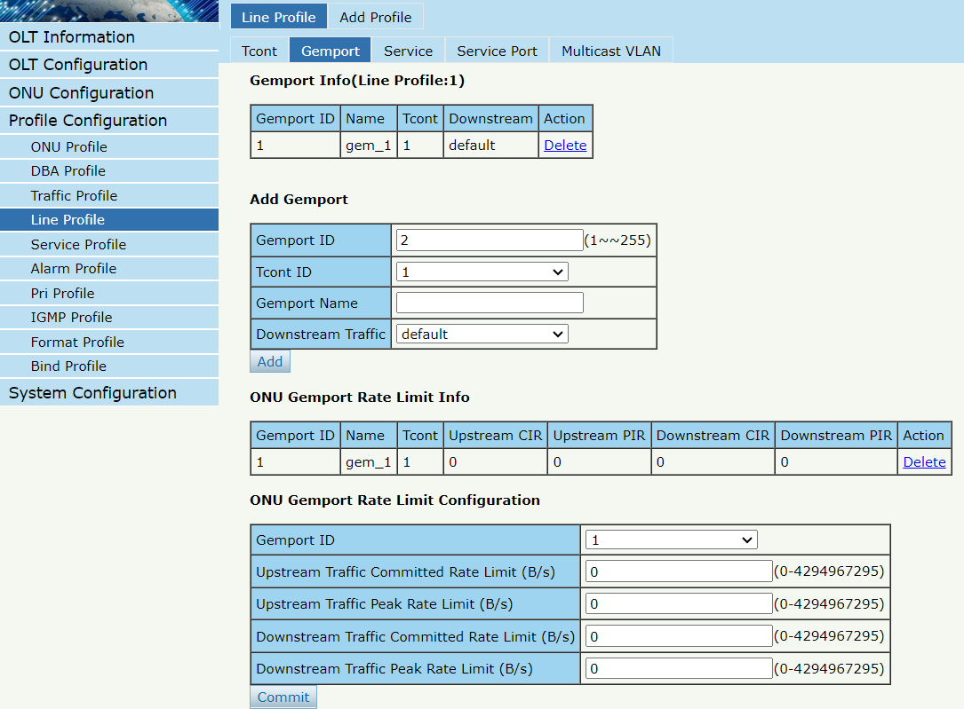
Figure 5.4-5: Add Gemport

5.4.2.3 Service
Add service, set the VLAN mode and VLAN ID and bind one gemport ID.
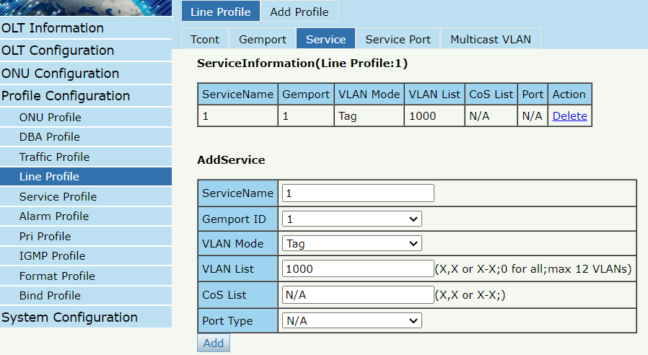
Figure 5.4-6: Add Service

5.4.2.4 Service Port
Create a service port, set the user VLAN and translate VLAN and bind one gemport ID. If don’t need VLAN translation, just set translate VLAN the same as user VLAN.

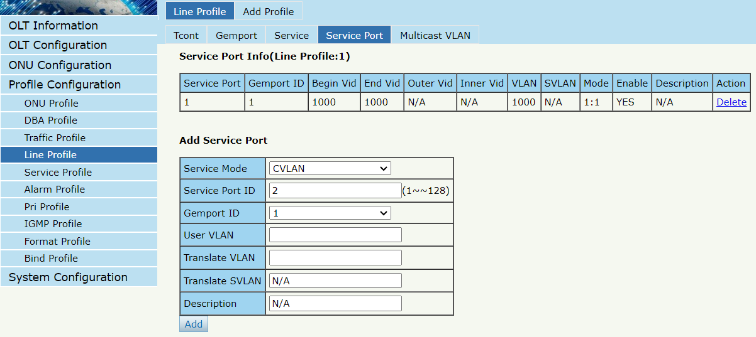
Figure 5.4-7: Add Service Port

5.4.2.5 Multicast Vlan
Set the Multicast VLAN of ONU.
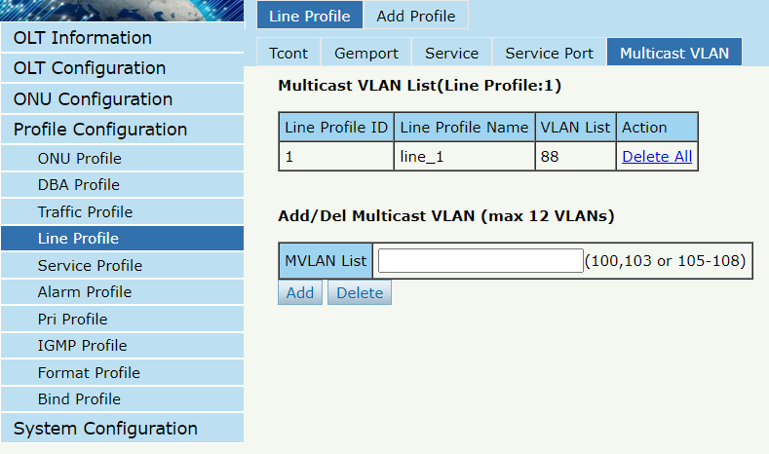
Figure 5.4-8: Configure Multicast VLAN

5.5 Service Profile
Service profile is used to configure the UNI side services of onu, such as Ethernet port, wifi, veip, and so on.

5.5.1 Service profile
Profile ConfigurationService Profile Service Profile
The table displays service profile list. You can also do some operations, such as delete and modify.
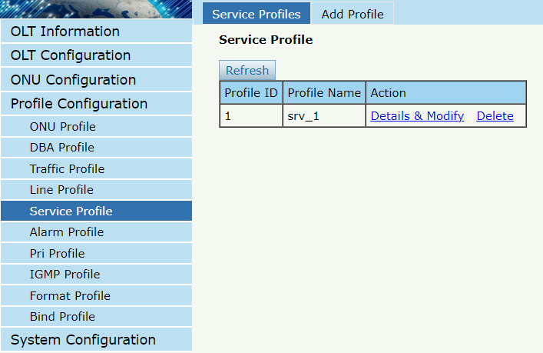
Figure 5.5-1: Service Profile List

5.5.2 Add profile
Profile ConfigurationService Profile Add Profile
Add a new service profile.
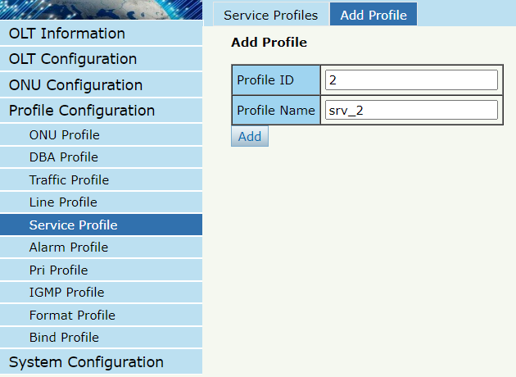
Figure 5.5-2: Add Service profile
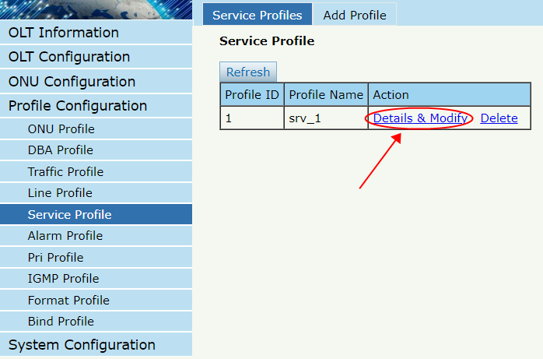
Figure 5.5-3: Modify Service Profile

5.5.2.1 PortVlan
Set the VLAN mode of the ONU’s port. For HGU, need to configure veip 1 transparent; for SFU, configure Ethernet port directly.
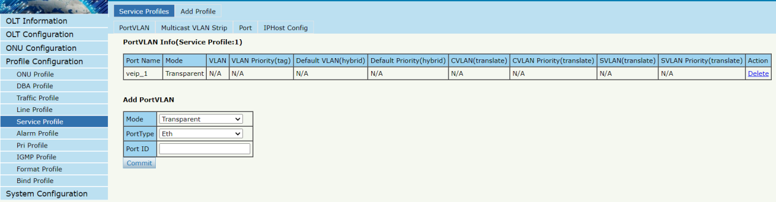
Figure 5.5-4: Port VLAN mode

5.5.2.2 Multicast Vlan Strip
Set the multicast VLAN mode of ONU’s port.
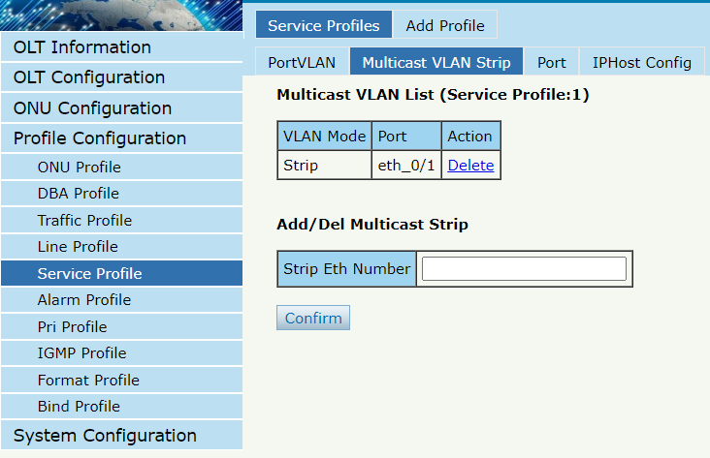
Figure 5.5-5: Port Multicast VLAN Mode

5.5.2.3 Port
Configure the status and rate of the onu port
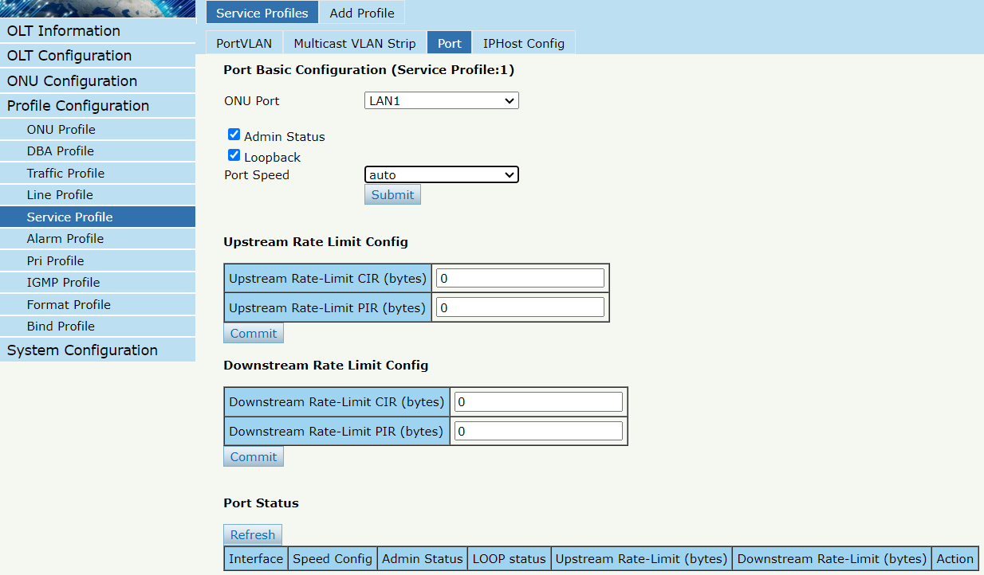
Figure 5.5-6: Port status

5.5.2.4 Iphost Config
Add Iphost for ONU wan connection. IPhost is used for ONU management.
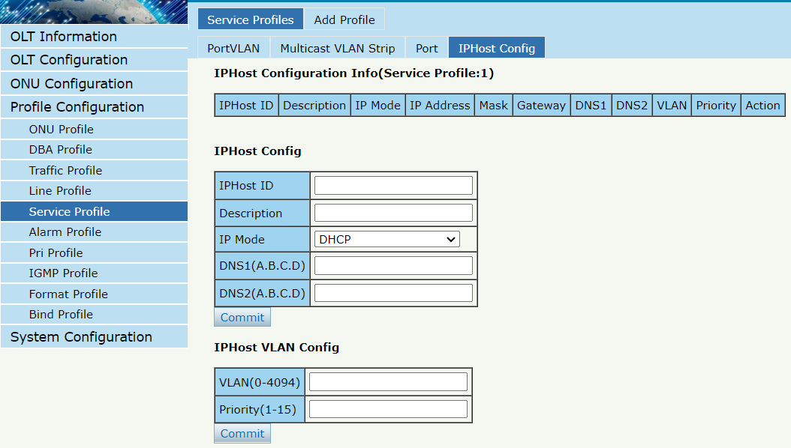
Figure 5.5-7: Add IPhost

5.6 Alarm Profile
Alarm profile is used to configure the parameters of ONU alarm.

5.6.1 Profile Infomation
Profile ConfigurationAlarm Profile profile infomation
The table displays alarm profile list.
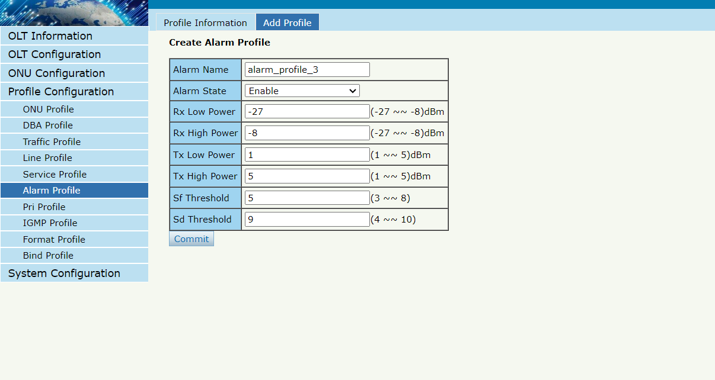
Figure 5.6-1: Alarm Profile List

5.6.2 Add Profile
Profile ConfigurationAlarm Profile Add profile
Add new alarm profile, set the threshold of alarm generation.
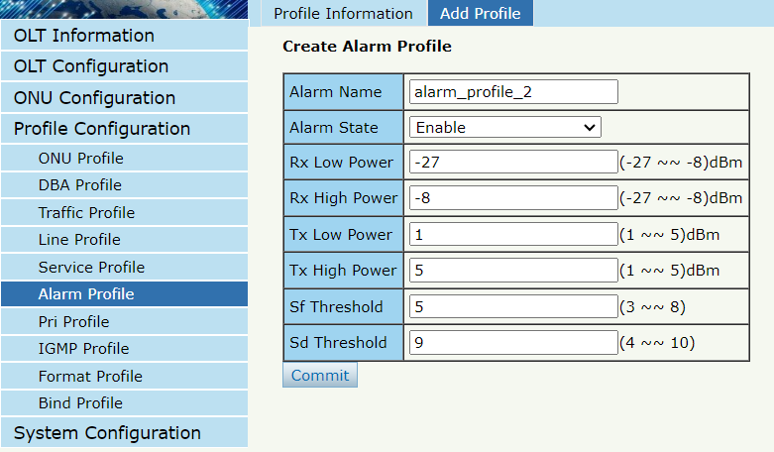
Figure 5.6-2: Add Alarm Profile

5.7 Pri Profile
Pri Profile is the profile which the parameters are configured by private OMCI, including WAN, SIP, WIFI, CATV, DHCP Server, and so on.

5.7.1 Pri Profile
Profile ConfigurationPri Profile
The table displays private profile list. You can also do some operations, such as delete and modify.
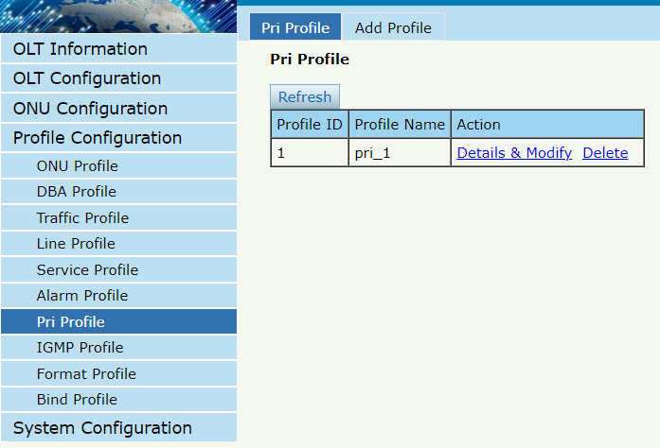Figure 5.7-1: Pri Profile

5.7.2 Add Profile
Profile ConfigurationPri Profile Add profile
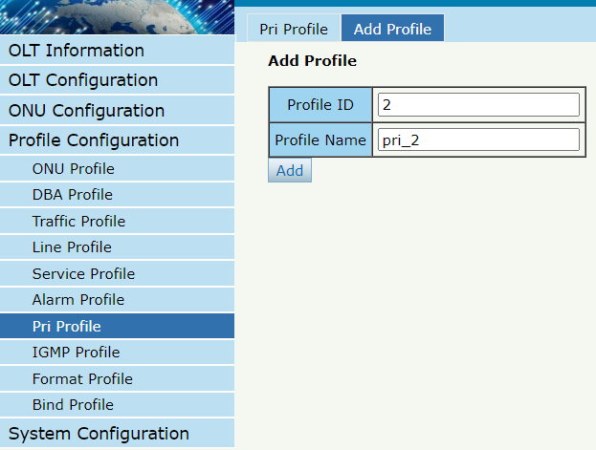
Figure 5.7-2: Add Private Profile

5.8 IGMP Profile
IGMP profile is used to configure the parameters of ONU multicast .

5.8.1 IGMP Profile
Profile ConfigurationIGMP Profile IGMP Profile
The table displays IGMP profile list.
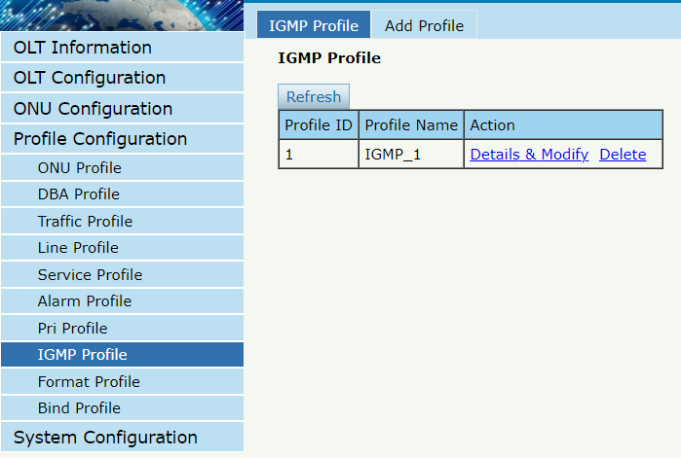
Figure 5.8-1: IGMP Profile List

5.8.2 Add Profile
Profile ConfigurationIGMP Profile Add profile
Add new IGMP profile, set the threshold of alarm generation.
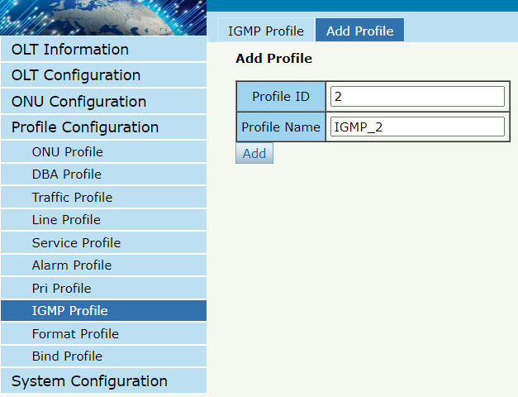
Figure 5.8-2: Add IGMP Profile

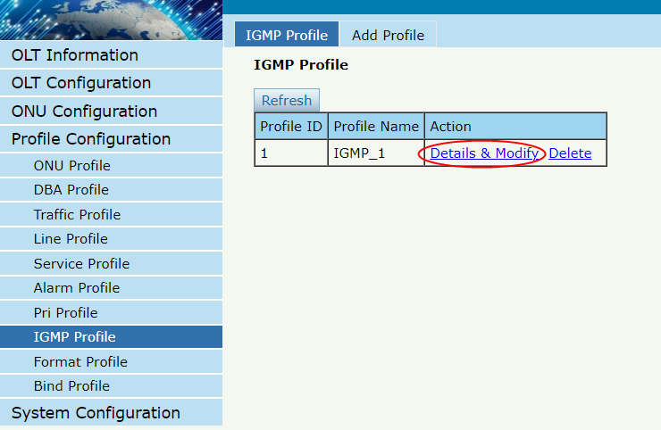
Figure 5.8-3: Modify IGMP Profile

5.8.2.1 Config
Configure multicast related data.
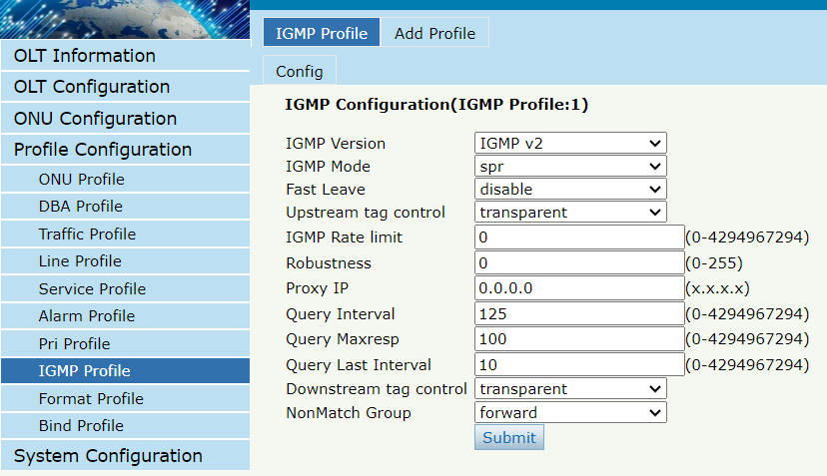
Figure 5.8-4: Config

5.9 Format Profile
Format profile is used to configure the parameters of ONU DHCP related information .

5.9.1 Format Profile
Profile ConfigurationFormat Profile Format Profile
The table displays Format profile list.
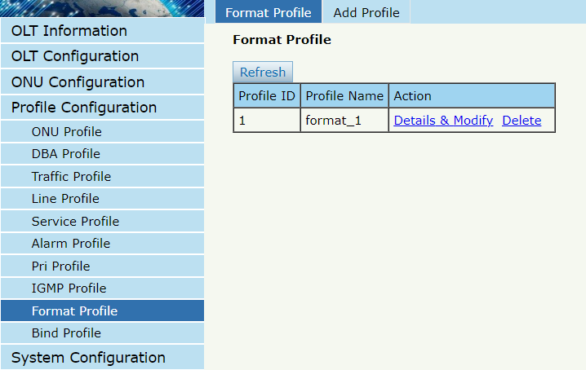
Figure 5.9-1: Format Profile List

5.9.2 Add Profile
Profile ConfigurationFormat Profile Add profile
Add new Format profile.
Figure 5.9-2: Add Format Profile

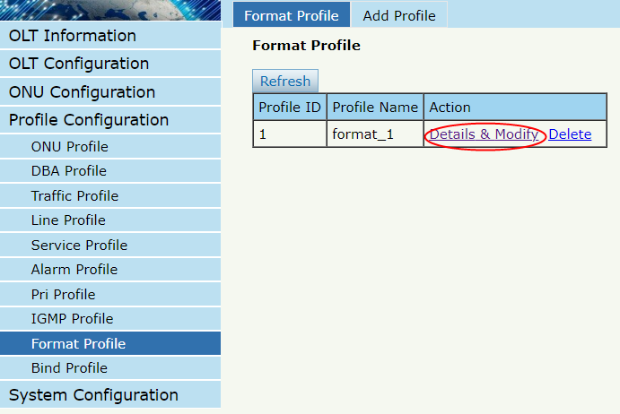
Figure 5.9-3: Modify Format Profile

5.9.2.1 Config
Configure Format related data.
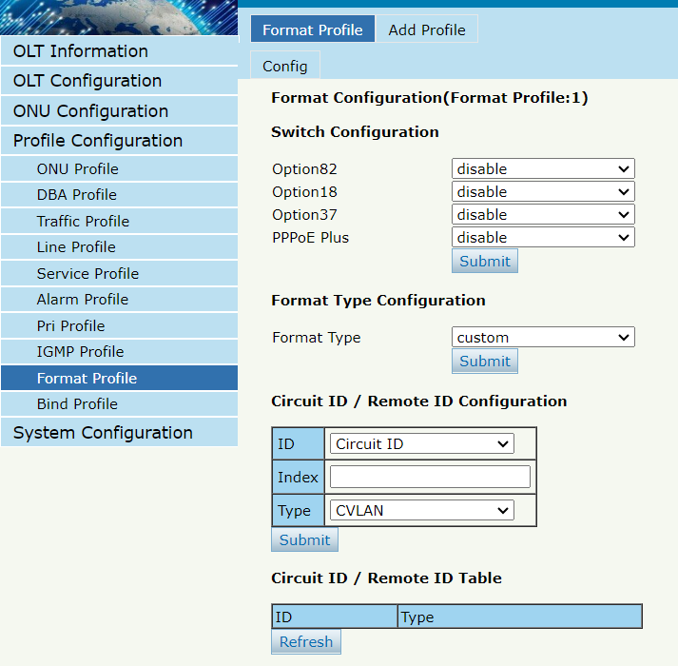
Figure 5.9-4: Config

5.10 Bind Profile
After profile is configured, it is necessary to bind it to ONU.
Profile ConfigurationBind Profile
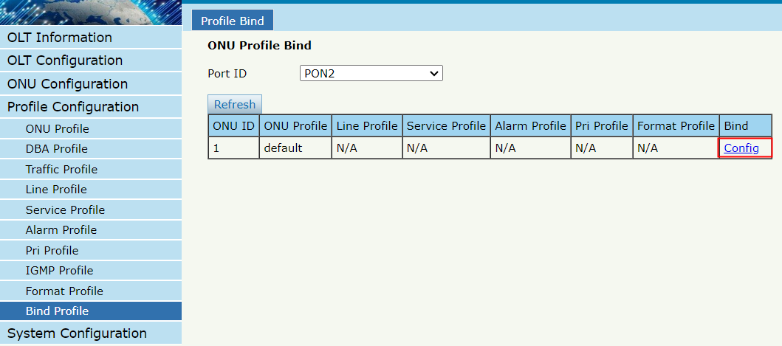
Figure 5.10-1: Bind profile
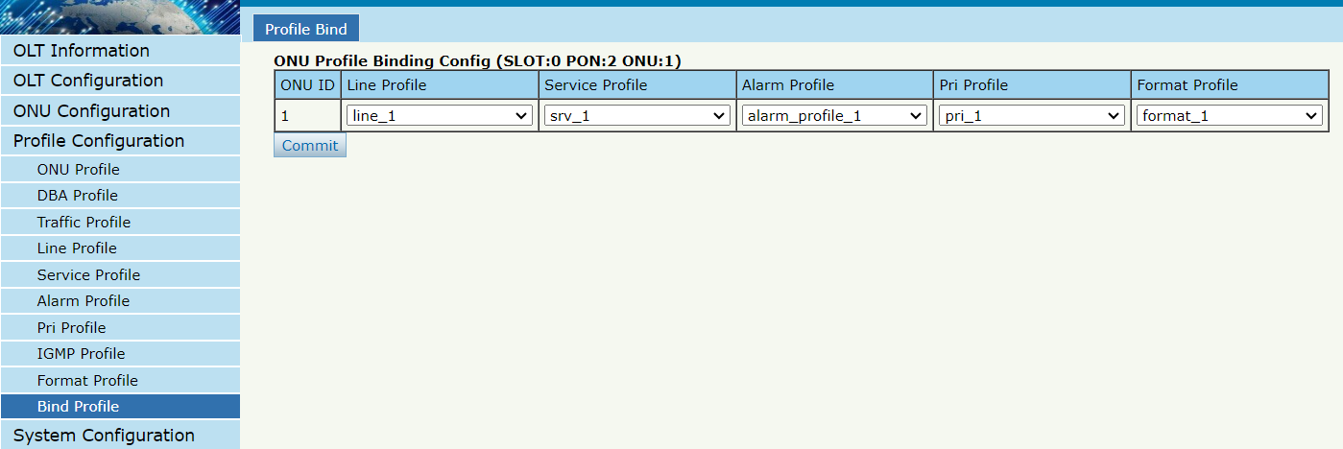
Figure 5.10-2: Select Profile

Chapter 6 System Configuration
This chapter is about the global management of OLT.

6.1 System Log

6.1.1 System Log
System ConfigurationSystem Log
This page displays OLT system alarms and events.
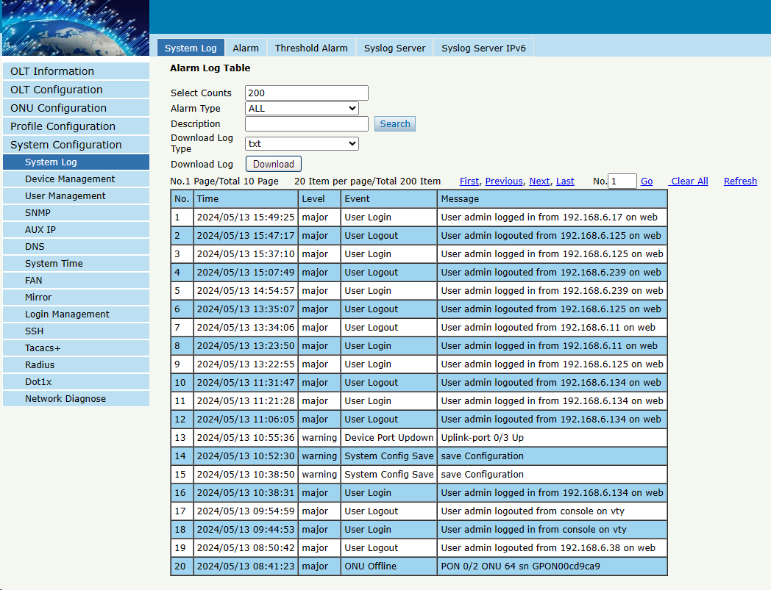
Figure 6.1-1: System Log

6.1.2 Alarm
System Configuration System Log Alarm
It contains all the alarms of OLT. User can choose the different alarms to "Print", "Record", "Trap" and "Remote".
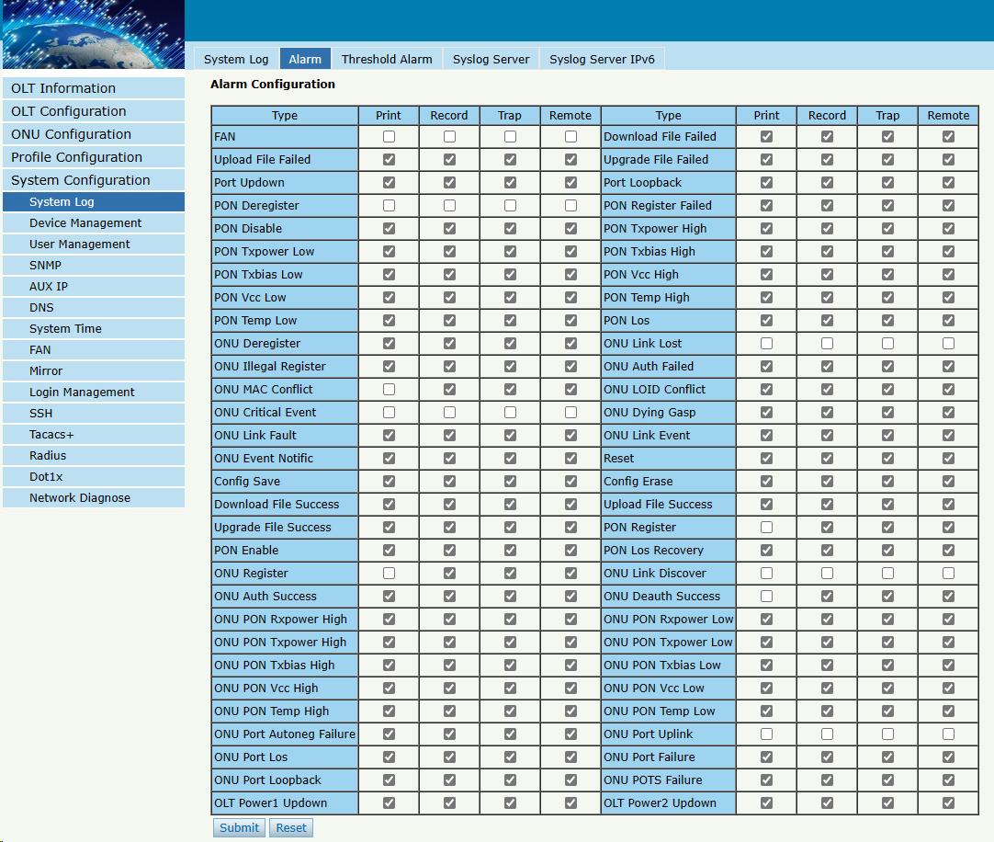
Figure 6.1-2: Alarm
options | Illustration
Print | Alarm and event show in console and telnet, but not show in syslog, EMS and remote log server.
Record | Alarm and event show in syslog, but not show in console, telnet, EMS and remote log server.
Trap | Alarm and event show in EMS, but not show in console, telnet, syslog and remote log server.
Remote | Alarm and event show in remote log server, but not show in console, telnet, syslog and EMS.

6.1.3 Threshold Alarm
System Configuration System Log Threshold Alarm
This page is used to configure OLT temperature threshold, CPU-usage threshold and memory- usage threshold, PON optical threshold.
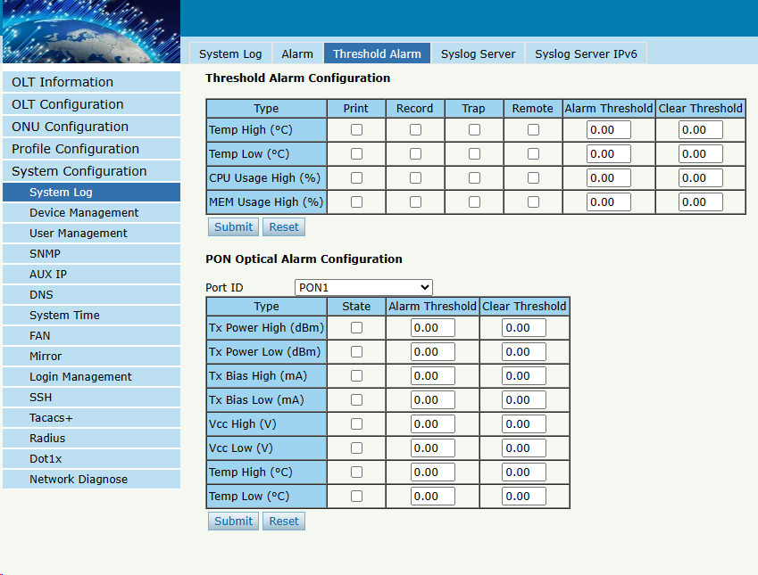
Figure 6.1-3: Threshold Alarm

6.1.4 Syslog Server
System ConfigurationSystem Log Syslog Server
This page is used to configure remote IPv4 server of OLT system log.
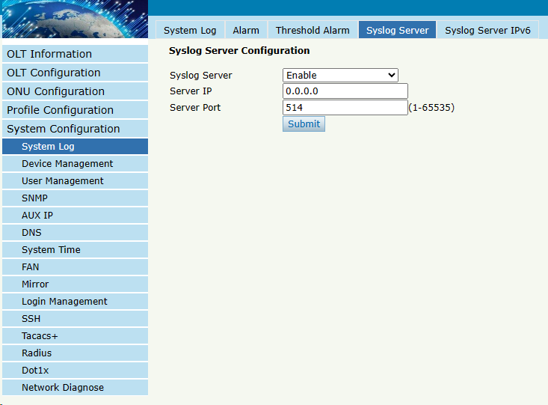
Figure 6.1-4: Syslog Server

6.1.5 Syslog Server IPv6
System ConfigurationSystem Log Syslog Server IPv6
This page is used to configure remote IPv6 server of OLT system log.
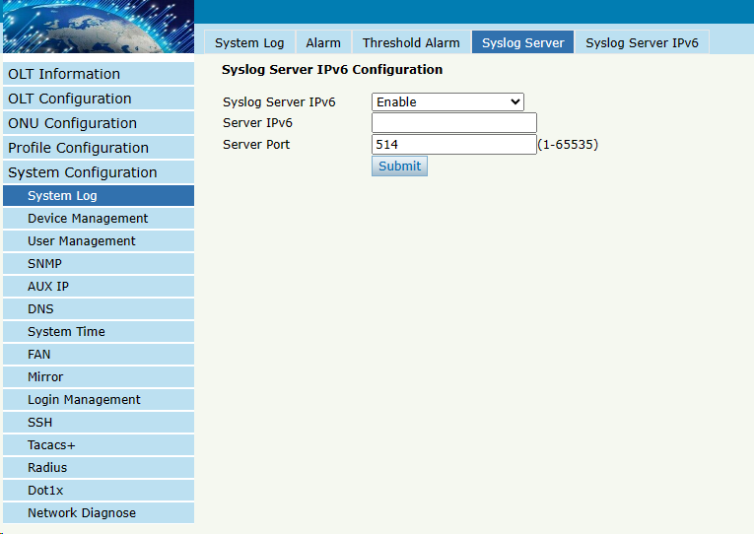
Figure 6.1-5: Syslog Server IPv6

6.2 Device Management

6.2.1 Firmware Upgrade
System ConfigurationDevice Management Firmware Upgrade
You can upgrade the OLT firmware on this page. OLT will reboot automatically with the new firmware after upgraded.
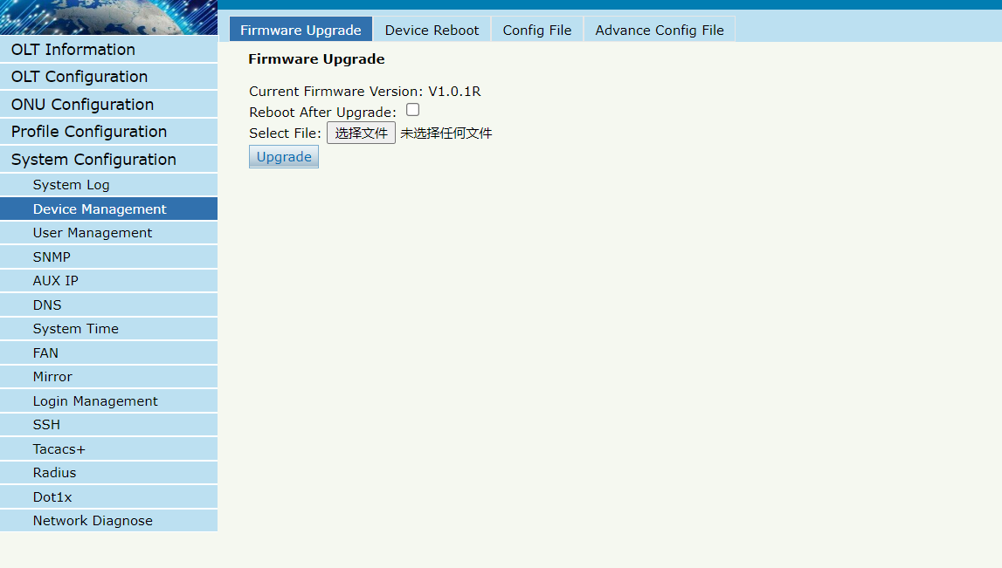
Figure 6.2-1: Firmware Upgrade

6.2.2 Device Reboot
System ConfigurationDevice Management Device Reboot
You can reboot the entire system on this page. Please do save the configuration before reboot.

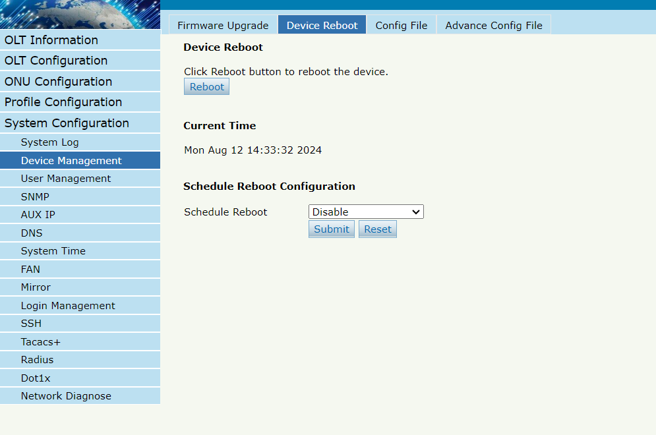
Figure 6.2-2: Device Reboot

6.2.3 Config File
System ConfigurationDevice Management Config File
You can backup configuration, restore configuration, restore factory defaults and save configuration on this page.
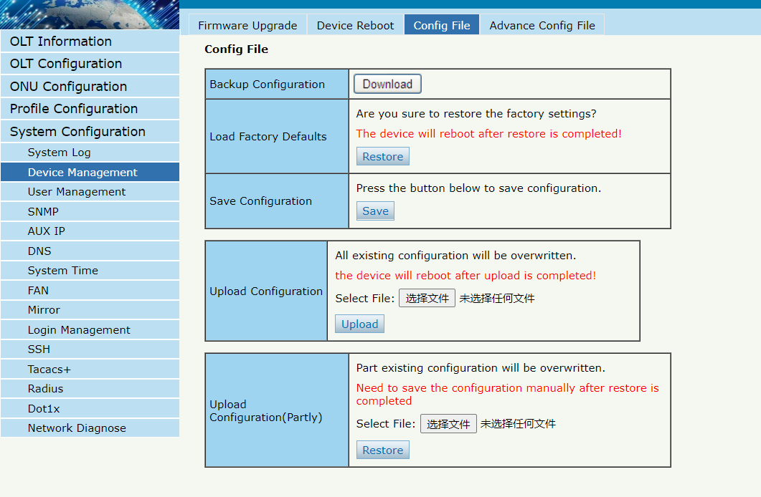
Figure 6.2-3: File Configuration

6.2.4 Advance Config File
System ConfigurationDevice Management Advance Config File
You can choose between periodic auto-save configuration and periodic auto-backup configuration, There are three modes: Timeout, Fix-Time and Week-Day.
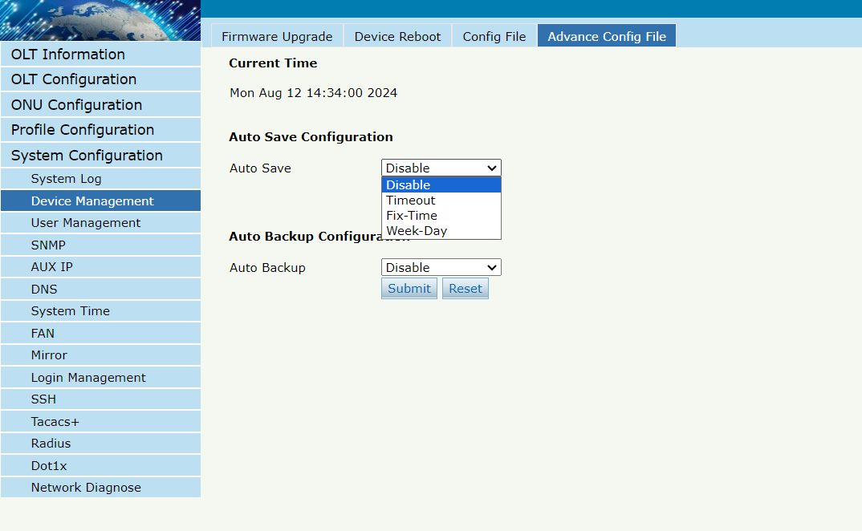
Figure 6.2-4: Auto Save

6.3 User Management

6.3.1 User manage
System ConfigurationUser managementUser manage
Two types of user have been defined, Normal and Admin. There are limitations to normal user, and Admin user has no limits to full function of OLT. The default account member is Admin level.
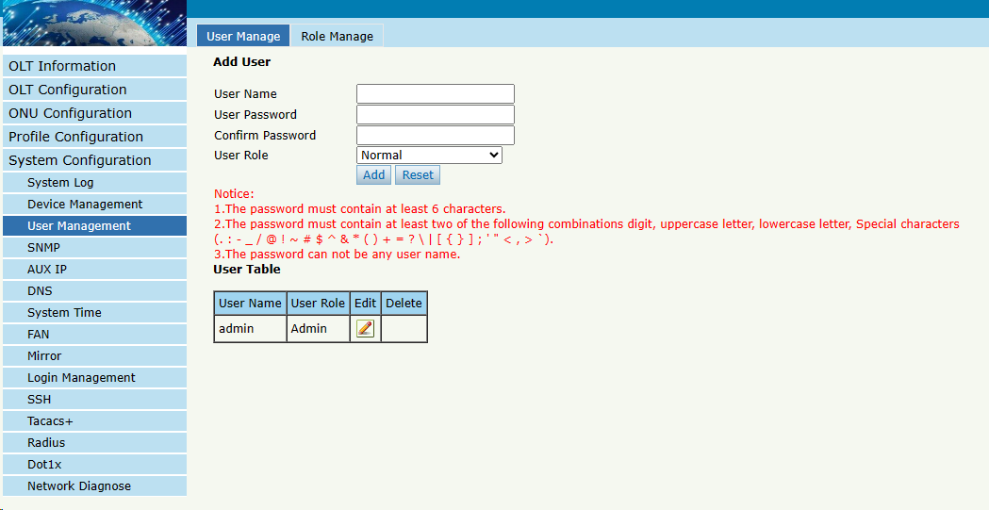
Figure6.3-1: User Manage

6.3.2 Role manage
System ConfigurationUser managementRole manage
You can add roles and assign different permissions to different roles.
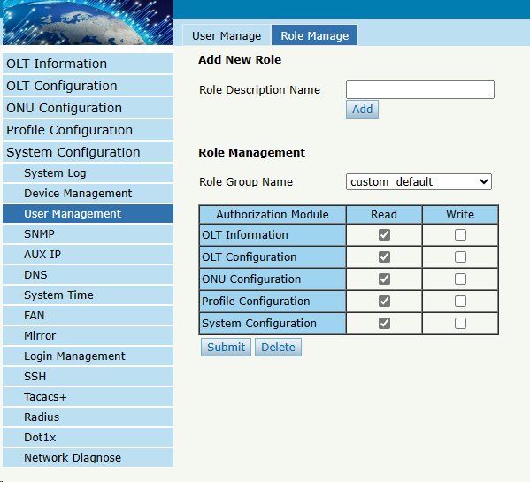
Figure6.3-2: Role Manage

6.4 SNMP

6.4.1 SNMP V1/V2
System Configuration SNMP SNMP V1/V2
This page is used to configure SNMP parameters of version 1 and version 2 for OLT management.
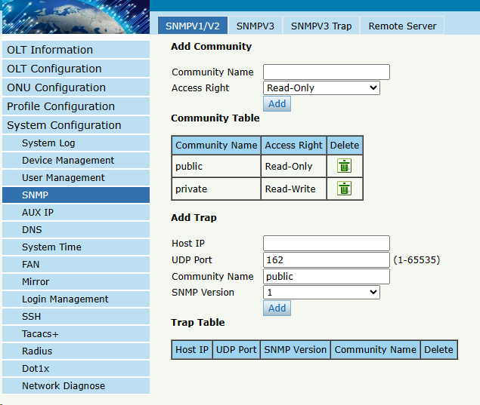
Figure6.4-1: SNMP V1/V2

6.4.2 SNMP V3
System Configuration SNMP SNMP V3
This page is used to configure SNMP parameters of version 3 for OLT management.
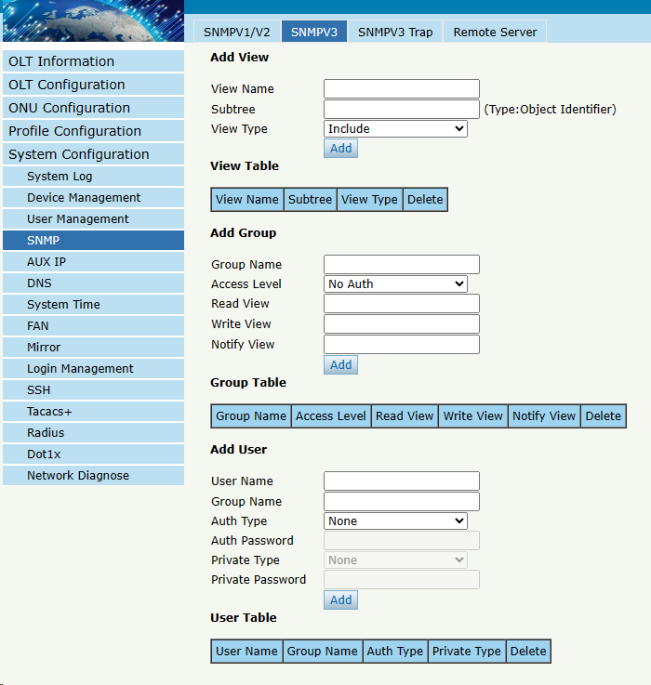
Figure6.4-2: SNMP V3

6.4.3 SMNP V3 Trap
System Configuration SNMP SNMP V3 Trap
Configure the target host IP address of trap messages.
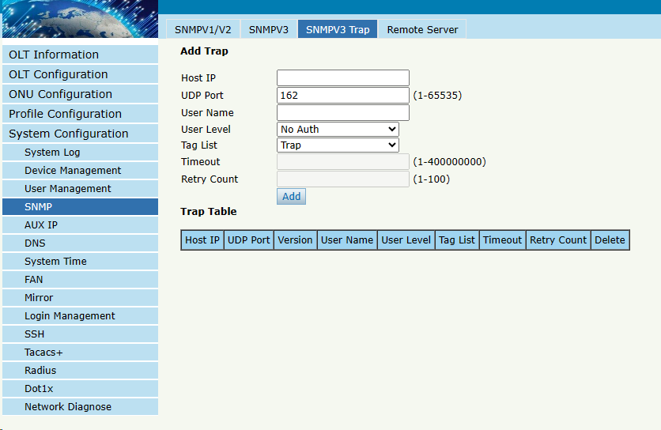
Figure 6.4-3: SNMP V3 Trap

6.4.4 Remote Server
System Configuration SNMP Remote Server
Configure the IP address of your SNMP network management server.
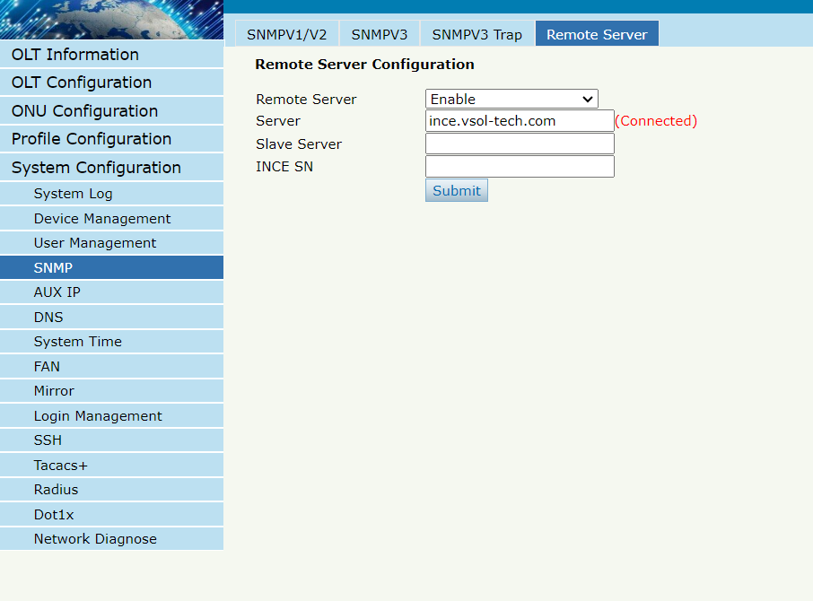
Figure 6.4-4: Remote Server

6.5 AUX IP

6.5.1 AUX IP
System Configuration AUX IP AUX IP
AUX port is out band management port. The IP address of aux port is out band management IP. Default IPv4 address is 192.168.8.200.
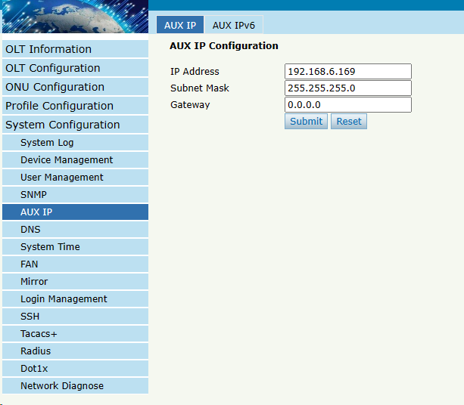
Figure 6.5-1: AUX IP

6.5.2 AUX IPv6
System Configuration AUX IP AUX IPv6
AUX port is out band management port. The IP address of aux port is out band management IP. By default, there is a link local address.
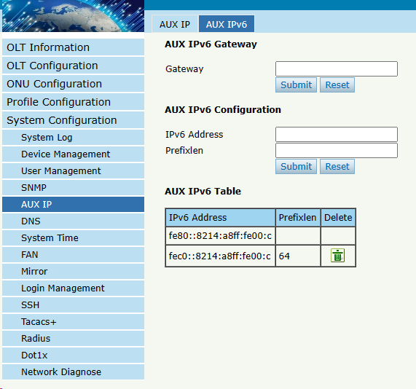
Figure 6.5-2: AUX IPv6

6. 6 DNS
DNS is used for domain name resolution. When OLT need to visit a site or a destination by domain, take NTP server for example, DNS is required.

6.6.1 IPv4 DNS
System Configuration DNS IPv4 DNS
This page is used to configure IPv4 DNS.
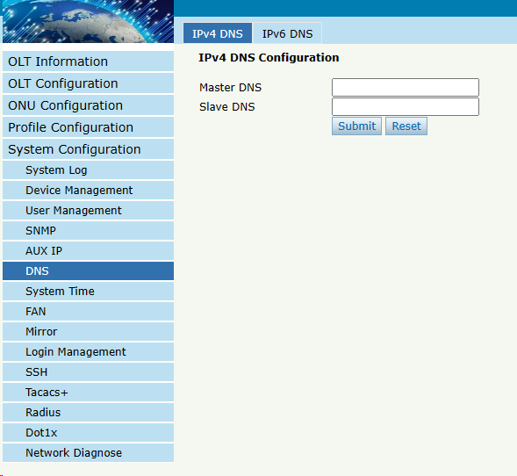
Figure 6.6-1: IPv4 DNS

6.6.2 IPv6 DNS
System Configuration DNS IPv6 DNS
This page is used to configure IPv6 DNS.
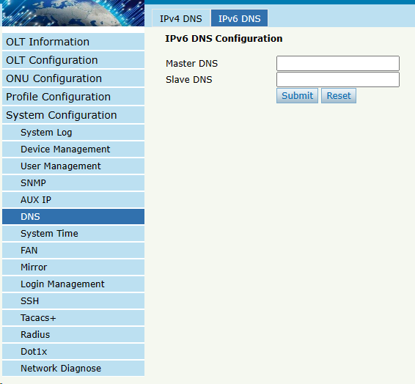
Figure 6.6-2: IPv6 DNS

6.7 System Time

6.7.1 RTC
System Configuration System TimeRTC
This page is used to set OLT system time. RTC stands for Real-Time Clock, it provides clock signal to the system. There is no battery inside OLT, so the time will not be saved after powered off.
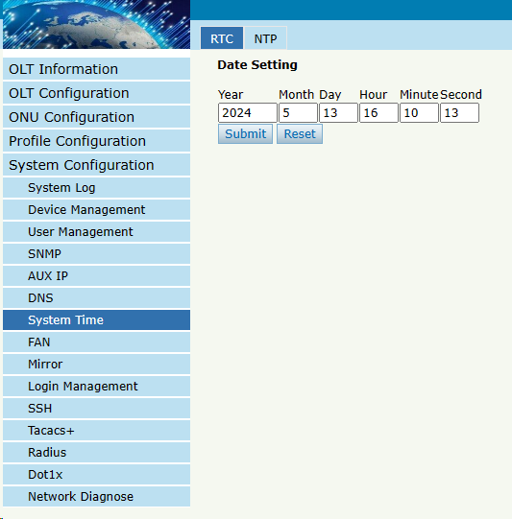
Figure 6.7-1: RTC Setting

6.7.2 NTP
System Configuration System TimeNTP
This page is used to configure NTP server. OLT will synchronize time with the NTP server at a given time.
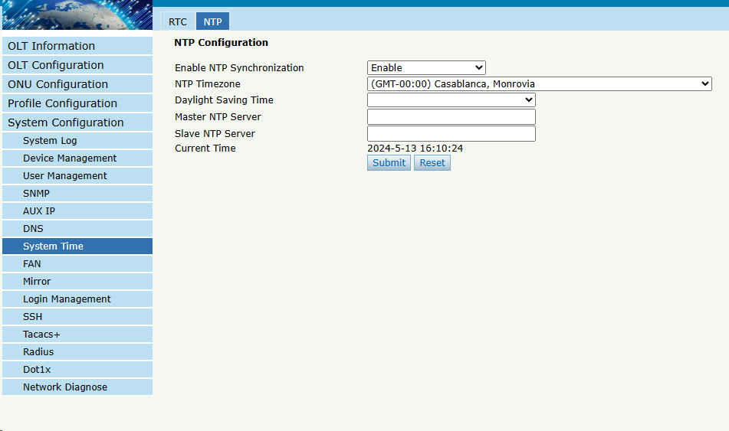
Figure 6.7-2: NTP Configuration

6.8 FAN
System Configuration FAN
The fans can be turned on and turned off manually; and also can be turned on and off automatically according to the temperature of OLT main chip.
This configuration will not be saved after reboot.
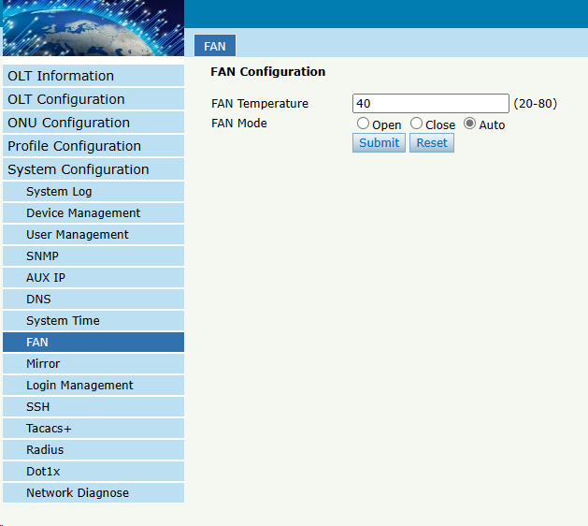
Figure 6.8-1: FAN Configuration

6.9 Mirror
System Configuration Mirror
Port mirror is usually used for troubleshooting. Each monitor session can be set with one destination port and up to 5 source ports.
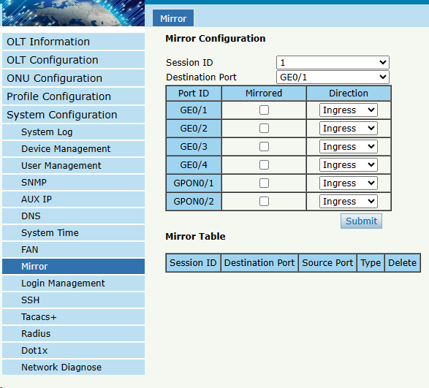
Figure 6.9-1: Mirror Configuration

6.10 Login Management

6.10.1 Login Access List
System Configuration Login Management Login Access List
This page is used to configure access rights for management. You can configure access rights for telnet, web, SNMP, SSH according to source IP address.
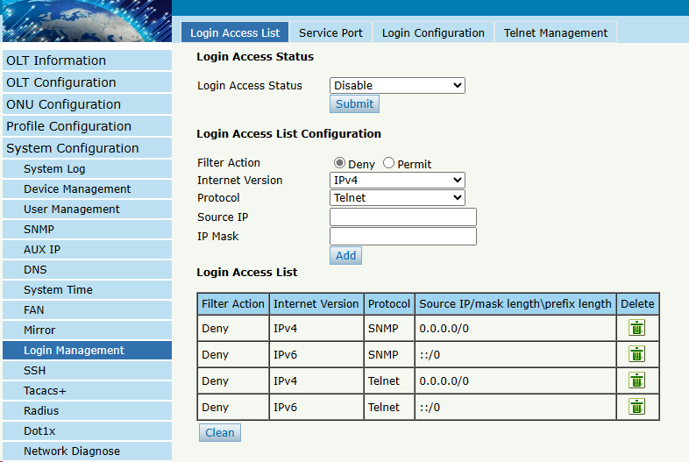
Figure 6.10-1: Login Access List Configuration

6.10.2 Service Port
System Configuration Login Management Service Port
This user interface allows you to modify the default remote service port.
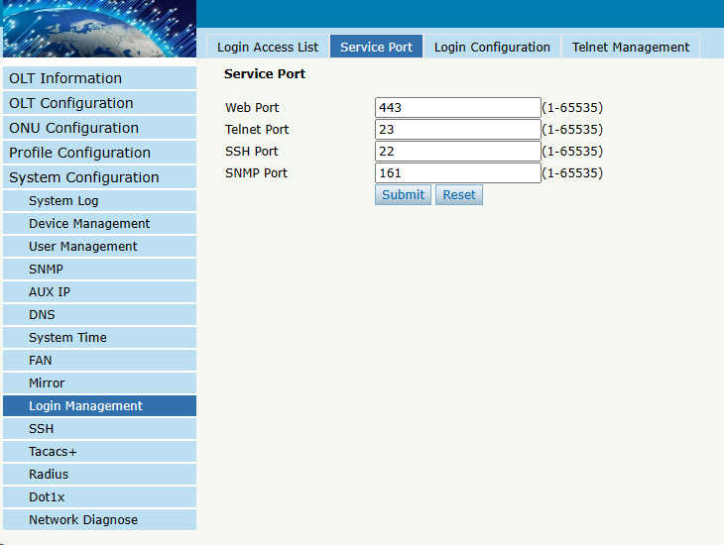

Figure 6.10-2: Service Port Configuration

6.10.3 Login Timeout
System Configuration Login Management Login Timeout
This page is used to set web timeout.
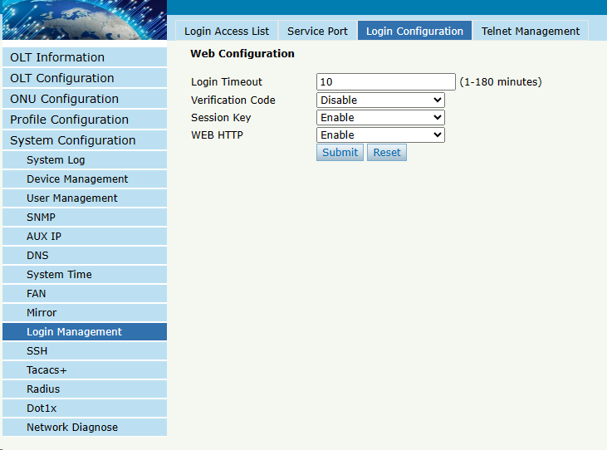
Figure 6.10-3: Login Timeout Configuration

6.10.4 Telnet Management
System Configuration Login Management Telnet Management
Here you can see the user who telnet into OLT.
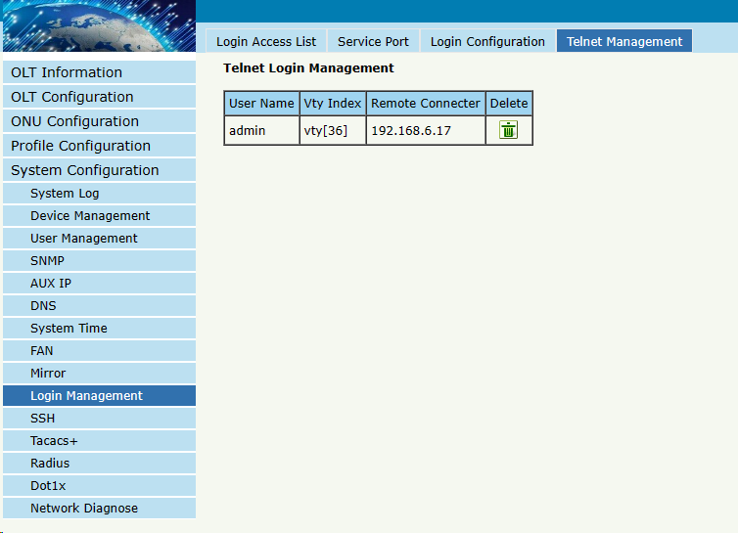
Figure 6.10-4: Telnet Management

6.11 SSH
SSH (Secure Shell) is a reliable protocol that provides security for remote login sessions and other network services. The SSH protocol can effectively prevent information leakage during remote management.

6.11.1 SSH State
System Configuration SSH SSH State
This page displays current connections that have established by SSH protocol.
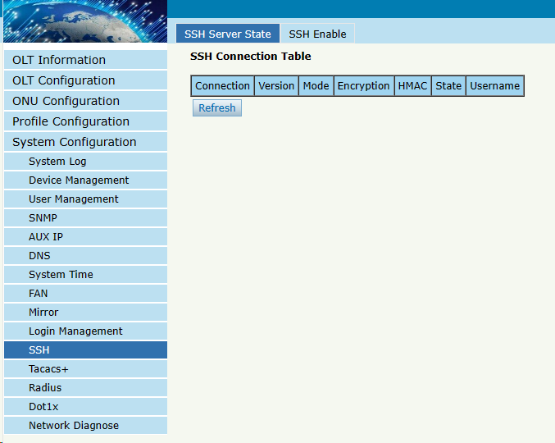
Figure 6.12-1: SSH State

6.11.2 SSH Enable
System Configuration SSH SSH Enable
This page is used to configure SSH protocol related parameters.
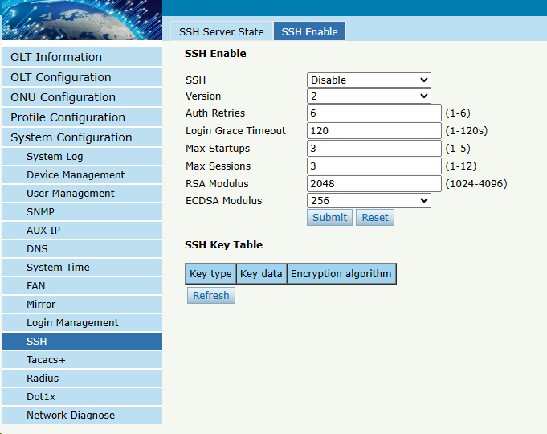
Figure 6.12-1: SSH Global Configuration

6.12 Tacacs+
Tacacs+ is a protocol that provides access control for routers, network access servers, and other interconnected computing devices through one or more centralized servers. Tacacs+ provides independent authentication, authorization, and billing services.This interface allows you to configure the Tacacs+ server IP address and other specific parameters.
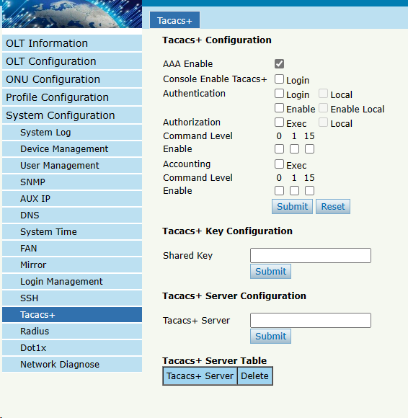
Figure 6.14-1: Tacacs+ Configuration

6.13 Radius
Radius is a protocol for authentication, authorization, and accounting information.The Radius server is responsible for receiving the user's connection request, authenticating the user, and then returning all the necessary configuration information to the client to send the service to the user.This interface allows you to configure the Radius server IP address and other parameters.
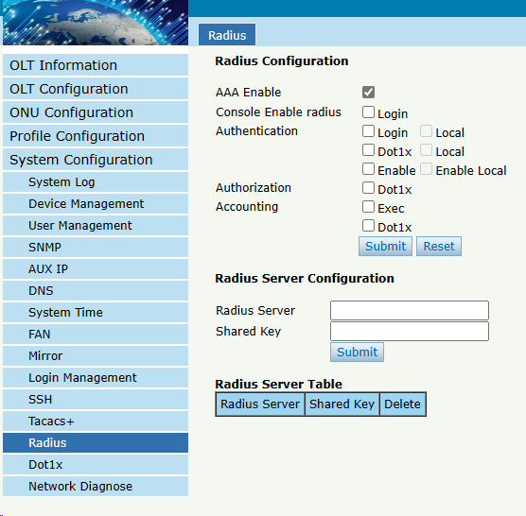
Figure 6.15-1: Radius Configuration

6.14 Dot1x
802.1x is a Client/ server-based access control and authentication protocol. It can restrict unauthorized users/devices from accessing a LAN/WLAN through an access port. After the authentication, normal data can pass through the Ethernet port.

6.14.1 Dot1x Information
This interface will display dot1x entry information when an 802.1x user passes authentication on the server, the server sends the authorization information to the device.
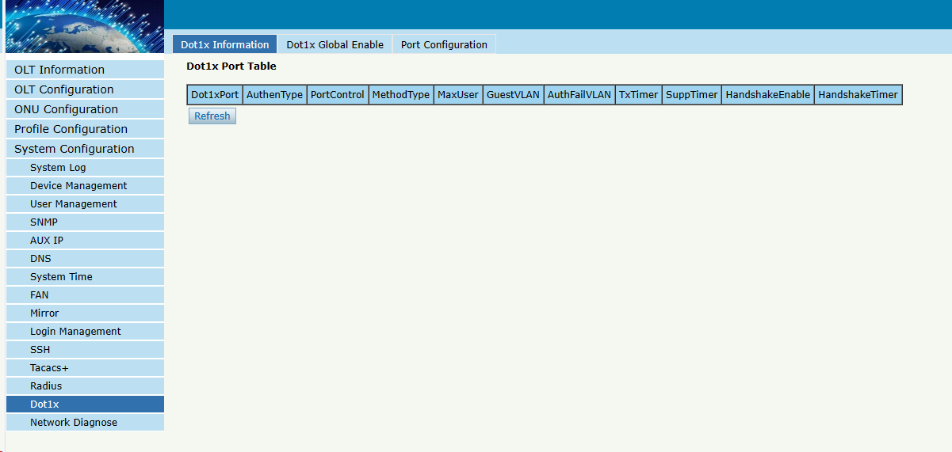
Figure 6.14-1:Dot1x Information

6.14.2 Dot1x Global Enable
You can enable Dot1x on this interface. 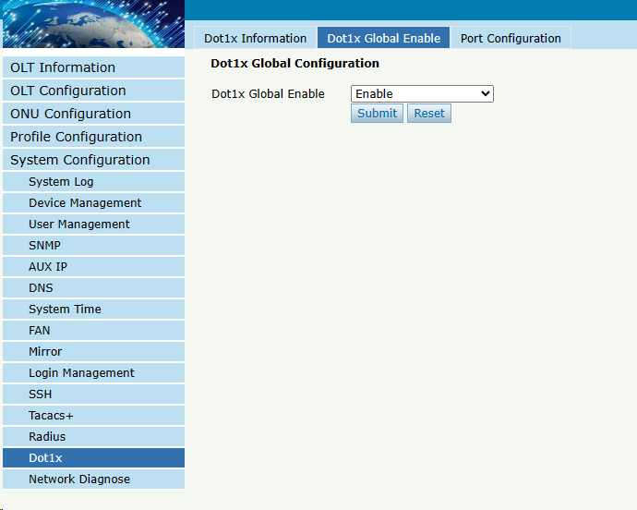
Figure 6.14-2:Dot1x Global Enable

6.14.3 Port Configuration
You can configure detailed Dot1x parameters for a specified port on this interface.
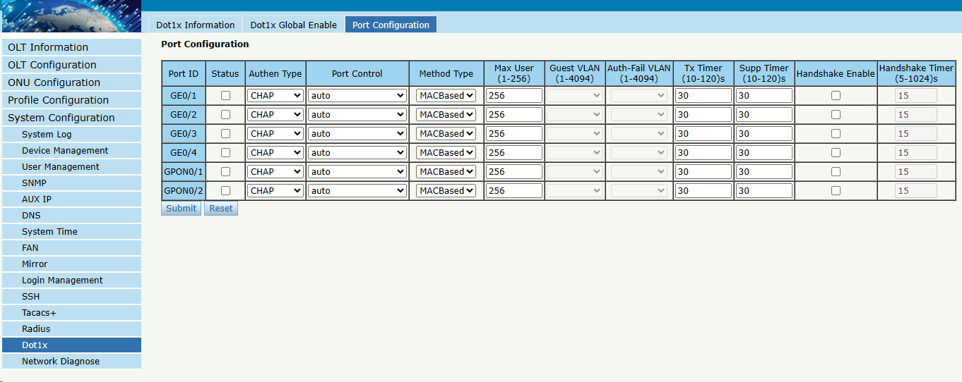
Figure 6.14-3:Port Configuration

6.15 Network Diagnose

6.15.1 Ping Diagnose
System Configuration Diagnose Ping Diagnose
This interface is used to diagnose network connectivity.
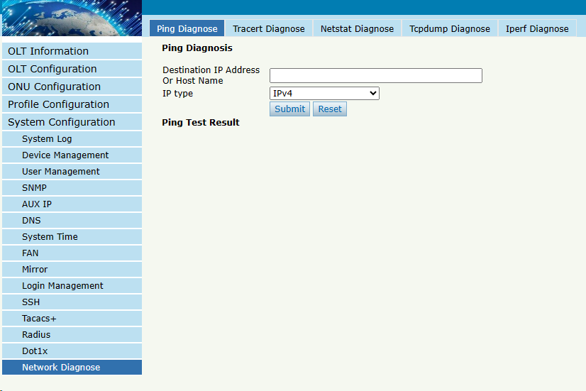
Figure 6.15-1: Ping Diagnose Configuration

6.15.2 Tracert Diagnose
System Configuration Diagnose Tracert Diagnose
This interface is used to track and diagnose routing and forwarding.
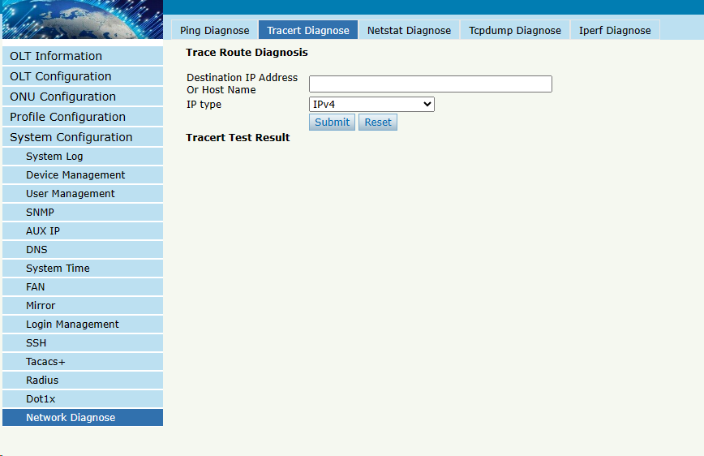
Figure 6.15-2: Tracert Diagnose Configuration

6.15.3 Netstat Diagnose
System Configuration Diagnose Netstat Diagnose
This is a network test.
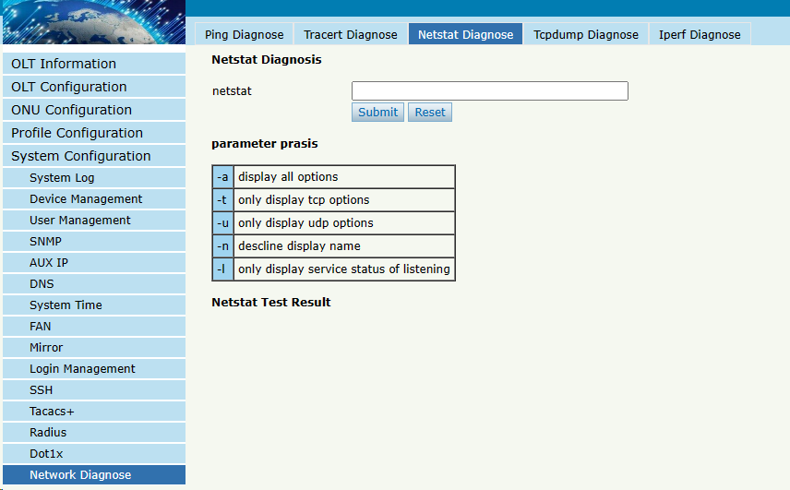
Figure 6.15-3: Netstat Diagnose Configuration

6.15.4 Tcpdump Diagnose
System Configuration Diagnose Tcpdump Diagnose
This is the PCP link test. 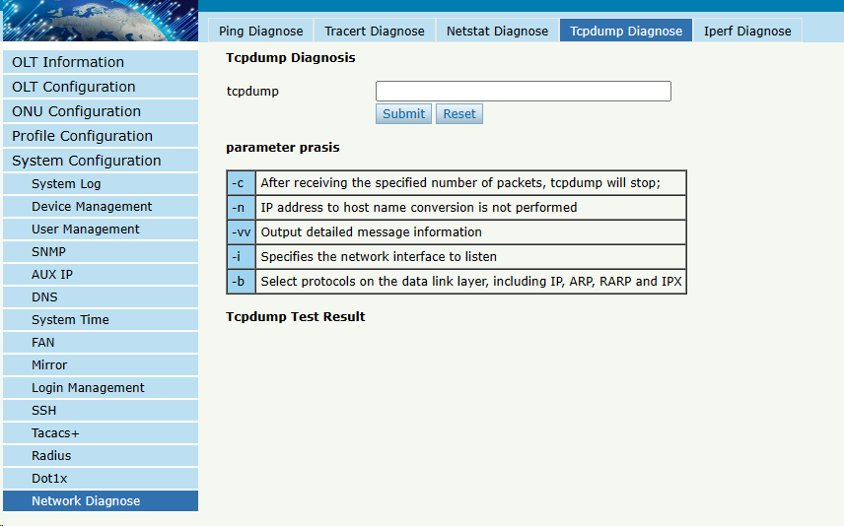
Figure 6.15-4: Tcpdump Diagnose Configuration

6.15.5 Iperf Diagnose
System Configuration Diagnose Iperf Diagnose
This is Iperf-related testing.
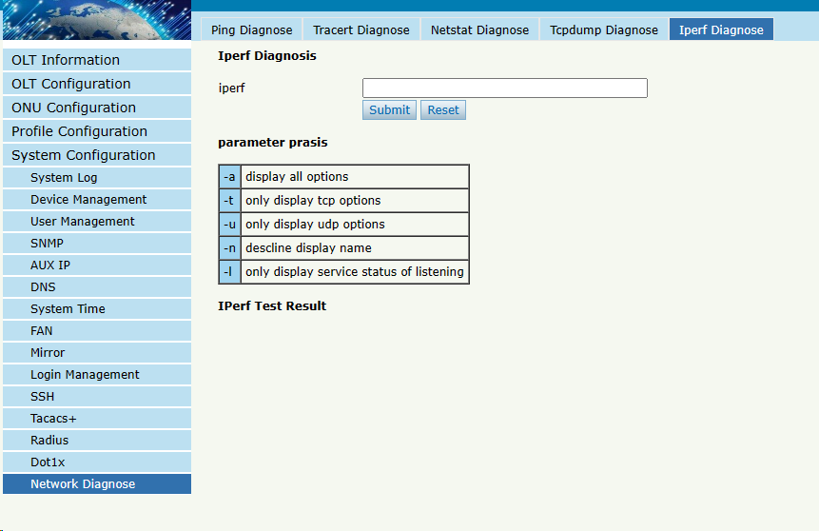
Figure 6.15-5: Iperf Diagnose Configuration

Thank you!

