V1600GS VOIP INITIALIZE WEB CONFIGURATION

Creat vlan777
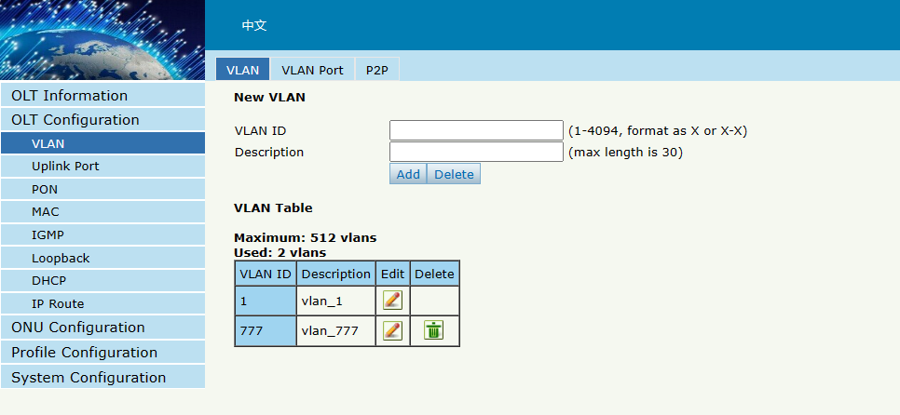
Put PVID VLAN777 IN GE1
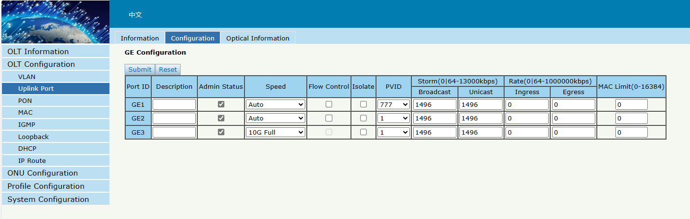
ONU CONFIG
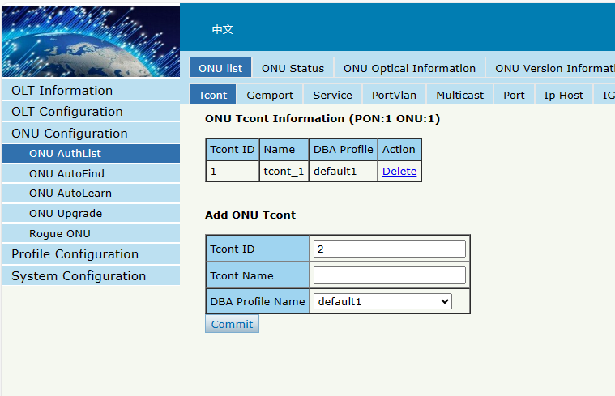
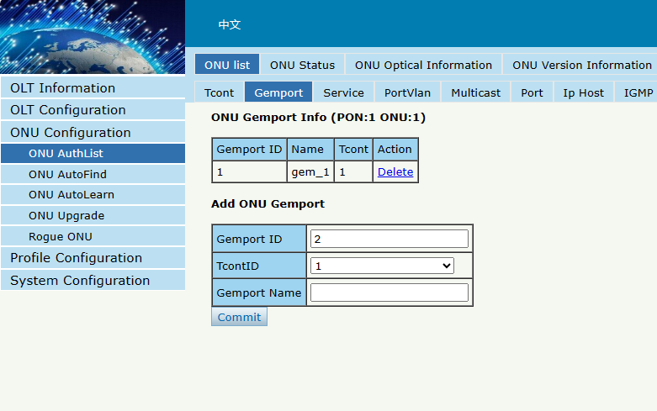
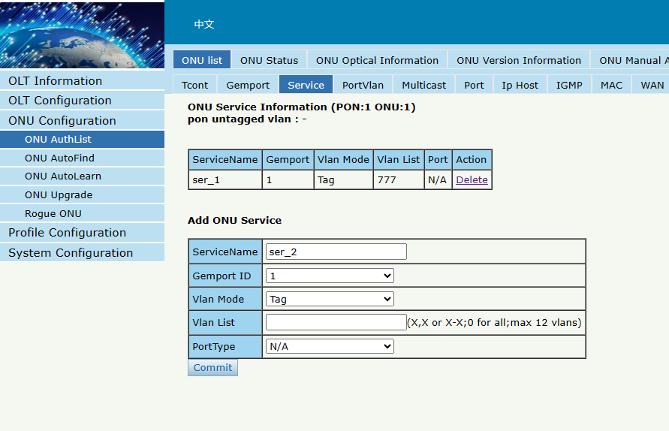
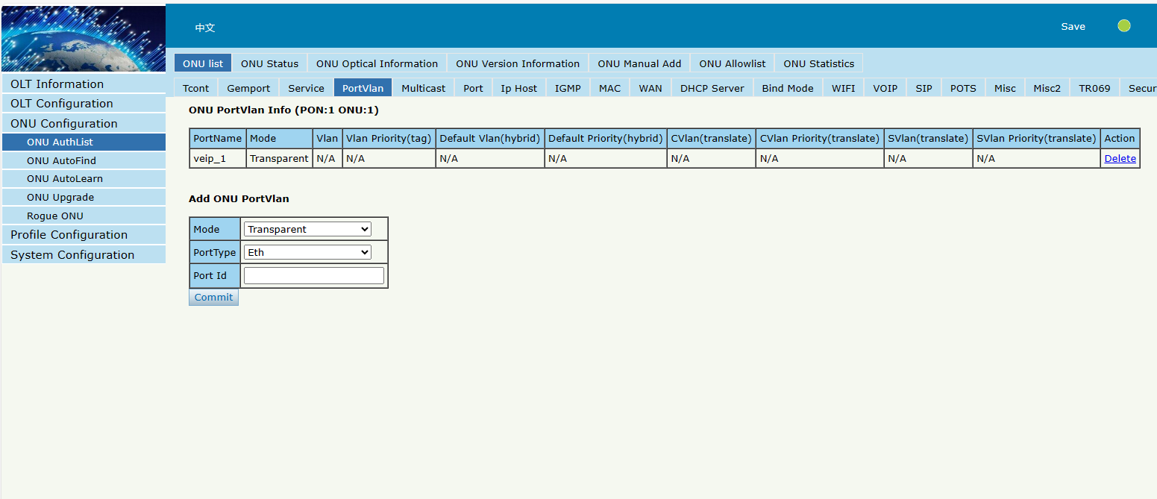

VOICE WAN/VOIP SERVER/SIP ACCOUNT PASSWORD(ONLY VSOL ONU)
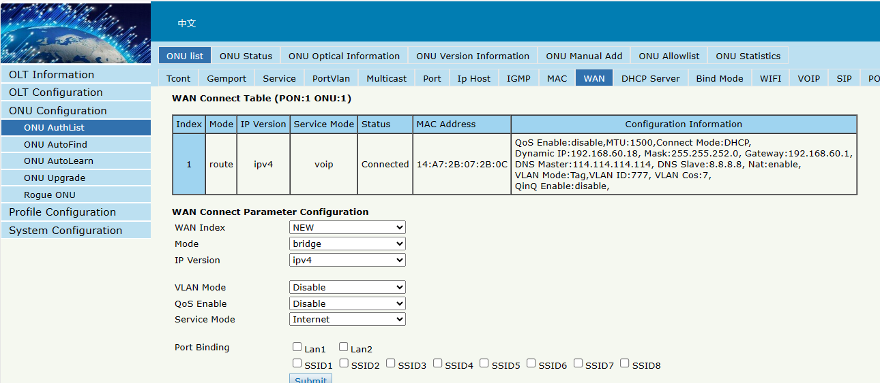
Config sip account/password
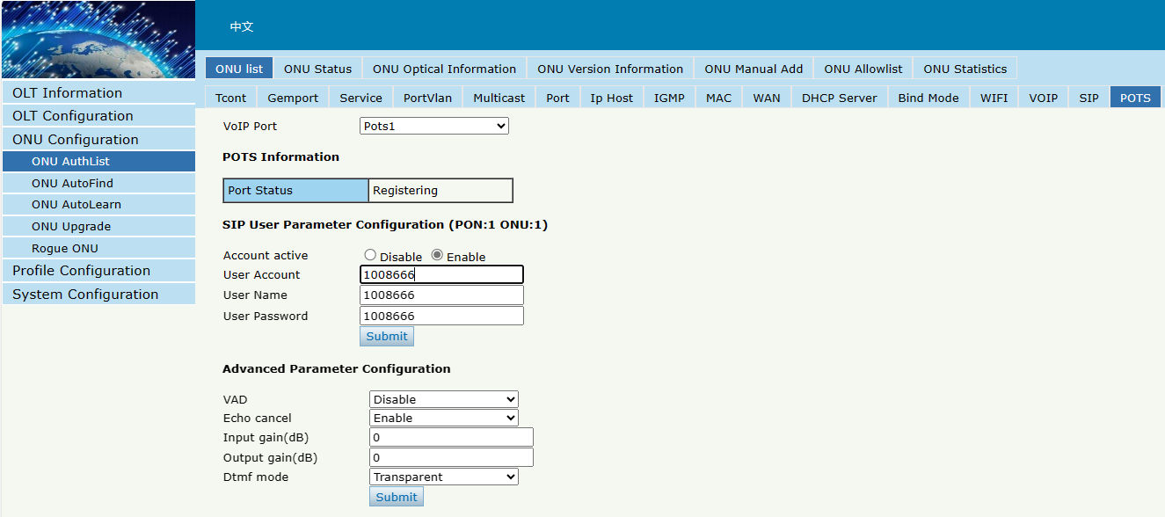
Config sip server detail
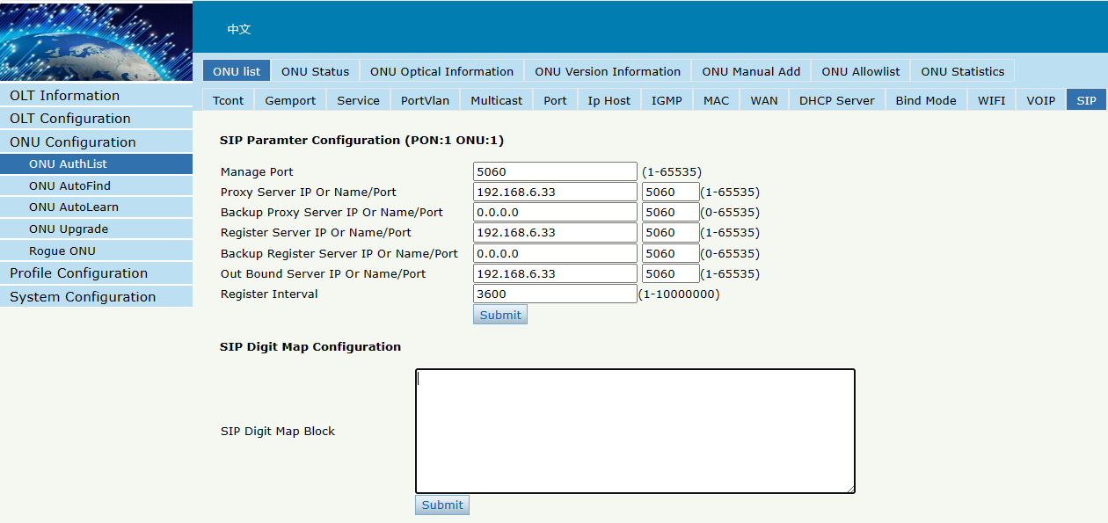

V1600GS INTERNET INITIALIZE CLI CONFIGURATION
Input login username and password
Login: admin
Password:Xpon@Olt9417#
gpon-olt> en
Password:Xpon@Olt9417#
gpon-olt# c t

Create vlan777 for voice

gpon-olt(config)# vlan 777

gpon-olt(config-vlan-777)# ex
gpon-olt(config)# interface gigabitEthernet 0/1 /
gpon-olt(config-if-ge0/1)# switchport hybrid pvid vlan 777 //put pvid in ge1

ONU Config
gpon-olt(config)# interface gpon 0/1
gpon-olt(config-pon-0/1)# onu 1 tcont 1 dba default1
gpon-olt(config-pon-0/1)# onu 1 gemport 1 tcont 1
gpon-olt(config-pon-0/1)# onu 1 service 1 gemport 1 vlan 777
gpon-olt(config-pon-0/1)# onu 1 portvlan veip 1 mode transparent

VOICE WAN/VOIP SERVER/SIP ACCOUNT PASSWORD(ONLY VSOL ONU)
gpon-olt(config-pon-0/1)# onu 1 pri wan_adv add route
gpon-olt(config-pon-0/1)# onu 1 pri wan_adv index 1 route mode voip mtu 1500
gpon-olt(config-pon-0/1)# onu 1 pri wan_adv index 1 route ipv4 dhcp nat enable
gpon-olt(config-pon-0/1)# onu 1 pri wan_adv index 1 vlan tag wan_vlan 777 7
gpon-olt(config-pon-0/1)# onu 1 pri wan_adv commit
gpon-olt(config-pon-0/1)#onu 1 pri pots 1 sip_user_config active enable account 1008666 name 1008666 pwd 1008666 //config sip account and password
gpon-olt(config-pon-0/1)#onu 1 pri sip_global_param mg_port 5060 proxy_serv 192.168.6.33 5060 reg_serv 192.168.6.33 5060 out_bound_serv 192.168.6.33 5060 reg_interval 3600 heartbeat disable //config sip server detail

